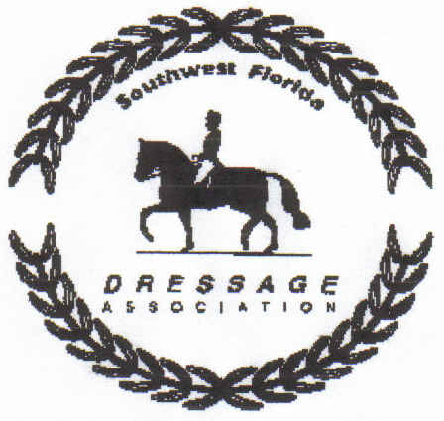

SWFDA Year End Award Declaration
2020-2021 Competition Year

This is an annual declaration of intent to compete for SWFDA awards. Riders must be current SWFDA members.
One declaration form for each horse/rider combination must be submitted for each category declared. One Option may be submitted for each category. (Ex: if you wish to declare for First Level AA and for Novice you must submit two (2) forms and fulfill an Option for each declaration.)
All of the following options require that the Year End Declaration Form must be completed and submitted prior to any scores being earned. Other paperwork to fulfill remaining criteria should be submitted with respect to their required deadlines.
Test Copies may be submitted until May 22, 2021

OPTION #1: Submit a Year End Award Declaration form with a payment of $55.00 for each declaration on or before May 22, 2021.

OPTION #2: Submit a Year End Declaration form and commit to earning eight (8) Work Credits per declaration. Work Credit Form must be submitted on or before May 22, 2021.

Rider Name:______________________________________

Horse Name:______________________________________

SWFDA Award Category: (For award purposes, please submit one form per horse/rider category. Categories are listed on the Year End Requirements Form)

______________________________________________________________

Rider Signature:_____________________________________

Date:__________________ Fees Enclosed:____$55.00________

**Forms & payment can be mailed to the address below OR paid via Venmo @swfda with forms emailed to volsandcubs@yahoo.com

Please make check payable to SWFDA and MAIL form(s) and payment to:
Susan Cox
8691 Kilkenny Court
Ft. Myers Fl 33912

Questions: email swfldressage1988@gmail.com

