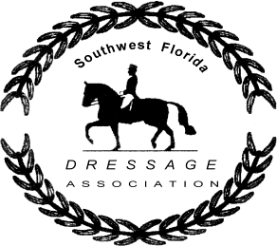
SWFDA Team Declaration Form
2021-2022 Show Season

Please use this form to declare your team on or before January 1, 2022
Please only submit one (1) form per team.

RULES: The team will consist of 4 Horse/Rider combinations representing a minimum of 2 levels. A minimum of 2 scores are required from each horse/rider combination, with a total of 12 scores overall. Horse/Rider combinations can ride in either 1 or 2 consecutive levels. If a team member or horse is unable to compete before earning the minimum 2 scores, a substitute may be nominated. The substitute’s scores will replace any score that may have been earned by the original team member. Scores from the substitute team member will only count from the day of the postmark on the new Team Declaration Form. All other team-member scores will count from the postmark on their original Team Declaration Form.

Date:

Team Name:

Rider’s Name | Horse’s Name | Level Showing

Mail Form To:

Susan Cox

8691 Kilkenny Court

Ft. Myers FL 33912

Questions? Please contact swfldressage1988@gmail.com

