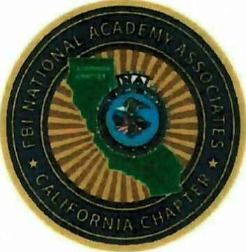
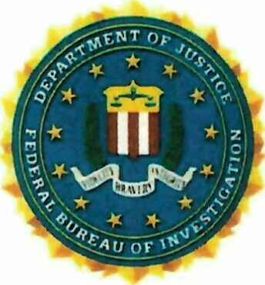
Law Enforcement Executive Development Seminar
(LEEDS)
Hyatt Regency Hotel
Sonoma Wine Country
170 Railroad Street, Santa Rosa, CA 95401

Please send this completed form to Tricia Seyler-Campbell at:
SanFranciscoVP@fbinaacalifornia.org

Hotel Room Block Link HERE: 2026 CA LEEDS Conference
Regular Attendee: $490 Click Here to Pay
You can also pay by check at registration.

Please complete the below information and email to Tricia Seyler-Campbell at:
SanFranciscoVP@fbinaacalifornia.org

Name: _______________________________________________
Rank/Title: ____________________________________________
Organization: __________________________________________
Address Line 1: _________________________________________
Address Line 2: _________________________________________
Phone: ________________________________________________
Email: _________________________________________________

