LADIES!


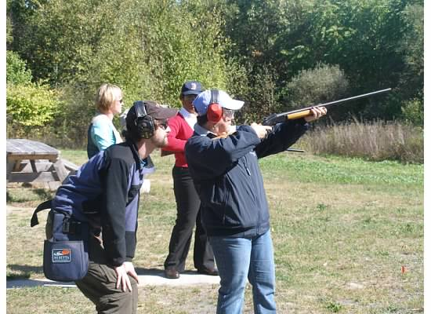

20th Annual
Women's Instructional Shoot!

October 15, 2022 from 8:30am to 3:30pm,
At the

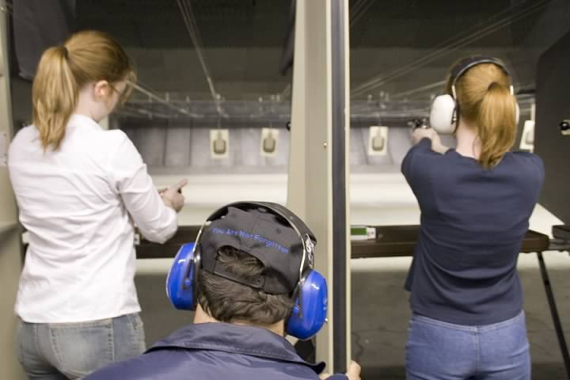
Braintree Rifle and Pistol Club

Have you ever thought of trying a firearm? Now is the time! Haven’t shot in a very long time? Are your firearm skills rusty? Well, then, come on down! This event is geared toward new women shooters, but all women, regardless of experience are invited to attend. No previous experience is necessary just the desire to learn and have fun. You will receive instruction in firearm safety and hands-on instruction in shooting a pistols, rifles, shotguns, and more.
crazy axes, etc.

Sponsored by Second Amendment Sisters of Ma
and the Braintree Rifle and Pistol Club.

The event fee is $65. We will supply all the equipment. A light lunch will be provided or you can bring your own. The event will be limited to 50 participants. You must pre-register to insure we have enough food and supplies for all. Please bring a baseball-type cap. Feel free to bring your own eye and ear protection if you prefer. This is a rain or shine event!!

TO REGISTER: Mail and make payable a check with name, address, tel #, *email and experience level (none, beginner, rusty, etc.) to: SASMA, PO Box 904, Norwood, MA 02062.
*Important: Please be sure to include an email address so we can confirm your registration.
Registration deadline is October 12, 2022.

The Braintree Rifle and Pistol Club is located at 800 Liberty Street, Braintree, a “state of the art” facility on 85 acres of land. Download directions from www.brp.org GPS address: Matthew Ct Braintree 02184
Questions? Email Lynne at lroberts167@outlook.com.

