***Using E-Expenses via a desktop***

1. Enter [www.sel-expenses.com](http://www.sel-expenses.com) the below will appear, if logging in for the first time click on forgotten details and follow the instructions you will be sent two emails with your username and password. If you have an account already enter your details the company is RFL.

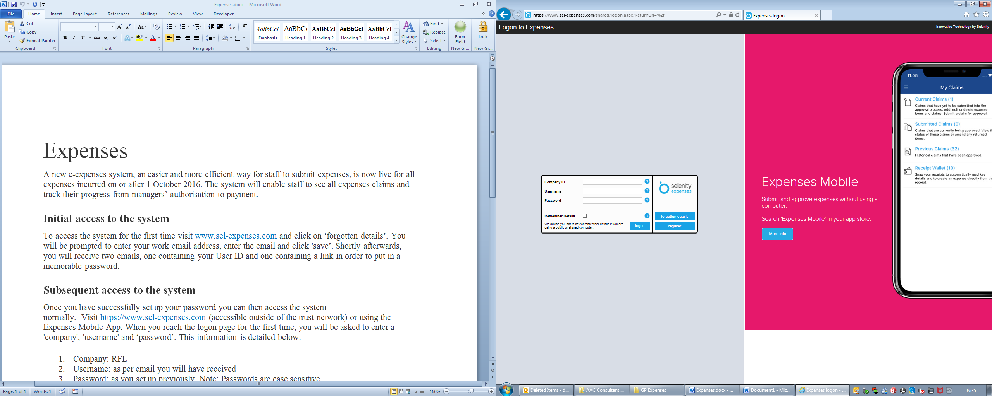

**If you are having trouble with accessing/logging into the system please email:** [rf-tr.expenseclaims@nhs.net](mailto:rf-tr.expenseclaims@nhs.net)

1. Click on add new expenses as shown below.

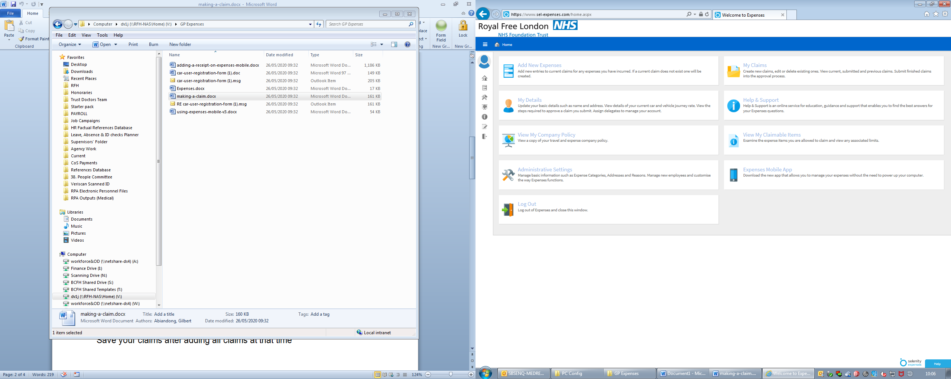

1. Fill out the form as shown below, select “Medical Course Fees”

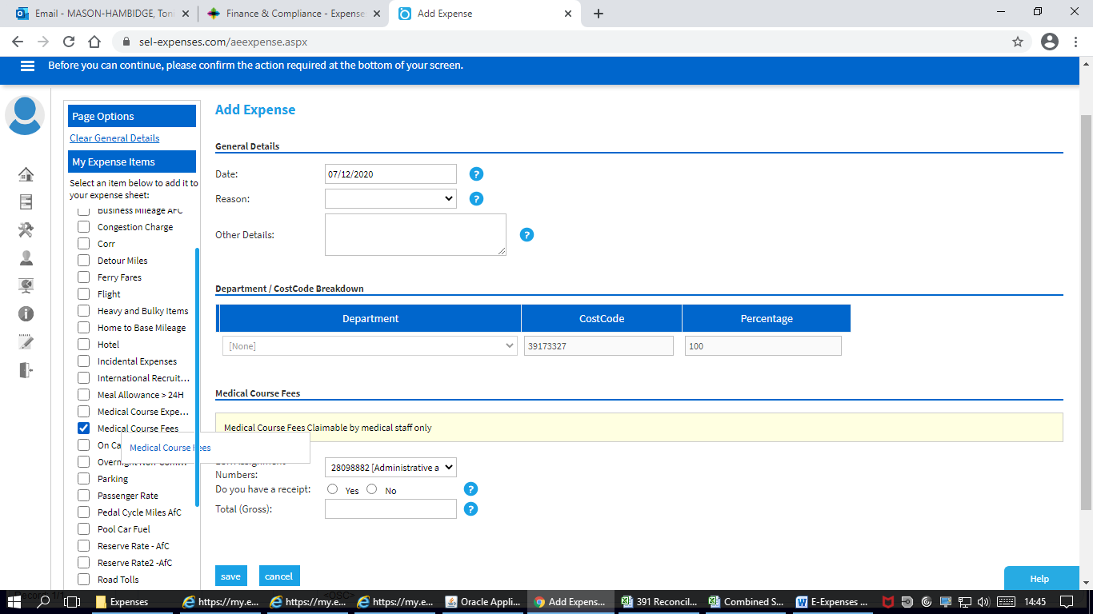

1. Please complete the following Fields:

* **Date of Course**
* **Reason (Training, Conference, Study Day)**
* **Other Details (Name of the course if applicable)**
* **Do you have a Receipt? – Please state Yes as your email evidence/Study Leave Expenses Reimbursement Form will act as the receipt.**
* **Press Save**

1. Add “Receipt”by clicking on the manage receipts option, the below documentation will need to be added for Study leave expenses;

* Proof of payment
* Study leave expenses reimbursement form (confirming what has been approved and its’ value)
* Proof of attendance (this means please submit your claim once the course has commence
* Please add in the correct course code available from <https://lasepgmdesupport.hee.nhs.uk/support/solutions/7000016490>

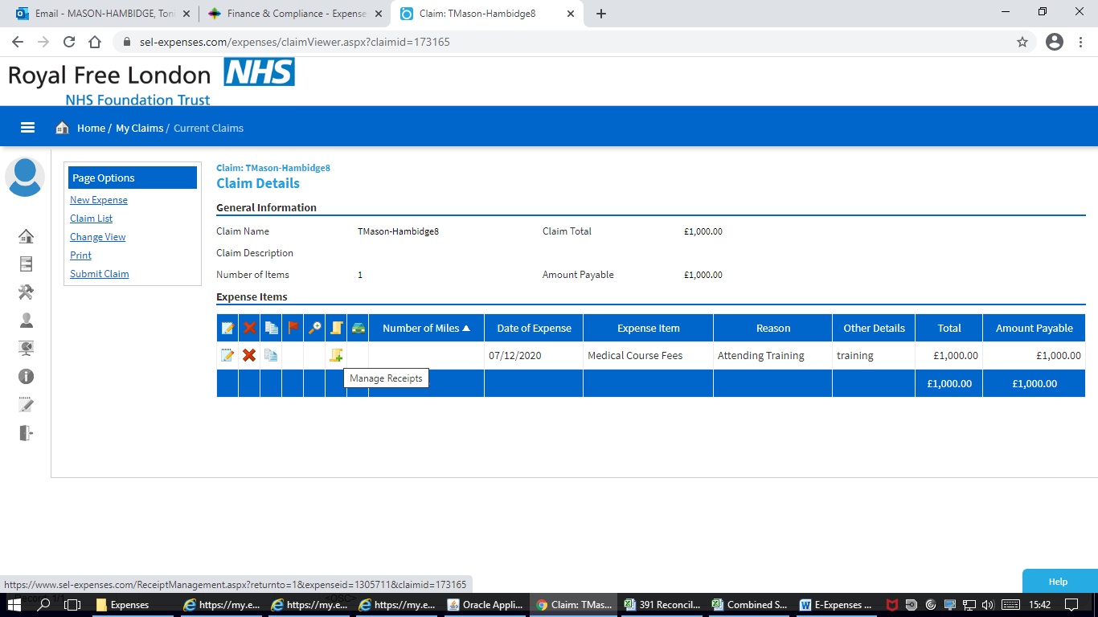

The below options will show and you will need to click on green + icon to upload the documents. Then click save.

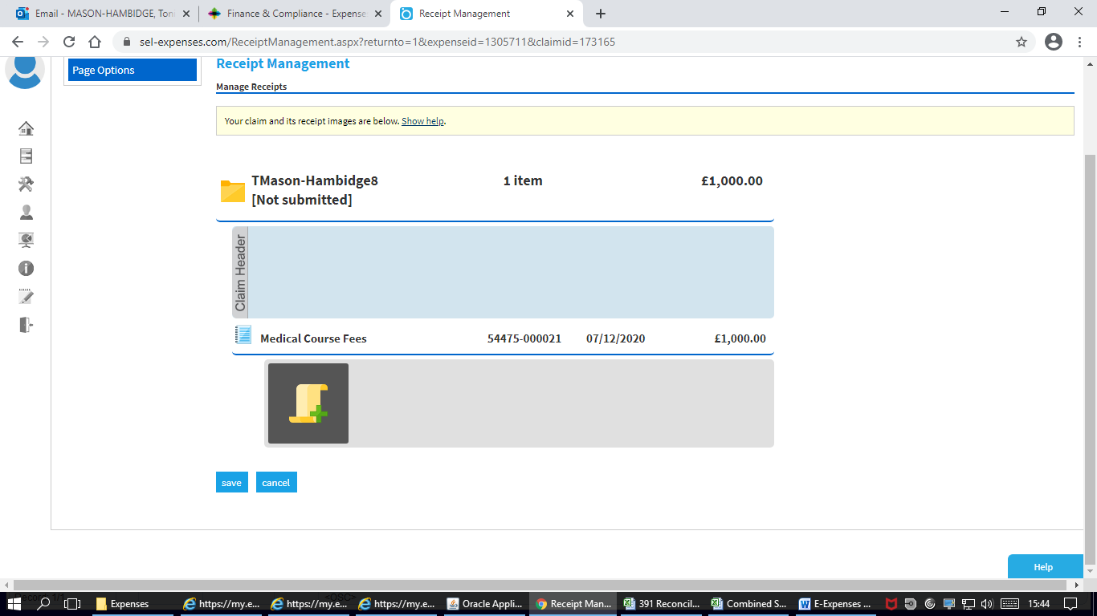

1. Once all the expenses of your Study claim have been added please submit your claim using the option in the left hand menu below.

Click here to add another item.

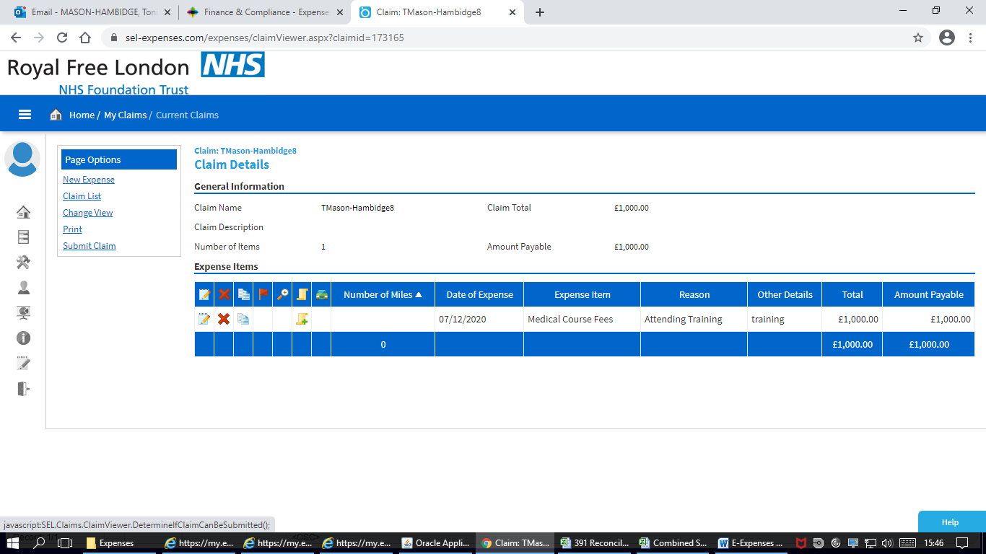

Click here to complete your claim.

**Help and Support**

**If you are having trouble with accessing/logging into the system please email:** [rf-tr.expenseclaims@nhs.net](mailto:rf-tr.expenseclaims@nhs.net)

The site has been designed to be user friendly, with help text on each page and a help and support icon on the home page. The icon provides various demonstrations, including how to add your expenses onto the system, how to add mileage and how to approve claims.

You can also access 'my details' and check the details held within the system for the purpose of claiming your expenses. If any of these details appear to be incorrect, click on the option to advise your system administrator.

If you have a question please email our dedicated helpdesk:  [rf-tr.expenseclaims@nhs.net](mailto:rf-tr.expenseclaims@nhs.net), escalation should be directed to [Karen.hamilton7@nhs,net](mailto:Karen.hamilton7@nhs,net). For queries in regards to the reimbursement payment please contact SBS through their online portal <https://www.sbs.nhs.uk/article/14408/Self-Service-Portal>, for approval queries please direct these to [rf-tr.gpleomonthly-return@nhs.net](mailto:rf-tr.gpleomonthly-return@nhs.net)