**ASHFORD INTERNATIONAL MODEL RAILWAY**

**EDUCATION CENTRE**

A PROJECT BY ASHFORD MODEL RAILWAY MUSEUM

REGISTERED CHARITY 1168774

POLICY STATEMENT AND PROCEDURE FOR SAFEGUARDING

Document Reference AIMREC/P01

|  |  |  |  |  |
| --- | --- | --- | --- | --- |
| Issue No | Date | by | Approved | Notes |
| 1 | 09-02-2022 | Nigel Hoad | Fred Garner | First Issue |
|  |  |  |  |  |
|  |  |  |  |  |
|  |  |  |  |  |

Unit 2 Mill Farm Business Units, Fridd Lane, Bethersden, Kent, TN26 3DB

Tel 01233 333877

|  |  |  |
| --- | --- | --- |
| **Contents**  **AIMREC Safeguarding Policy Statement**  **AIMREC Safeguarding Procedure** | |  |
| **Section 1** | **Policy** Page 5 |  |
|  | Purpose |  |
|  | Definitions |  |
|  | Scope |  |
|  | Values and Beliefs |  |
|  | Responsibilities |  |
|  |  |  |
| **Section 2** | **Procedures** Page 7 |  |
|  | Procedures where there are allegations or disclosures of abuse. |  |
|  | Recognising abuse |  |
|  | How to Respond to a Disclosure of Abuse. |  |
|  | Procedures where there is a concern about a child |  |
|  | Procedures where there is a concern about an adult |  |
|  | Procedure for allegations of abuse by a VOLUNTEER with children/adults at risk |  |
|  | **Contact Numbers** Page 9 |  |
|  |  |  |
| **Section 3** | **Good Practice Guidelines: Children** Page 10 |  |
|  | Code of behaviour |  |
|  | Discipline |  |
|  | Transporting children |  |
|  | Use of photography |  |
|  | Social media and online communication |  |
|  |  |  |
|  | **Good Practice Guidelines: Adults** Page 12 |  |
|  |  |  |
| **Section 4** | **Prevention** Page 13 |  |
|  | Appointing, training and supervising volunteers |  |
|  | Practice issues |  |
|  | Staff ratios |  |
|  | Working to prevent bullying |  |
|  | Supervision of offenders attending Centre |  |
|  |  |  |
| **App 1** | Roles of Safeguarding Administrator and Safeguarding Officer Page 15 |  |
| **App 2** | Definitions and Signs of Child Abuse Page16 |  |
| **App 3** | Sites of Non-Accidental and Accidental Injury Page19 |  |
| **App 4** | Definitions and Signs of Abuse of Adults at Risk Page20 |  |
| **App 5a-d** | Concern Forms Pages 23 - 29 |  |
| **App 6a** | Children’s VOLUNTEER Information Form Page 32 |  |
| **App 6b** | Volunteer Agreement Page 33 |  |
| **App 7** | Statement on the Recruitment of Ex-Offenders Page 34 |  |
| **App 8** | Boundaries to Consider in Contract with Sex Offender Page 35 |  |
|  |  |  |
|  | **COPIES OF THE FORMS WILL BE KEPT AT UNIT 2, MILL FARM BUSINESS UNITS, FRIDD LANE, BETHERSDEN, KENT TN26 3DB** |  |

Safeguarding Policy Statement for Children, Young People and Adults

The purpose of this policy statement is:

* to protect children, young people and adults from harm whilst they are visiting AIMREC’s premises, engaging in activities provided by AIMREC or working with AIMREC in a volunteer capacity, including children of adults who similarly visit, engage with or volunteer for AIMREC.
* to provide staff and volunteers, as well as children and young people and their families, with the overarching principles that guide AIMREC’s approach to both child protection and prevention of bullying

This policy applies to anyone engaged on activities on behalf of AIMREC including Directors, Trustees and Volunteers, both at AIMREC’s premises and external locations.

This policy has been drawn up on the basis of legislation, policy and guidance that seeks to protect children in England and is supported by our Safeguarding Procedure which contain full details of our organisational approach and arrangements for the protection of children and young adults.

We believe that children, young people and adults should never experience abuse of any kind and we have a responsibility to keep them safe whilst engaged in activities with AIMREC. We will practise in a way that protects them through the creation and fostering of a safeguarding and anti-bullying environment with processes to deal effectively with any instances that may arise.

We recognise that the welfare of children and young or vulnerable adults is paramount in all the work we do and in all the decisions we take all children, regardless of age, disability, gender reassignment, race, religion or belief, sex, or sexual orientation have an equal right to protection from all types of harm or abuse, including those that have vulnerabilities derived from previous experiences, their level of dependency, communication needs or other issues. We will therefore work in partnership with children, young people, their parents, carers and other agencies to safeguard and promote young people’s welfare, with a particular emphasis on valuing, listening to and respecting them.

We will appoint a nominated trustee for child protection and safeguarding and overseeing the implementation of safeguarding best practice through our policies, procedures and code of conduct including the recruitment and training for staff and volunteers. Our procedures will include the appropriate management of allegations against staff and volunteers, and ensuring that we have effective complaints and whistleblowing measures in place

We will record, store and use information professionally and securely, in line with data protection legislation and guidance, and make sure that children, young people and their families know where to go for help if they have a concern.

We are committed to reviewing our policy and good practice annually.

**Signed Trustee Responsible for safeguarding and child protection**

Name: Fred Garner Phone/email: [fred.garner@aimrec.co.uk](mailto:fred.garner@aimrec.co.uk) / 07874980652

**NSPCC Helpline** 0808 800 5000

**SECTION 1 – Purpose & Definitions**

**The Purpose of this Policy**

1. To ensure that children and adults at risk within the Centre are treated with the respect and dignity due to them as individuals. This means that they should be kept safe from harm, and free from abuse and neglect.
2. To ensure that everyone working with children and adults at risk in the Centre, whether paid or voluntary volunteers, understands their responsibilities under the policy, as well as the personal protection that working within the guidelines provides.
3. To provide confidence in the activities of the Centre and ensure the Centre is open to scrutiny.
   1. Parents and carers entrust their children to the care of Centre volunteers in the expectation that all activities will be carried out in a safe and secure environment.
   2. The reputation of the Centre is bound up with how we treat people. Failure to care for children will affect how the message of the gospel is received.
   3. The Centre has a responsibility to comply with all legal requirements relating to safeguarding, and the activities of the Centre must be fully transparent and open to scrutiny to all safeguarding authorities.

This policy is drawn up based on **law and guidance** that seeks to protect children and safeguard adults at risk namely, The Children Act (1989+2004), Data Protection Act 1998, Sexual Offences Act 2003, The Care Act 2014, Public Interest Disclosure 1998, General Data Protection and Regulations 2018 (GDPR), Safeguarding Vulnerable Group Act 2006, Protection of Freedoms Act 2012, Safe To Grow 2011 and Safe To Belong 2015 and Working Together to Safeguard Children 2018.

**Definitions**

**Safeguarding** means protecting an individual’s right to live in safety, free from abuse and neglect. It involves actions taken to promote the welfare of children and adults. The Children Act 1989 defines a **child** as being up to the age of 18. Any reference to child will also include young people and any reference to **parents** will include guardians or any others acting in a parental capacity.

An **adult at risk** is defined as any person aged 18 years and over who (1) has additional support needs, (2) is at risk of abuse (identifiable), (3) and because of the additional needs is unable to protect themselves effectively from the risk of abuse. ‘Additional needs’ refers to a person who may need community care services due to mental health issues, learning or physical disability, sensory impairment, age or illness.

**The Scope of this Policy**

1. The policy applies specifically to everyone who works on behalf of the Centre with children, and their parents and adults at risk.
2. It applies to the Trustees of the Centre, all Volunteers, activity leaders in the Centre and those appointed to carry out specific duties in relation to safeguarding.
3. It applies to all VOLUNTEERs of AIMREC.

**Our Responsibilities**

1. To ensure that the protection of children and adults at risk and their well-being is paramount.
2. To value, respect and listen to every VOLUNTEER of our community, including those who are vulnerable or find it difficult to make their voice heard.
3. To treat each person with fairness and equality without discrimination based on race, gender, age, ability, or any other defining characteristic.
4. To ensure that the interests of those working with children and adults at risk are fully taken account of and to provide protection from false accusations of abuse.
5. To work in partnership with other agencies and organisations to protect and promote the welfare of children/adults at risk.

**Fulfilling our Responsibilities**

Trustees

* The Trustees of the Centre will actively seek to create and maintain a culture of working with children and adults at risk that is in line with good practice in safeguarding.
* The Trustees carry the ultimate shared responsibility for ensuring that adequate safeguarding is in place; for supporting the development of good practice and for providing accountability for following procedures.

Centre volunteers

Volunteers involved with children and adults at risk must recognise that safeguarding is a crucial part of their responsibility. Specifically, they should:

* Be aware of any particular needs regarding a child or adult at risk.
* Be alert to signs and effects of abuse and neglect.
* Know what to do if a child or adult says they have been abused or ill-treated.
* Know what to do if an allegation is made against a fellow VOLUNTEER.
* Know and implement the guidelines for good practice.
* Ensure they conduct themselves correctly at all times and do not put themselves at risk.

Designated roles

The **Safeguarding Administrator** will oversee the administration of the safeguarding policy, including DBS checks. The **Safeguarding Officer** will be the person that volunteers and others will go to if they have safeguarding concerns about a child or adult at risk. A **Deputy** will act in the absence of the Safeguarding Officer.

See **Appendix 1** for a full description of responsibilities.

**AIMREC will ensure that all information relating to safeguarding will be processed in line with our data protection policy. In particular, we will ensure that personal data is accurate, retained securely and only held whilst the information is relevant. Any information shared will be necessary and proportionate.**

**Activities of the Centre Relating to this Policy** are any publicised events, any ad hoc gatherings of the Centre.

**SECTION 2 Procedures**

**Procedures where there are allegations or disclosures of abuse.**

Abuse and neglect are forms of maltreatment. A person may abuse/neglect by inflicting harm or failing to prevent harm. Children may be abused within a family, or a community setting, by those known to them, or more rarely, by a stranger. They may also be abused by another child. Definitions of abuse are in **Appendix 2** (children) and **Appendix 4** (Adults at Risk).

**Recognising abuse:**

It is important to be aware of possible signs and indicators of abuse. See **Appendix 2** for those relating to children, and **Appendix 4** for those relating to adults at risk. See **Appendix 3** for diagram of common sites for non-accidental and accidental injury.

Some signs could be indicators of a number of different categories of abuse. It is essential to note that these are only *indicators* of possible abuse. There may be other, innocent, reasons for these signs and/or behaviour. These will, however, be a guide to assist in assessing whether abuse of one form or another is a possible explanation for a child or adults’ behaviour.

**How to Respond to a Disclosure of Abuse.**

*A VOLUNTEER SHOULD*: -

* Remain calm, listen well, and show acceptance.
* Reassure the child or adult that they are right to share their concern.
* Allow time for the child or adult to speak. You may have to ask the person to repeat themselves or to check that you have understood what they said.
* Take seriously what you are hearing.
* Don’t rush or interrupt or ask more questions than you need.
* Only ask questions that arise clearly from what has been said. Do not introduce any new themes or ideas.
* Use open-ended questions e.g. “who is it you are afraid of?” not leading questions e.g. “are you afraid of X?”
* Explain what will happen next and that the information will be shared with a limited number of other people who will be asked to help. Do not promise confidentiality.

*A VOLUNTEER SHOULD THEN*: -

* **Record** in writing the nature of the concerns/disclosure, an exact record of what the child/adult said, including the volunteer’s response, description of any bruising/injuries or other observations, actions taken, signed with date and time. See **Appendix 5c and 5d** for ***Concern Form*** ***and Body Maps.***
* **Report** to the Safeguarding Officer or Deputy within 24 hours to discuss concerns and if any action required.
* If the child or adult is in imminent danger of harm and the Safeguarding Officer and Deputy, cannot be contacted, then a report should be made immediately to the Police and/or Social Services. The Safeguarding Officer should be informed as soon as possible after the report has been made and will then liaise with the Police or Social Services.

**Procedures where there is a concern about a child**

***Allegations of physical injury, neglect, emotional abuse,*** ***and sexual abuse***

If **a VOLUNTEER** notices that a child has a physical injury, indicators of neglect, concerns about sexual abuse or emotional abuse, they should:

* Always take seriously the concerns.
* Never confront the adult about whose behaviour there are concerns.
* Never investigate allegations.
* Make a written, (not electronic), record of the concern, ideally using concern form Appendix 5a/b, retain this confidentially/securely until this can be passed to the Safeguarding Officer/Deputy, which should be done as soon as possible.

**The Safeguarding Officer** will elicit from the VOLUNTEER the reasons for concern and discuss details along with other relevant information, and a decision will be taken as to what action will follow. This might involve:

* Contacting Social Services/Police in cases of deliberate injury, allegations/suspicions of sexual abuse, concerns about a child’s safety and well-being, or if a child is afraid to return home.
* Seeking medical help, if needed urgently, informing the doctor of any suspicions.
* For lesser concerns (e.g. poor parenting), encouraging parents to seek support from appropriate services. The Safeguarding Officer may offer to assist/accompany them, if appropriate. If unwilling to seek help and concerns remain, then Children Social Services will be contacted for advice.
* A record of all discussions/action will be kept and stored securely.
* Formal referrals to Social Services will be reported back to the Trustees.

**Procedures where there is a concern about an adult**

If there are suspicions or allegations of abuse or harm, these should be treated in the same way as a concern/disclosure about a child. The VOLUNTEER should **recognise** that abuse may be taking place, **respond** to the concern, **record** all information and **report** to the Safeguarding Officer who will decide on appropriate action. This may involve:

* Contacting the Adult Social Services Team.
* If the adult is in immediate danger or has sustained a serious injury, contacting the Emergency Services, informing them of any suspicions.

***Mental Capacity and if the adult refuses help***

If an adult refuses help, any action should assume that the adult has the capacity to make their own choices. If possible, always make sure they know where to get appropriate help and support if they change their mind.

There may be occasions when you are **unsure** if an adult has the capacity or ability to make decisions about their safety and wellbeing. In these instances, always refer to adult social services for advice.

There may also be occasions when it is still necessary to inform the police or Adult Social Services, if for example, the adult lacks the mental capacity to make such a choice, when there is a risk of harm to others and in order to prevent a crime.

**Procedure for allegations of abuse by a person who works with children/ adults at risk**

Centre **volunteers** should encourage an atmosphere of mutual accountability, holding each other to the highest standards of safeguarding practice. If an allegation of abuse is made, **do not approach the alleged perpetrator** about it. Record the allegation and report it to the Safeguarding Officer.

The **Safeguarding Officer** alongside a Trustee will:

* Establish whether any immediate action is required to ensure the safety of all involved.
* Contact the Local Authority Designated Officer (LADO) within 1 working day.
* If a crime is believed to have been committed, the Police must be contacted immediately and then a LADO referral should be made.
* In some situations, it may be necessary to tell the VOLUNTEER that an allegation has been made so as to remove them from the situation. The details of the allegation should not be given, and the individual must be supported throughout the investigation. There may also be occasions when it is not right to tell the VOLUNTEER of an allegation, for example, if there is evidence they could try to dispose of.
* LADO/Adult Social Services will advise on the next course of action. This may involve suspension of VOLUNTEER, putting a contract in place or if considered an unwise action, re-educating.
* Contact the Charity Commission and DBS only if the threshold is met. (E.g. sexual abuse.)
* Contact the Insurance Company where an allegation is made against someone in Centre.
* Follow up all contacts with third parties in writing.
* When allegations concern the Safeguarding Officer or a VOLUNTEER of their family, the Deputy/Leader will contact and liaise with the necessary authorities.
* No information about the allegation will be shared with people in the Centre other than those directly involved in safeguarding.

**Contact Numbers**

**Kent County Council Central Duty Team**:-

Children: 03000 411111 (08:30 -17:00 hours)

Adults: 03000 416161 (08:30 -17:00 hours)

Out of Office hours: 03000 419191

Email: socialservices@kent.gov.uk

Immediate Risk of Harm: **Kent Police 999**

**KCC Local Authority Designated Officer Team**: 03000 410888

**Other Agencies**

**Crimestoppers:** 0800 555 111

**Modern Slavery:** 0800 0121 700

**UK Visas and Immigration:** 01303 247 088

**National Domestic Violence Helpline:** 0808 2000 247

**NSPCC:** 0808 800 5000

**Child Exploitation and Online Protection Centre:** 0870 000 33 44

**Crossroads:** 03450 956 701

**Shelter:** 0808 800 4444

**Citizen’s Advice Bureau:** 01474 878 639

**SECTION 3**

**Good Practice Guidelines - The Care of Children and the Protecting of Leaders**

This **code of behaviour** should not only be seen as an important safeguarding measure, but also be about modelling positive patterns of behaviour to children.

**General Guidelines:**

* Treat all children with dignity and respect
* Value and listen to all children. Do not appear to favour one child.
* Work in an open and accountable manner and be willing to accept questions or criticism regarding good practice. Be willing to discuss any concerns about the practice of others.
* Do not engage in any of the following:
* Rough games involving physical contact
* Sexually provocative games
* Make sexually suggestive comments about or to a child, ‘even in fun’
* Scape-goating, belittling, ridiculing, or rejecting a child
* Use appropriate and respectful forms of discipline and communication. See following section on discipline.
* Never physically discipline children.
* Physical intervention is only necessary if the child is a risk to themselves or others.
* If a child makes sexual or suggestive comments, be ready to challenge.
* Don’t discriminate or leave discrimination or bullying unchallenged.
* Discuss any concerns about a child’s wellbeing with the Safeguarding Officer.
* Be vigilant and aware of how actions can be misinterpreted by children.
* Work in view of others wherever possible; be wary of working alone and unobserved. If a child wants to talk one-to-one about an issue, tell another VOLUNTEER and find somewhere quieter, but still public, to talk. A record that the conversation was held should be made in a **log book**, signed, and dated.
* If a young child needs the toilet, a VOLUNTEER should wait in the corridor. Parents should be immediately contacted if their child needs assistance. If the parent is unavailable, then another DBS checked VOLUNTEER should be called to assist.
* Touch should be:
* age-appropriate (e.g. helping/playing/lifting a young child)
* initiated by the child (e.g. reaching for your hand, needing comforting), and with an older child, an arm around the shoulder may be more appropriate.
* always be for the sake of the child.
* avoided if you are alone with the child.

**Discipline**

* Have a conversation with the children about what is expected of them in terms of behaviour, why this matters and what the sanctions will be.
* Involve the children in making simple rules.
* Be insistent, consistent, and persistent.
* Keep rules simple.
* Talk about discipline issues with individual children away from the group.
* Each child is unique and may need a different method of being dealt with. Consider the following: (i) why is the child behaving like that? (ii) what are the best way of disciplining and encouraging that child?

**Practical ideas for managing activities**

* Separate children who tend to be disruptive when together. Warn them first.
* Have a child sit right in front of you.
* Get a helper to sit next to the child.
* Encourage helpers to be assertive and not to wait to be asked to deal with situation.
* Take a child aside and talk to them, challenging them to change, whilst encouraging them on their strengths.
* Warn a child that you will speak to their parents and do so if necessary.
* If necessary, ban a child from an activity for a week.

**Use of Photography**

***Photographs for Centre use:***

* The Centre will have designated photographers, one of whom will take responsibility for collating them, deciding which photographs to use and storing them.
* Photographs may be used for publicity (e.g. website, banners, leaflets) or in displays or photo books. Photographs will be for Centre use only and not for third party use unless specific permission has been obtained (e.g. a newspaper report).
* Permission for photographs to be taken in two stages. The first will be at an event such as a service, a fellowship meal where an announcement will be made that photographs are going to be taken so people can choose to opt out if they wish by telling the photographer(s). Secondly, if it is proposed that a particular photograph is suitable for use in publicity material then all those shown in the photograph will be asked to sign a form.
* Registration forms for all groups will include the option for parents/guardians to give consent for photographs of their child to be taken.
* Photographs should only be used in ways agreed by all parties involved. When photographs are displayed, avoid identifying children by adding names or addresses.
* Photography or video recording should focus on the activity, not on a particular person unless it is a personal photograph/recording for a testimony etc.
* Only use images of individuals in suitable dress.
* No photos of children should be stored on volunteers’ mobile phones.
* All concerns regarding inappropriate behaviour or intrusive photography should be reported to a Trustee.

***Photographs for personal use:***

* As a Centre we will meet on social occasions and it is reasonable for people to take photos, however this should be for personal use only and not posted on any social media site unless specific permission has been given from everyone in the image.

**Social Media and On-Line Communication**

AIMREC acknowledges electronic communication as a legitimate means of communicating with young people as long as the following guidelines are followed.

* Permission should be sought from parents and from the young person before communicating by email, phone, or social networking sites.
* Electronic communication should primarily be used for factual/administrative purposes, (for example, to communicate information about an activity).
* Clear, unambiguous language should be used, avoiding unnecessary abbreviations.
* Electronic communication should only be used between the hours of 9:00am and 9:00pm.
* Where communication with children is made by text/email/SMS or IMS etc. a record of such communication should be kept. Printing of emails/IMS conversations and copying of text/SMS messages to paper will allow for this.
* Where possible communicate with young people via group chats, (e.g. youth group when planning an activity or pooling ideas).
* Where volunteers communicate in this way, the records of such communications should be shown to one of the group leaders on a regular basis.
* Volunteers should not share any personal information with children, nor encourage them to do so.
* Volunteers should not accept a friend request from a young person nor request one.
* If the group leader/Safeguarding Officer does not consider that the communications are relevant or appropriate, the VOLUNTEER will be required to cease communication with the child in this way.

**Good Practice Guidelines – The Care of Adults at Risk.**

AIMREC wants to create a welcoming and inclusive environment for all adults with additional needs.

* We aim to ensure there is safe and easy access, (for example, layout of chairs, removal of obstacles), the building is suitably decorated to assist people living with dementia, there are necessary aids and adaptations, and there are effective audio/sound provisions and sufficient lighting.
* Where there are communication needs, efforts will be made to speak patiently and in a clear, straightforward manner and individually where necessary.
* We will aim to provide copies of any printed materials in large print.
* Speakers should face the attendees and not cover their mouths, enabling those who rely on lip reading, and describe what is being presented on a screen for those who cannot see clearly.
* We will aim to support and encourage people to make their own decisions and seek any help they might need.

**SECTION 4**

**Prevention**

**Appointing, Training and Supervising Volunteers**

The **Trustees** will ensure all volunteers will be appointed, trained, supported and supervised in accordance with government guidelines on safe recruitment. This means:

* They will identify and approach potential new volunteers and all decisions to appoint will be made by at least two Trustees.
* They will ensure that all **prospective volunteers**:
* understand their role in the activity.
* complete an Information Form (**Appendix 6**) which provides their history of work with children, their skills and motivation and a signed declaration that there is no reason why they should not be working with children.
* have a discussion with a Trustee regarding their involvement and where appropriate, agree for contact to be made with a previous Centre for information on their suitability.
* agree to an enhanced DBS check.
* have a copy of and have understood and signed an undertaking to work within the Safeguarding Policy and procedures.
* review their involvement after an agreed time.

In the event of a **previous offence(s) on a DBS check**, this will be discussed openly with the person in question, circumstances will be taken into account and a **risk assessment** will be carried out before any decision is made regarding an appointment. See Policy Statement on the Recruitment of Ex-Offenders (**Appendix 7**)

**Volunteers** will be:

* given opportunities to meet with the Trustees to discuss the activity(ies) they are involved in and raise any areas of concern.
* expected to follow the code of behaviour in section 4 and understand what will happen if they fail to do so.
* expected to attend any sessions on safeguarding training.

**Practice Issues**

* Parental Consent/Information Forms will be completed for any Centre groups involving children or young people.
* Parents will be made aware that they can contact the Safeguarding Officer or Deputy if they have any concerns about the welfare of their child in relation to the Centre.
* Risk Assessments will be created for all the groups by the group leaders and will be reviewed annually or following changes in circumstance.
* All accidents will be recorded.
* All personal data will be held confidentially and securely in accordance with GDPR.

**Staff Ratios**

* There should be at least 2 vetted volunteers per group, preferably a male and female.
* Children and leaders should be registered at each session (name, date, time).
* Adult to child ratios are:

|  |  |  |
| --- | --- | --- |
| **Age range** | **Recommended minimum ratio for INDOOR activities** | **Recommended minimum ratio for OUTDOOR activities** |
| 0-2 years | 1 adult to 3 children | 1 adult to 3 children |
| 3 years | 1 adult to 4 children | 1 adult to 4 children |
| 4-8 years | 1 adult to 6 children | 1 adult to 6 children |
| 9-12 years | 1 adult to10 children | 2 adults to 15 children  with an extra adult for every 8 additional children |
| 13 years and over | 1 adult to 10 children | 1 adult to 10 children |

**Working to Prevent Bullying**

Bullies can be children bullying children/adults, and adults bullying children/adults.

* The children will agree the code of behaviour for their groups, making it clear that bullying is unacceptable.
* The leaders will model the importance of valuing and respecting each other even in disagreements.
* All allegations of bullying will be taken seriously, and details will be checked before action is taken.
* An attempt will be made to help bullies understand and change their behaviour.

It is also important to distinguish bullying from other behaviour, such as respectfully challenging or disagreeing with someone else’s beliefs or behaviours, reasonable expectations with regard to work deadlines and activities or taking legitimate disciplinary action.

**Supervision of Known Offenders in the Centre**

When someone attends the Centre who is known to be a sex offender or there are reasons to believe they pose a risk to children/adults, there will need to be a **written agreement** in which boundaries are set**.**

The Trustees, in consultation with the Safeguarding Officer, will

* speak openly to the individual to understand the situation
* speak to external agencies as appropriate
* undertake a formal risk assessment which will result in
* a written agreement which will be
* signed, monitored, and reviewed regularly. (See **Appendix 8**).

**APPENDIX 1**

**THE ROLE OF THE SAFEGUARDING ADMINISTRATOR**

Responsibilities will include: -

* Ensuring they are familiar with safeguarding policies, procedures, and guidelines.
* Ensuring that AIMREC Safeguarding Policy is accessible and that volunteers are familiar with it.
* Supporting the Safeguarding Officer and deputy in their work.
* Ensuring all documentation in relation to safeguarding is stored securely and handled confidentially.
* Ensuring volunteers have up to date Disclosure and Barring Service Checks.
* Assisting in organising ongoing safeguarding training for all volunteers in AIMREC.
* Initiating the annual review of all policies and procedures, including risk assessments.

**THE ROLE OF THE CENTRE SAFEGUARDING OFFICER/DEPUTY**

**To coordinate safeguarding policy and procedure in the Centre.**

* To ensure that volunteers understand their duty to report safeguarding concerns.
* To familiarise themselves with policies and procedures in relation to safeguarding and to keep abreast of any changes and developments.
* To ensure safer recruitment practises are operated in the recruitment of volunteers.

**To be the first point of contact for safeguarding issues***.*

* To be a named person that children and adults at risk, Centre VOLUNTEERs and outside agencies can talk to regarding any safeguarding issues.
* To be aware of the names and telephone numbers of appropriate contacts within Social Services and the Police in the event of a referral needing to be made.
* To be aware of when to seek advice, and when it is necessary to inform Social Care, the Police or the Local Authority.
* To take appropriate action in relation to any safeguarding concerns.
* To cooperate with Social Services and the police in safeguarding investigations.
* To ensure that appropriate records are kept and information in relation to safeguarding is handled confidentially and stored securely.
* To inform the Trustees of any pending or submitted referrals to the statutory authorities, or any information received.

**To be an advocate for good safeguarding process in the Centre**.

* To ensure that children and adults at risk are offered information on where to get help if they have been affected by abuse.
* To promote positive safeguarding procedures and practice.
* To arrange and promote opportunities for training in safeguarding.
* To provide advice and guidance to staff when concerns are raised.
* To update their own safeguarding training.
* To seek appropriate support and advise in carrying out this role.

**APPENDIX 2**

**DEFINITIONS AND SIGNS OF CHILD ABUSE**

Child abuse happens when a person – adult or child – harms a child. It can be physical, sexual, or emotional, but can also involve a lack of love, care, and attention, namely neglect. Children may be abused in a family or in an institutional or community setting, by those known to them or more rarely, by a stranger, for example, via the internet. Children suffering abuse often experience more than one type of abuse. The abuse usually happens over a period of time, rather than being a single incident.

The following definitions and indicators are not meant to be definitive but should help you to be more alert to possible abuse.

**Physical abuse**

Physical abuse happens when a child is deliberately hurt, causing injuries such as cuts, bruises, burns and broken bones. It can involve hitting, kicking, shaking, throwing, poisoning, burning, or suffocating. It is also physical abuse if a parent or carer makes up or causes the symptoms of illness in children. For example, they may give them medicine they don’t need, making them unwell. This is known as fabricated or induced illness.

Most children will collect cuts and bruises as part of daily life. Injuries should always be interpreted in light of the child’s medical and social history, developmental stage and the explanation given.

*Physical signs may include:*

* Unexplained injuries/marks
* Multiple bruises – in clusters, often on the upper arm, outside of the thigh
* Injuries that are inconsistent with the explanation
* Cigarette burns
* Human bite marks
* Broken bones
* Scalds, with upward splash marks
* Untreated injuries

*Changes in behaviour may include:*

* Fear of adults being approached for an explanation
* Aggressive behaviour or severe temper outbursts
* Flinching when approached or touched
* Wearing cover up clothing in hot weather
* Depression
* Withdrawn behaviour
* Running away from home

**Emotional abuse**

Emotional abuse is persistent, and, over time, it severely damages a child’s emotional health and development. Some level of emotional abuse is involved in all types of maltreatment of a child, though it may occur alone. It may involve:

* humiliating, putting down or constantly criticising a child
* shouting at or threatening a child or calling them names
* mocking a child or making them perform degrading acts
* constantly blaming or scapegoating a child for things which are not their fault
* trying to control a child’s life and not recognising their individuality
* not allowing them to have friends or develop socially
* pushing a child too hard or not recognising their limitations
* manipulating a child
* exposing a child to distressing events or interactions such as drug taking, heavy drinking or domestic violence
* persistently ignoring them, being cold or emotionally unavailable
* never saying anything kind, positive or encouraging and failing to praise their achievements and successes.

*Changes in behaviour may include:*

* Neurotic behaviour e.g. sulking, hair twisting, rocking
* Being unable to play
* Fear of making mistakes
* Sudden speech disorders
* Self-harm
* Fear of parent being approached regarding behaviour
* Developmental delay in terms of emotional progress

**Sexual abuse.**

Sexual abuse involves forcing or enticing a child to take part in sexual activities, whether or not the child is aware of what is happening. The activities may involve physical contact including both penetrative (for example, rape or oral sex) or non-penetrative acts such as kissing, rubbing, or touching the child’s genitals or breasts. They may also involve children looking at sexual images, watching sexual activities, encouraging children to behave in sexually inappropriate ways, or grooming a child in preparation for abuse (including via the internet).

Sexual abuse is not solely perpetrated by adult males. Women can also commit acts of sexual abuse, as can other children. Usually, it is the child’s behaviour that may cause you to become concerned, although physical signs can also be present.

*Physical signs include:*

* Pain or itching in the genital area
* Bruising or bleeding near the genital area
* Sexually transmitted disease
* Vaginal discharge or infection
* Stomach pains
* Discomfort when walking or sitting down
* Pregnancy

*Changes in behaviour may include:*

* Sudden or unexplained changes in behaviour e.g. becoming aggressive or withdrawn
* Fear of being left with a specific person(s)
* Having nightmares
* Running away from home
* Sexual knowledge which is beyond their age/level
* Sexual drawings or language
* Bedwetting
* Eating problems such as overeating or anorexia
* Self-harm
* Substance or drug abuse
* Suddenly having unexplained sources of money
* Not allowed to have friends
* Acting in sexually explicit way towards adults

**Neglect**

Neglect is persistently failing to meet a child’s basic physical and/or psychological needs usually resulting in serious damage to their health or development. Neglect may occur during pregnancy as a result of maternal substance abuse. It may involve a parent or carer failing to provide adequate food, clothing, and shelter; failing to protect a child from physical and emotional harm or danger; failure to ensure adequate supervision including the use of inadequate caregivers; or the failure to ensure access to appropriate medical care and treatment. It may also include neglect of, or unresponsiveness to, a child’s basic emotional needs.

Neglect can be a difficult form of abuse to recognise yet have some of the most lasting and damaging effects on children.

*Physical signs may include:*

* Constant hunger, sometimes stealing food from other children
* Constantly dirty or smelly
* Loss of weight, or being constantly underweight
* Inappropriate clothing for the conditions

*Changes in behaviour may include:*

* Complaining of being tired all the time
* Not requesting medical assistance and/or failing to attend appointments
* Having few friends
* Mentioning being left alone or unsupervised

**APPENDIX 3**

**COMMON SITES FOR NON-ACCIDENTAL AND ACCIDENTAL INJURY**

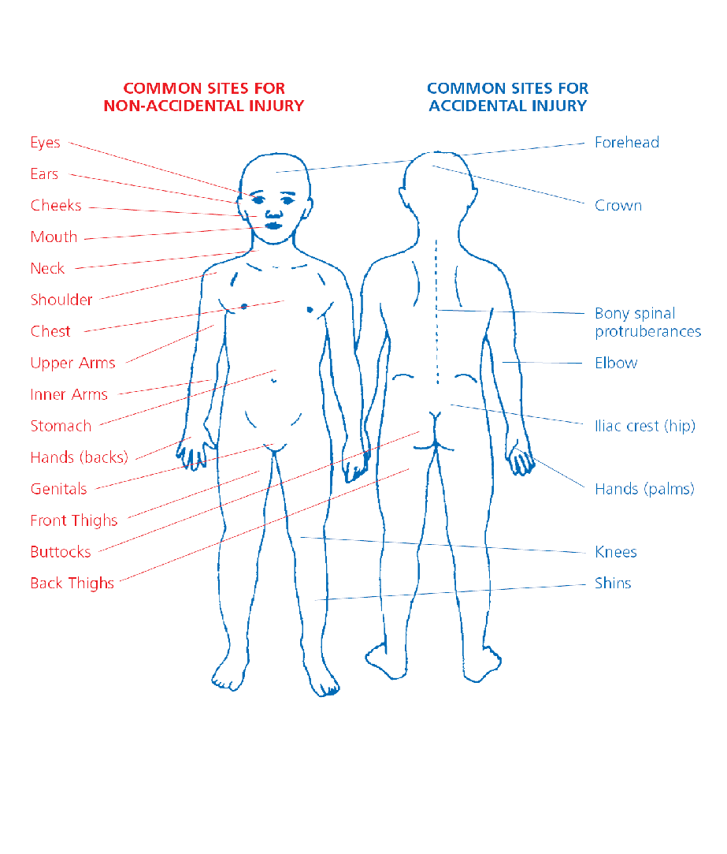

**APPENDIX 4**

**DEFINITIONS AND INDICATORS OF ABUSE OF VULNERABLE ADULTS**

People with care and support needs, such as older people or people with disabilities or mental ill-health, are more likely to be abused or neglected. People with communication difficulties and cognitive impairment are particularly at risk because they may not be able to alert others and may not be aware that they are being abused.

Types of abuse include the following: -

**Physical abuse**

This is the infliction of pain or physical injury, which is either caused deliberately or through lack of care.

*Signs may include:*

* Bruising, cuts, welts, burns/marks, or loss of hair
* Frequent injuries and no explanation/inconsistent explanation for injuries
* Subdued or changed behaviour in the presence of a particular person
* Signs of malnutrition
* Under or over use of medication and/or medical problems unattended

**Psychological or emotional abuse**

These are acts or behaviour, which cause mental distress or ignore the wishes of the adult. This could involve enforced social isolation, removing mobility or communication aids, being left unattended, failing to respect privacy, preventing stimulation, intimidation, humiliation, bullying and verbal abuse, threats of harm and preventing the expression of choice.

*Signs may include:*

* Alteration in psychological state e.g. withdrawn, agitated, anxious, tearful
* Intimidated or subdued in the presence of the carer
* Fearful, flinching or frightened of making choices or expressing wishes
* Change in appetite, weight loss/gain
* Low self-esteem
* Tearfulness, anger

**Sexual abuse**

This is the involvement in sexual activities to which the person has not consented or does not understand and so cannot give informed consent or where the other person is in a position of trust, power or authority and uses this to override lack of consent.

*Signs may include:*

* Pregnancy in a woman who is unable to consent to sexual intercourse
* Unexplained changes in behaviour or sexually implicit/explicit behaviour
* Torn, stained or bloody underwear
* Unusual difficulty in walking or sitting
* Infections or sexually transmitted diseases
* Full or partial disclosure or hints of sexual abuse
* Self-harming
* Bruising, particularly to the thighs/buttocks and upper arms
* Poor concentration, withdrawal, sleep disturbance
* Fear of receiving help with personal care
* Reluctance to be alone with a particular person

**Neglect or Act of Omission**

This is the repeated deprivation of assistance that the adult needs for important activities of daily living, including the failure to intervene in behaviour which is dangerous to the adult at risk or to others. Examples include failure to provide or allow access to food, shelter, clothing, heating, activity, personal and medical care; failing to give medication as prescribed; refusing access to visitors; ignoring or isolating the person; preventing the person from making their own decisions; failing to ensure privacy and dignity.

*Signs may include:*

* Malnutrition, weight loss and/or persistent hunger
* Poor physical condition, poor hygiene, varicose ulcers, pressure sores
* Being left in wet clothing or bedding and/or clothing in a poor condition
* Failure to access appropriate health, educational services, or social care
* No callers or visitors

**Self-Neglect**

This is a lack of self-care to an extent that it threatens personal health and safety, a neglect to care for one’s personal hygiene, health or surroundings, an inability to avoid self-harm, failure to seek help or access services to meet health and social care needs, an inability or unwillingness to manage personal affairs.

*Signs may include:*

* Very poor personal hygiene and unkempt appearance
* Inability or unwillingness to take medication or treat illness/injury
* Lack of essential food, clothing, or shelter
* Malnutrition and/or dehydration
* Living in squalid or unsanitary conditions
* Non-compliance with health or care services

**Financial or material abuse**

This is inappropriate use, misappropriation, embezzlement or theft of money, property, or possessions.

*Signs may include:*

* Disparity between assets and living conditions
* Unexplained withdrawals from accounts or disappearance of financial documents
* Sudden inability to pay bills
* Carers or professional fail to account for expenses incurred on a person’s behalf
* Recent changes of deeds or title to property

**Discriminatory abuse**

This is unequal treatment, which could be in the form of derogatory remarks, deliberate exclusion, substandard care, denying healthcare/education/employment – because of their age, gender, race, religion, cultural background, and disability. It could also be denying access to communication aids/interpreter/lip reader.

*Signs may include:*

* Withdrawn and isolated
* Anger, frustration, fear, or anxiety
* The support on offer not meeting the person’s needs

**Institutional abuse**

This is the mistreatment or abuse of a vulnerable adult by a regime or individuals within an institution (e.g. hospital or care home) or in the community. It can be through repeated acts of poor or inadequate care and neglect or poor professional practice.

*Signs may include:*

* Lack of flexibility or choice over meals, bed times, visitors, phone calls, etc.
* Inadequate medical care and misuse of medication
* Inappropriate use of restraint
* Sensory deprivation e.g. denial of use of spectacles or hearing aids
* Missing documents and/or absence of individual care plans
* Public discussion of personal matters
* Few social, educational, or recreational activities

**Domestic Abuse**

This includes any incident or pattern of incidents of controlling, coercive or threatening behaviour, violence, or abuse between those aged 16 or over who are or have been, intimate partners or family VOLUNTEERs. It also includes so called honour-based violence, female genital mutilation and forced marriage.

**Modern Slavery**

Types of modern slavery include human trafficking, forced labour, domestic servitude, sexual exploitation, being forced to work to pay off debts that realistically they never will be able to.

*Signs may include: -*

* signs of physical or emotional abuse
* appearing malnourished, unkempt, or withdrawn
* appearing frightened or hesitant to talk, seeming under the control or influence of others
* living in dirty, cramped, or overcrowded accommodation
* lack of personal belongings or identification documents

**Appendix 5a**

**Recording a cause for concern about a child or young person**

Name of child/young person:

Date of birth (if known):

Name of person making this report:

Role (if applicable):

Circumstances leading you to make this report:

*what you noticed? / what happened? / when did it happen / where did it happen? / what was said - actual words used / was anyone else involved, and in what way? who else was there?/ any other observations?*

Please continue overleaf

|  |
| --- |
| Continuation  Date and Time this happened: Date … / … / … Time … : …  If you noticed any physical marks or injuries on the child or young person’s body, please tick this box  and complete an Appendix 5b form |

Action taken by you immediately following this incident:

Who have you notified about this and when?

Date: …/…/… Time: … : …

Signed

Date: …/…/… Time: … : …

Passed to Designated Safeguarding Officer:

(NAME)

Date: …/…/… Time: … : …

**Appendix 5b**

**Recording a cause for concern about a child or young person**

**-further observations concerning physical marks or injuries**

Please ensure that you have completed Appendix 5a before completing this form, and once completed submit both forms to the Safeguarding Officer.

Name of child/young person:

Date of birth (if known):

Name of person making this report:

Date and time of observation

Please use a cross to indicate the site of any physical mark or injury

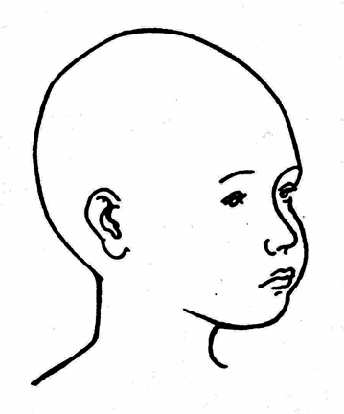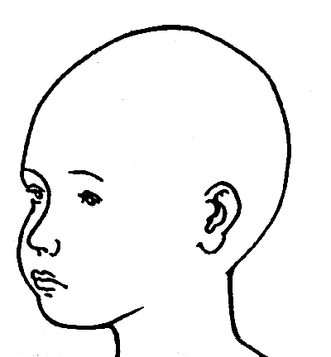

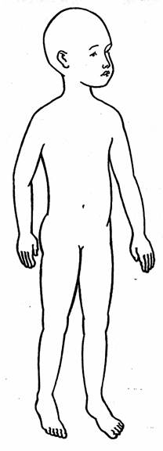 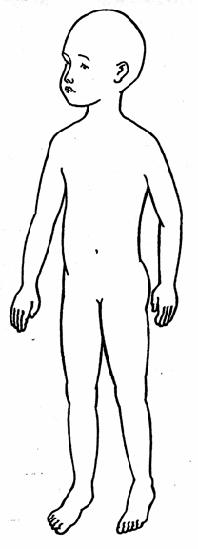 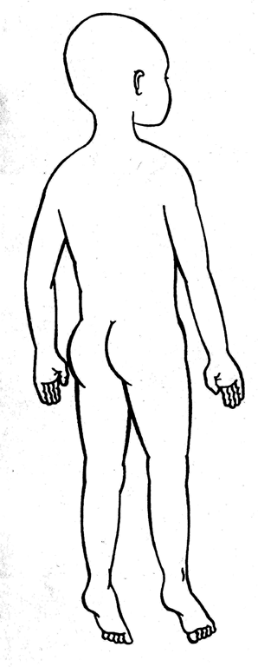 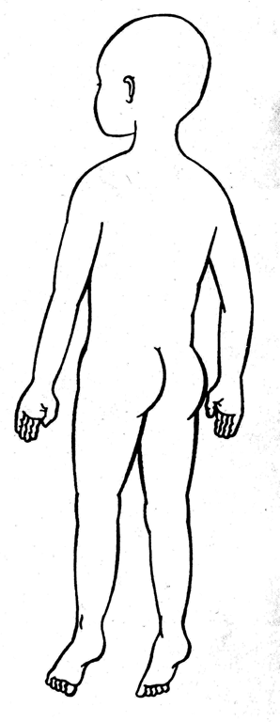

|  |
| --- |
| Additional notes about marks or injuries: |
| Signed: Date: Time: |

**Appendix 5c**

**Recording a cause for concern about an adult (age 18 and over)**

Name of adult:

Date of birth (if known):

Name of person making this report:

Role (if applicable):

Circumstances leading you to make this report:

*what you noticed? / what happened? / when did it happen / where did it happen? / what was said - actual words used / was anyone else involved, and in what way? who else was there?/ any other observations?*

Please continue overleaf

Continuation

Date and Time this happened: Date … / … / … Time … : …

If you noticed any physical marks or injuries on the child or young person’s body, please tick this box  and complete an Appendix 5d form

Action taken by you immediately following this incident:

Who have you notified about this and when?

Date: …/…/… Time: … : …

Signed

Date: …/…/… Time: … : …

Passed to Designated Safeguarding Officer:

(NAME)

Date: …/…/… Time: … : …

**Appendix 5d**

**Recording a cause for concern about an adult (age 18 and over) - further observations concerning physical marks or injuries**

Please ensure that you have completed Appendix 5c before completing this form, and once completed submit both forms to the Safeguarding Officer.

Name of adult:

Date of birth (if known):

Name of person making this report:

Date and time of observation

Please use a cross to indicate the site of any physical mark or injury

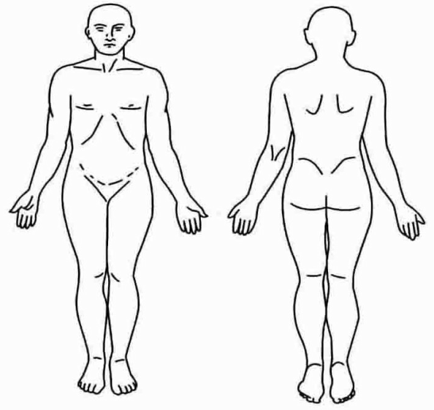

|  |
| --- |
| Additional notes about marks or injuries: |

Signed: Date: Time:

**Appendix 6a**

**Children’s VOLUNTEER Information Form**

Thank you for volunteering to be involved in this activity at AIMREC. You are joining a team which, together with the whole Centre, commits itself to the care, safety and nurture of children and young people.

We ask all prospective volunteers to complete this form.

|  |  |  |
| --- | --- | --- |
| Full Name |  | |
| Address |  | |
| Telephone Number(s) |  | |
| Please tell us about previous Centre involvement, if any (with dates) | | |
| Please give details of previous experience of working with children/young people. | | |
| Please give reasons why you are interested in this work and the gifts and qualities you can bring to this role. | | |
| **Signed** | | **Date** |

|  |  |
| --- | --- |
| **Criminal Records Declaration:**  I can confirm that there is no reason why I should not be working with children and young people and I agree to an enhanced DBS check. | |
| **Signed** | **Date** |

**Appendix 6b**

**Volunteer Agreement**

|  |  |  |
| --- | --- | --- |
| **Name of VOLUNTEER** |  | |
| **Role** |  | |
| I have read AIMREC’s Safeguarding Policy. I understand that it is my duty to protect the children with whom I come into contact. I agree to work within the policies and procedures agreed by the Centre for the protection of children.  I will also endeavour to attend any safeguarding training organised by AIMREC. | | |
| **Signed** | | **Date** |

**Appendix 7**

**Policy on the Recruitment* of Ex-offenders**

It is a requirement of the DBS (Disclosure and Barring Service) Code of Practice that all employers must treat Disclosure applicants who have a criminal record fairly and do not discriminate because of a conviction or other information revealed.

It obliges employers to have a written policy on the recruitment of ex-offenders.

DBS checks are carried out on behalf of AIMREC by Disclosure Services or Christian Safeguarding Services. To cover the requirements laid out above they also require organisations using their services to have a written policy on the recruitment of ex-offenders.

This document meets that requirement.

1. As an organisation using the DBS Disclosure service to assess an applicant’s suitability for positions of trust, AIMREC complies fully with the DBS Code of Practice and undertakes to treat all applicants or volunteers for roles fairly. It undertakes not to discriminate unfairly against any subject of a Disclosure on the basis of a conviction or other information revealed.
2. This Policy Document on the recruitment of ex-offenders will be made available to all Disclosure applicants at the outset of the recruitment process.
3. We make every subject of a DBS Disclosure aware of the existence of the DBS Code of Practice and make a copy available on request.
4. Where a Disclosure is to form part of the recruitment process, we encourage the person concerned to provide details of any criminal record confidentially to a designated person within AIMREC, and we guarantee that this information will only be seen by those who need to see it as part of the recruitment process.
5. In the case of there being a criminal record, we ensure that an open and measured discussion takes place on the subject of any offences or other matter that might be relevant to the role.
6. A risk assessment will be carried out and a decision will be made whether or not a role is appropriate.

*‘Recruitment’ in this document means anyone asked to take on a role, paid or unpaid, within the Centre that would require a DBS check.

**APPENDIX 8**

**BOUNDARIES TO CONSIDER IN A CONTRACT FOR A SEX OFFENDER**

Boundaries will need to be agreed in consultation with the individual and their views taken into consideration. The Trustees will also endeavour to offer appropriate pastoral care and signpost to relevant support.

The following are examples of what might be included in a contract:

* I will never allow myself to be in a situation where I am alone with children or vulnerable adults.
* I will attend meetings and activities as directed by the Trustees.
* I will sit where directed at activities (e.g. Centre meetings, social gatherings) and will not place myself near children and vulnerable adults.
* I will not enter certain parts of the building designated by the Trustees, nor any area where activities for children and vulnerable adults are in progress.
* I will decline invitations of hospitality where there are children or vulnerable adults in the home.
* I agree that "x" and "y" will sit with me during activities (e.g. Centre meetings, social gatherings) and accompany me when I need to use other facilities. They will know I am a sex offender.
* I agree that the Safeguarding Officers and Trustees will need to be told of my circumstances in order for them to protect the children or vulnerable adults for whom they care.
* I agree that contact will need to be made with my probation officer, who will meet with Trustees as and when necessary (where appropriate).
* I understand that if I do not keep to these conditions, there will be further conversations and I may be barred from attending activities. The Trustees may also choose to inform the statutory agencies, (e.g. police, probation, Adult Services, Children’s Social Services), and any other relevant organisations, as well as VOLUNTEERs of AIMREC.
* I understand that any other concerns regarding my behaviour will be taken seriously and reported.
* I understand that this contract will be reviewed regularly every ______ months and will remain for an indefinite period.
* Signed _____ and dated_____