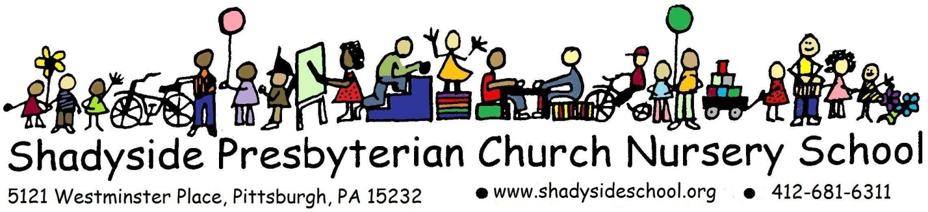
Acknowledgement of Covid-19 Procedures and
Financial Policies 2021-22

During this Covid-19 health emergency, we must work together to reduce the possible risk of exposure for all children, families, and staff. You have been provided with the SPCNS Health and Safety Plan, in which we have documented the full details of our health procedures.
Please initial, sign, and return this form with your first semester tuition payment to acknowledge that you understand the highlights of these important H &S protocols and additional operating policies.

____________ I understand that to enter the facility premises my child(ren) must be free from COVID- 19 symptoms. The list of child symptoms which require an exclusion from nursery school are detailed in the Health & Safety Plan. While we understand that many of these symptoms can also be related to non-COVID-19 related issues, we must proceed with an abundance of caution during this ongoing public health emergency in order to protect the health of all.

____________If during my child’s morning at nursery school any of the pertinent symptoms appear, my child(ren) will be separated from the rest of their classroom and taken to an isolation room. I will be contacted, and my child(ren) must be picked up from the facility within 1 hour of being notified.
____________ I understand that correctly wearing a mask at all times is required for my child, myself, and anyone aged 2 years and older who accompanies me when on facility premises to drop off or pick up my child. This applies to areas both indoors and outdoors.
____________I understand that I must show proof of vaccination if I wish to stay at SPCNS for an extended period of time (beyond drop-off or pickup), either in a classroom or in the school.
____________I understand that while in the facility, I must practice social distancing and remain 6 ft from all other people, except for my own child(ren).
______ I understand that my child(ren) will be required to wear a mask (except for snack time) and to wash their hands using CDC recommended hand washing procedures throughout the day using running water and rubbing with soap or approved hand sanitizer.

______ I understand that it is my responsibility to inform any Emergency Contact person or other caregiver of the information contained in this document.
Financial Policy and Liability Waiver
______ If public health guidance or the Shadyside Presbyterian Church mandates require the building to be closed, our program will be suspended for the safety and well-being of all involved. I understand that my paid tuition may not be refunded once the 2021-22 school year begins, even if unforeseen circumstances related to the pandemic would force the school/church to close. Decisions regarding refunds will be made by the Nursery School Board of Trustees.
______ I understand that while present in the facility each day, my child(ren) will be in contact with other children and employees who are also at risk of community exposure. I understand that no list of restrictions, guidelines or practices will remove 100% of the risk of exposure to COVID-19. I understand that I play a critical role in keeping everyone in the facility safe and reducing the risk of exposure by following the practices outlines herein.
_____ I certify that I have read, understand, and agree to comply with the provisions listed herein. I acknowledge that failure to act in accordance with the provisions listed herein, or with any other policy or procedure outlined by SPCNS could result in a termination of enrollment. I acknowledge that my child(ren)’s enrollment at SPCNS may be terminated if it is determined that my actions or lack of action unnecessarily exposes an employee, child, or family to COVID-19.

Child’s Name(s)
_____________________________________________________________

Parent/Guardian Signatures
_____________________________________________________________
______________________________________________________________

