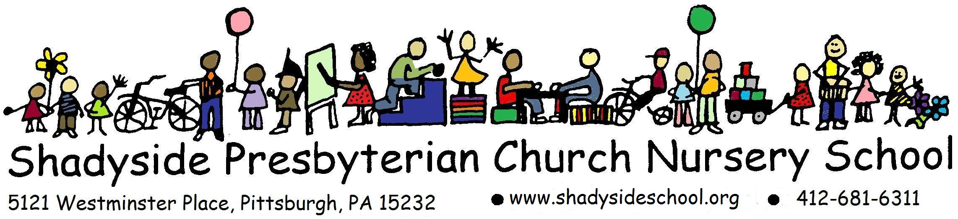
CHILD’S PERSONAL HISTORY FORM

Date_______________________

Last Name:________________________ First Name:____________________ Nickname: _________________
Birth date: ______________________ □Male □Female □Left Handed □Right Handed
Mo Day Year

Address:___________________________________________________________ Phone:____________________
Street City State Zip
Parent/Guardian name: __________________________________________Cell Phone______________________
Parent’s occupation:____________________________________________ Work phone_____________________
Preferred pronouns: _________________________ What your child calls you:____________________________

Parent/Guardian name: __________________________________________Cell Phone______________________
Parent’s occupation:____________________________________________ Work phone_____________________
Preferred pronouns: _________________________ What your child calls you:____________________________

Are parents divorced/separated? □Yes □ No
If yes, provide alternate address: _____________________________________________________________

Are you a member of the Shadyside Presbyterian Church? □Yes □No
If both parents are away from home during school, please provide the following information:
Caregiver’s Name:____________________________________________ Phone:__________________________
Siblings names and ages:________________________________________________________________________
If child is adopted: Age at adoption____________ Does child know he/she is adopted? _________________
Other members of household: ___________________________________________________________________

Please check any/all social experiences your child has been involved with in the past:
□Daycare □Preschool □Informal Play Groups □Play Dates □Nursery School □Neighborhood friends □Sunday/Church School
□Other (Specify) _____________________________________________________________________________

Has your child had any social experiences without a parent present? If yes, please specify____________________
____________________________________________________________________________________________

Sleeping: What is child’s usual bed time? ______________ Does he/she nap? □Yes □No
Any sleep problems? _______________________________________________________
Eating: Any feeding problems/difficulties? □Yes (explain) ________________________________ □No
Any food allergies? (List)_______________________________________________________________
IMPORTANT: A separate Allergy Record form must be returned if an allergy is listed.
Toileting: Does he/she tell an adult when he/she needs to go to the toilet? □Yes □No
Do you remind him/her? □Yes □No Does he/she need help? □Yes □No
By what word or name does your child refer to toileting (e.g., “potty” “tinkle”)? _________________
If boy, does he stand? □Yes □No

Dressing: How much help do you give in dressing and undressing? □Fully Independent □Fully Dependent
□Button □Zipper □Shoes □Shoe laces □Brushing hair
Can she/he put on her/his own coat and outerwear? □Yes □No
Play: Does he/she get along with other children? □Yes □No Explain: __________________________
With what does the child especially like to play? ______________________________________________

Please check your child’s preferences as related to play:
□ alone play □ quiet play □ play with others □active play
Attitudes: What is his/her attitude toward school? Does he/she want to attend school?_____________________
____________________________________________________________________________________________
Discipline: What method of behavior control is used at home and for what reasons? ________________________
____________________________________________________________________________________________
Emotions: Has the child shown any fears? □No □Yes If yes, please specify and explain how you have addressed them: ________________________________________________________________________
______________________________________________________________________________________

Senses: Do you read to your child? □Yes □No Does he/she enjoy music? □Yes □No
Does he/she speak plainly so that others besides those at home can understand him/her? □Yes □No
Does he/she hear all that is said to him/her and respond? □Yes □No
Does he/she have □Normal Vision □Wears glasses
Does your child have physical delays/disabilities? If so, please explain: ___________________________
______________________________________________________________________________________
Was your child born □ Full term □ Prematurely --at how many weeks? ______________________
Does your child have speech issues that have been evaluated? □Yes □No
Has your child had any speech therapy? If so, please explain ____________________________________
______________________________________________________________________________________
Does your child have any known developmental delays? □Yes □No
Does your child have any significant medical issues? Please explain: ______________________________
______________________________________________________________________________________
______________________________________________________________________________________
Does he/she have any other problems of which we should be aware? If so, please explain______________
______________________________________________________________________________________

If you would like a meeting to discuss your child prior to the start of the school year, please contact Liz Buchanan at director@shadysideschool.org.

What is your main goal for your child this year?

How would you describe your child’s personality? (Please use other side if more space is needed)

What language does your family speak at home? _____________________________________________________
Does your child speak English? □Yes □No
Do you need translation of school documents? □Yes □No If yes, which language_____________________
What is your cultural or ethnic heritage? ___________________________________________________________

Can you help us in the classroom occasionally? □Yes □No
Would you be interested in sharing any special talents with your child’s class? (storytelling, singing, weaving, musical instrument, painting, drawing, woodcarving, carpentry, etc.) □Yes □No
If yes, please share interest/talent: ________________________________________________________________

Please use the space below (or the back side of the page) to give any information that would be helpful for the Nursery School teacher to know in order to understand your child better and provide proper guidance for him/her.

