# PSI PI OMEGA CHAPTER OF ALPHA KAPPA ALPHA SORORITY, INC.

SCHOLARSHIP APPLICATION

2019-2020

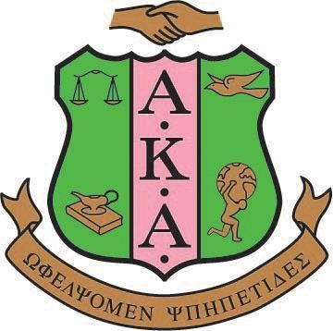

SCHOLARSHIP COMMITTEE

CONNIE GORE – CHAIRMAN

MARIAN CARPENTER

DAPHNE COOPER

CHARLENE EDWARDS

LATRICIA JAMES

TURQOUISE JOLLY

JANIETA WASHINGTON

MAILING ADDRESS

## Project Pink and Green Foundation

**Attn: Scholarship Committee**

**P. O. Box 1382 Stuart, FL 34995**



**SCHOLARSHIP ELIGIBILITY CRITERIA**

This scholarship is designed for high school seniors and is for one year only. All applicants must be a high school senior at any Martin County high school. **The following criteria must be adhered to in order to be awarded a scholarship:**

1. Scholarships awarded will be based on scholastic average, financial need, leadership skills and community service
2. Applicant must have a minimum of a 2.8 GPA
3. Applicant must complete the scholarship application and provide all supporting documents
4. Application dates:
   1. The Psi Pi Omega Chapter will submit applications to schools in October
   2. Applications must be completed and returned to Psi Pi Omega by January 31st
   3. Applications will be reviewed by the Scholarship Committee and selected students will be invited for an interview
   4. Scholarship recipients will be announced in April/May at the school’s Scholarship/Awards night ceremony
5. In 2020, scholarships will be awarded in the amount of Two Thousand dollars and will be awarded to four students; two students from Martin County and two students from the City of Port St. Lucie. The students will be selected from the following high schools.

**Martin County City of Port St. Lucie**

Clark Advanced Learning Center St. Lucie West Centennial High School Jensen Beach High School Port St. Lucie High School

Martin County High School Treasure Coast High School South Fork High School

1. The number of scholarships awarded may vary each year based on Psi Pi Omega’s chapter By- Laws and funding.
2. If selected, applicant must provide proof of college enrollment letter to Psi Pi Omega.
3. A check will be issued to the college or university where the student is enrolled, and will be disbursed by the fall semester.



# SCHOLARSHIP APPLICATION GUIDELINES

## Applications are available at your Guidance Counselors Office beginning in October. Each applicant must fully complete the application and submit all required documentation.

1. Complete the Psi Pi Omega application
2. Attach a current copy of your high school transcript
3. Attach two letters of recommendation (other than relatives) from a teacher, church member or leader of an organization in which you are affiliated
4. Attach a recent photo of yourself, full face (2 inch by 2 inch in size)
5. Completed applications should be enclosed in an 8 ½ x 11 envelope and mailed to the following address:

## Project Pink and Green Foundation

**Attn: Scholarship Committee**

**P. O. Box 1382 Stuart, FL 34995**

1. Applications must be post marked no later than **January 31, 2020.**