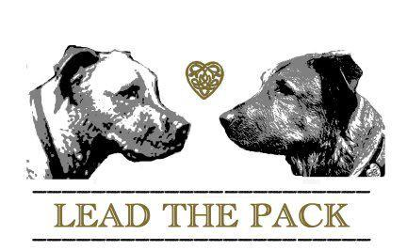

Board and Train
2-Week Basic

Thank you for choosing Lead the Pack for your dogs education. While with us during your pups board and train program you can expect your dog to learn a vocabulary, work out behavioral issues and be properly socialized.

What you can expect during the 2 week Board and Train experience

Vocabulary

- Yes
- No
- Sit
- Down
- Stay
- Come
- Lets go (informal heel)
- Place
- E collar training
- Start off leash training
Behavioral issues

- Jumping
- Nipping
- Over excitement
- Housebreaking
- Wildness
- Mouthiness
- Leash etiquette
- Excessive Barking

Socialization

- People skills
- Canine skills
- Appropriate behavior with other dogs
- Appropriate play behavior
- Learning an off switch
- Roughness
- Reactivity
- Maintaining commands and manners with distractions
- Social threshold tolerance (what type of environment they would thrive in)
- Coping skills for stress
- City life & town appropriate behavior

What we expect from YOU!

Whilst your dog will be returned calmer, well socialized and educated the burden of follow through lays on you the owner. Your dog’s success at home will depend solely on your follow through and practice, of all they learned here during their two weeks with us. Your Board and Train package includes an at home session…Please USE IT! Once they return home it is imperative that you imply the same boundaries, restrictions and corrections your dog experienced here or they will revert back to all their old tricks and naughty habits. We ask that if you are doing e collar training that you follow through with using it at home immediately rather than letting the dog “settle in”. Your dog will have a clear understanding of what a correction is and what the stimulation from the e collar feels like. There may be certain scenarios that we are not able to recreate here, for example an issue with cats or children that will need to be addressed at home. It is very important that you put your dog in scenarios to be corrected and use your e collar. Your dog needs to understand the same consequences will be delivered for disobeying commands by you without me being present. Your dog now has the education and you the tools to have that successful, happy relationship you always dreamed of with your four-legged best friend.

