**Does your dog love water? Come check out the dog sport of Dock Diving!**

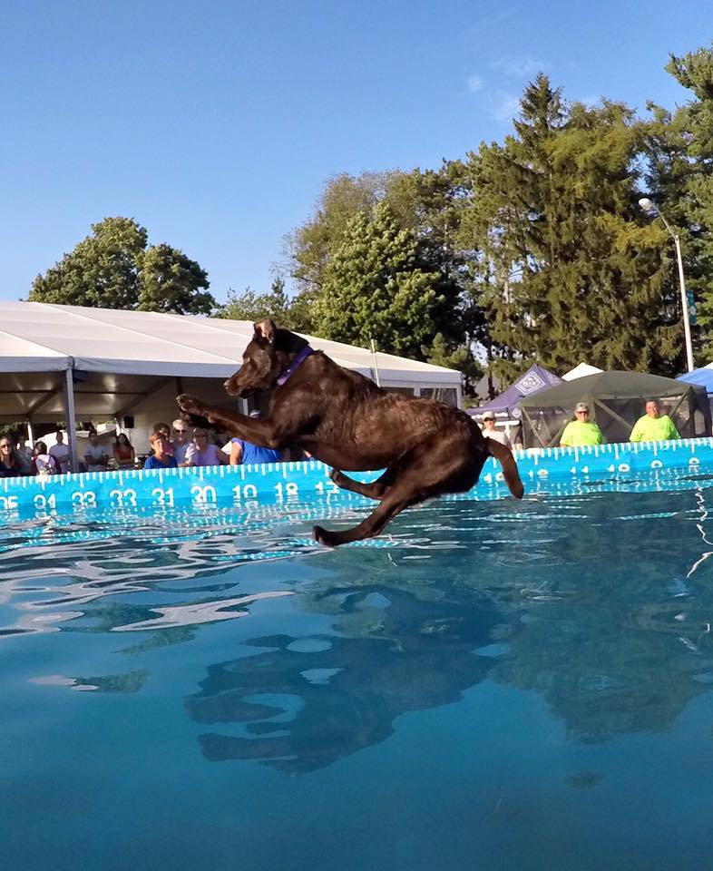

Long Island Dock Jumpers was formed to promote the sport of dock jumping in Long Island, N.Y. and the surrounding areas.

Any dog, any breed, any size, 6 months of age or older can participate. Handlers must be at least 7 years old. No prior experience necessary!

Both dry and dock practices, training sessions, and fun jumps will be scheduled for club members throughout the year. Long Island Dock Jumpers will be getting together at various locations to practice and work with their dogs.

The club founders have competed all up and down the east coast at various events and venues. Club members will be encouraged to participate in both club and national events all over NY state and surrounding areas. As a club, members will be available to support each other at events and practices, as well as helping new competitors get started!

Currently, Long Island does not have access to regulation public dock use, but through organization of this club and generating interest we hope to have some of the places in the works up and running soon!

**Join us April 19th at 7 pm to discuss the future of dock diving on Long Island!**

Please follow the Facebook page Long Island Dock Jumpers for events and up to date news!