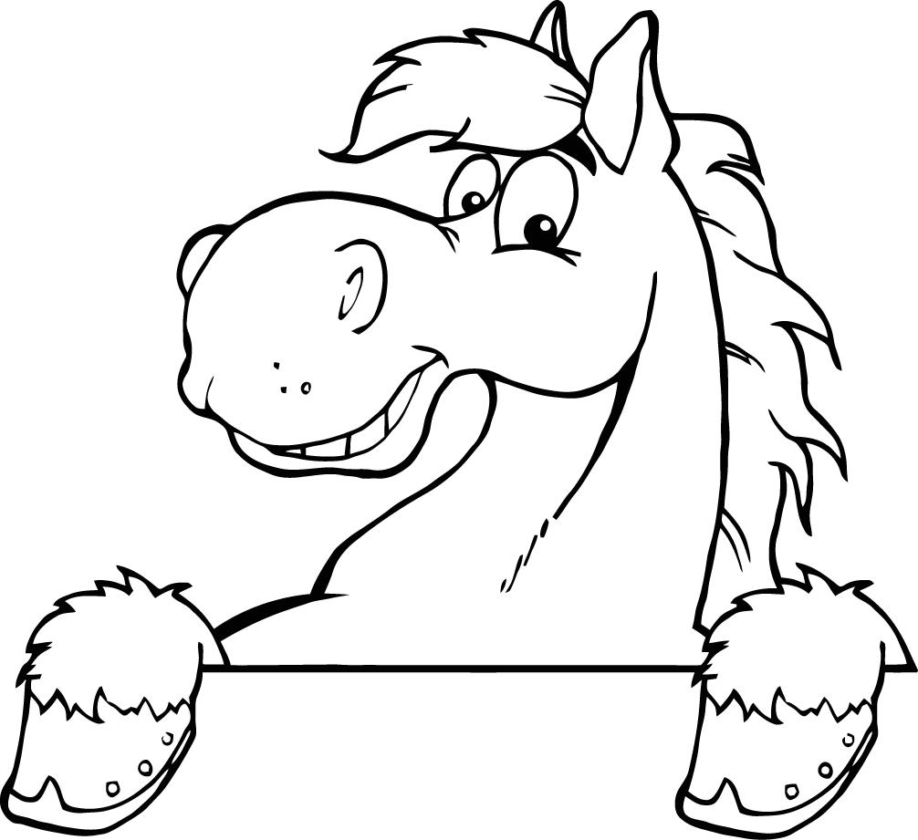
CHOCTAW ROUND-UP CLUB APPLICATION
PO Box 561, Choctaw, OK 73020
WELCOME
Annual membership dues are $30.00

Riders must have their own horse, transportation, gear, and uniform (if required). You will be issued a membership card; the by-laws are on the webpage. Club is not responsible for accidents on or around club premises.

(Please Print clearly)

Name:
Address:
City: __________________________, State: OK, Zip: _____________, Phone: _______________________
Email address:

Family Members: (all members, include children under 18 living at home)
Age: Age:
Age: Age:
Age: Age:

Prior Riding experience:

Former Club experience:

Are you a member of any other riding club: Yes: _____ No:_____
Where:

Interests: Playday:_____ Rodeo:_____ Drill_____ Team:_____ Barrel Racing:_____ Parades:_____
Team Roping:_____ Team Penning/Team Roping:_____ Other:_____________________________________

Willing to help: Playday:_____ Rodeo:_____ Drill_____ Team:_____ Barrel Racing:_____ Parades:_____ Building:_____ Advertising:_____ Concession:_____ Team Penning/Team Roping:_____
Other: ____________________________________ New Ideas:______________________________________

Signed: ______________________________________________________________ Date: ____/_____/2019

For Office Use Only

Membership year: 2019 Amount:$___.00 Cash:___ / Check#:________________ By:_________________________
Treasurer: Receipt provided □ Membership cards issued □

