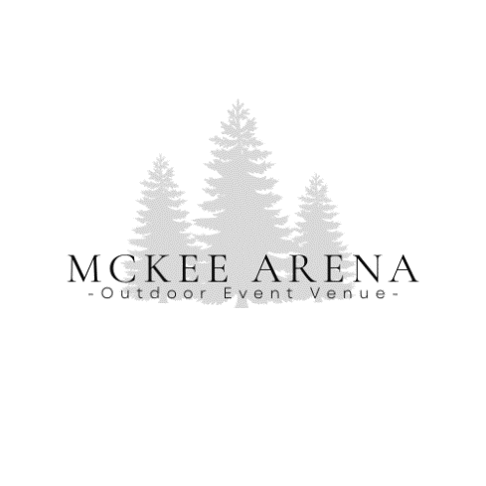

2024 SPONSORSHIP INFORMATION

***3rd ANNUAL HARVEST FEST AT MCKEE ARENA***

***BENEFITING THE CITY OF CAMBRIDGE (HOLIDAY LIGHTING/DECORATIONS)***

**October 19, 2024 @ McKee Arena, 2848 Gladhart Ln Rd, Cambridge, ID 83610**

Level 1: $150

*10x10 Booth

*Tagged/Mentioned in Social Media Advertising

*Small Logo on Main Sponsor Banner

*Thank You in (Post Event) Media Article

Level 2: $300

*10x10 Booth

*Thank you, Logo on Website Event Page,

*Tagged/Mentioned in Social Media Advertising

*Featured as a “Sponsor of the Week” on the Social Media Event Page

*Medium Logo on Main Sponsor Banner

*Thank You in (Post Event) Media Article

Level 3: $500

*10X20 Booth

*Event “Sponsored By” on the Website (with small business blurb and contact information)

*Tagged/Mentioned in Social Media Advertising

*Featured as a “Sponsor of the Week” on Social Media Event Page

*Large Logo on Main Sponsor Banner

*Thank You in (Post Event) Media Article

Activity Sponsor: $650 (Bounce House, Face Painting, Kids Craft Table, Axe Throwing, Carnival Games, Coloring Contest)

*10X20 Booth

*Event “Sponsored By” on the Website (with small business blurb and contact information)

*Tagged/Mentioned in Social Media Advertising

*Featured as a “Sponsor of the Week” on Social Media Event Page

*Large Logo on Main Sponsor Banner

*Thank You in (Post Event) Media Article

*Printed Yard Sign Next to the Sponsored Activity

Contact [mckeearena@gmail.com](mailto:mckeearena@gmail.com), Leci – (208)315-7455 or Tori – (208)550-0043 for information.