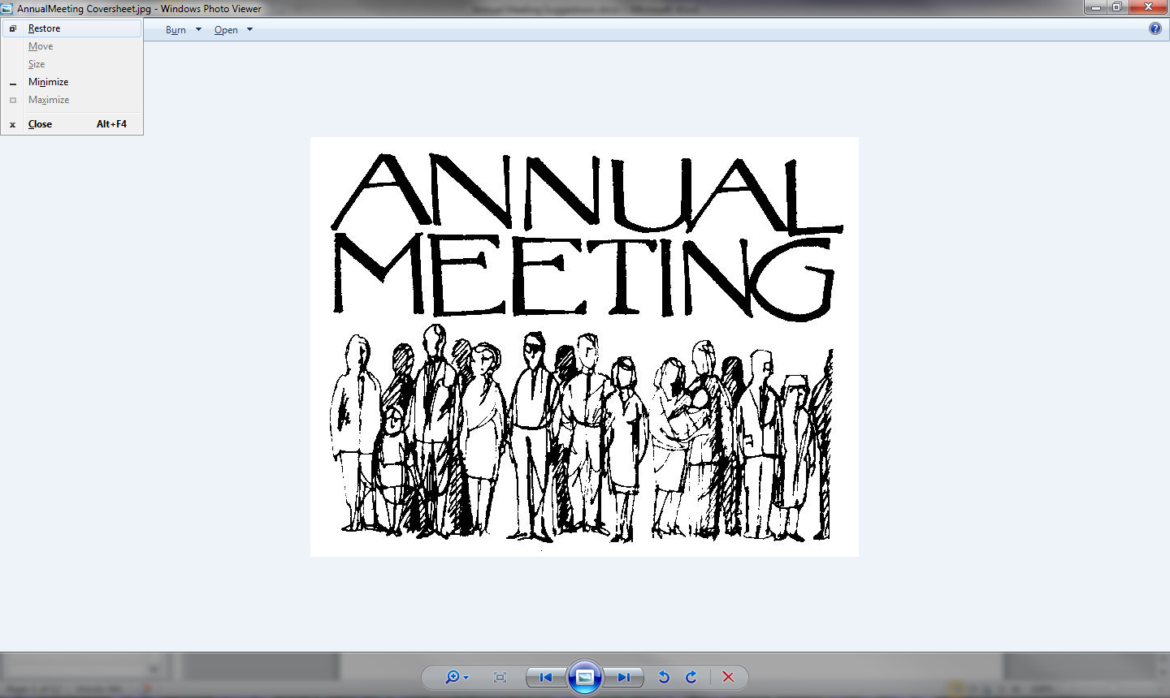

Creek Bridge Homeowners’ Association

2017 Annual Meeting

Saturday, March 4th @ 11am

Creek Bridge Homeowners’ Association

2017 Annual Meeting

Agenda

1. Approval of Meeting Minutes – 10/1/16
2. Approval of Agenda
3. Treasurer’s Update
   1. 2016 Actual Vs. Budget
   2. 2016 Dues Collected
   3. 2017 Budget Proposal
      1. Expenses included in budget
      2. Additional Assessments
      3. Slide Replacement
4. Committee Updates
   1. Architectural – Reuben, Susan
   2. Pool/Clubhouse – Reuben
   3. Landscaping – Lauren, Susan, Kathy
   4. Activities (in need of help)
   5. Rules & Regulations - Greg
5. Creek Bridge Covenants
   1. Additions & Amendments
6. Elect Board Members that term in 2017
7. Meeting Adjourn

Creek Bridge Homeowners’ Association

10/1/16 – Meeting Minutes

**2016 Mid-Year HOA Meeting – October 1, 2016**

Meeting was called to order at 10:05 AM at the Creek Bridge clubhouse by Lenny Ammerman

**Homeowner Attendees Present:**

Randy & Kathy Sell

Greg & Ruth Barton

Douglas Jeter

Gordon Carriker

Lenny Ammerman

Brian Grubbs

Steve Sharick

Casey & Lauren Murphy

Arica Bode

Reuben Ogle

John & Judy Hager

Scott Workman

Nicole Norman

Dylan & Kasey Lama

**Discussions Included:**

1. Lenny explains the reason for the meeting and confirms that this is not an official meeting and therefore, no voting will take place.
2. Greg motions to approve the meeting minutes from 3/5/16, Arica seconds his motion to approve the minutes.
3. 2016 Actual Vs. Budget
   1. Fix air conditioning fan - $684.00
   2. We anticipate the 2015 lien placed to be paid this year
   3. Lot #35, Gordon Carriker wants to know why we budget for profit. Lenny explains that we need to have a reserve for upcoming pool expenses in the future.
   4. Notify the insurance company and let them know of our new fence and camera system.
   5. Dylan Lama – wants to know what hits miscellaneous expenses.
      1. Emailed details in March
4. Rules & Regs
   1. Greg explains that the camera system has helped with vandalism
5. Official Complaints
   1. Truck and trailers parked in homeowner’s yard
   2. Leaving trashcans on the street
   3. Barking dogs
   4. Boats – behind fence, not in the street
   5. Trailers in driveways – adjust covenants to restrict all trailers
   6. Lenny discussed the visibility of cleanliness of the homes
6. Architectural
   1. Reuben discussed the large shed issue with a homeowner. The homeowner reduced the size of the shed, resolving the issue
   2. He reminded everyone that you need approval before adding a fence and it needs to be wooden.
   3. He suggests modifying the covenants to restrict certain types of fences and adding more specifications
7. Pool/Clubhouse
   1. Discussed adding a kiddie pool and the years left on this pool
   2. Add painting the clubhouse to the budget in 2017
   3. Paint the soffits and trim
   4. Replace the lights on the outside of the clubhouse
8. Slide
   1. Lauren discussed the 3 options we have for the slide to be voted on at the annual meeting
   2. We will contact Stewart to see if he can help with removal of the old slide
9. Landscaping
   1. Clean up day in the spring
   2. Add sign to the budget in 2017
   3. Mowing to continue in November (warm weather)
10. Activities
    1. Reuben suggests utilizing the empty lot to add a pavilion
    2. Need a committee head

Meeting was adjourned at 11:15 AM by Lenny Ammerman, Arica seconds the motion, motion carried.

Creek Bridge Homeowners’ Association

Treasurer’s Report

*2016 Fiscal Year*

* Revenues
  + Annual Dues
    - Collected 63 of the 63 homes assessed
* Expenses
  + Added mulch to the playground $590 - Maintenance
  + Setup fees for website $514 - Misc
  + Replaced blown motor on A/C unit $684* – Clubhouse
  + Fence around pool $5,500 – Pool
  + New Slide $2008 – Clubhouse (Not purchased)
  + Slide Removal - $500 estimated

Creek Bridge Homeowners’ Association

Additional Expenses Included in the FY 2017 Budget

* Painting the Clubhouse/trim & wall repair - $1,250
* Additional Pool Loungers - $250
* Replace outdoor lighting - $100
* Brush Hog field behind lots 1-7 - $960
* Filter Replacement - $600

Special Assessment in FY 2017 Budget

* New Sign - $1,950
* Gate Access System - $2,190
* Installation of new slide - $1,900

Creek Bridge Homeowners’ Association

Entry Sign - $1950

Special Assessment in FY 2017 Budget

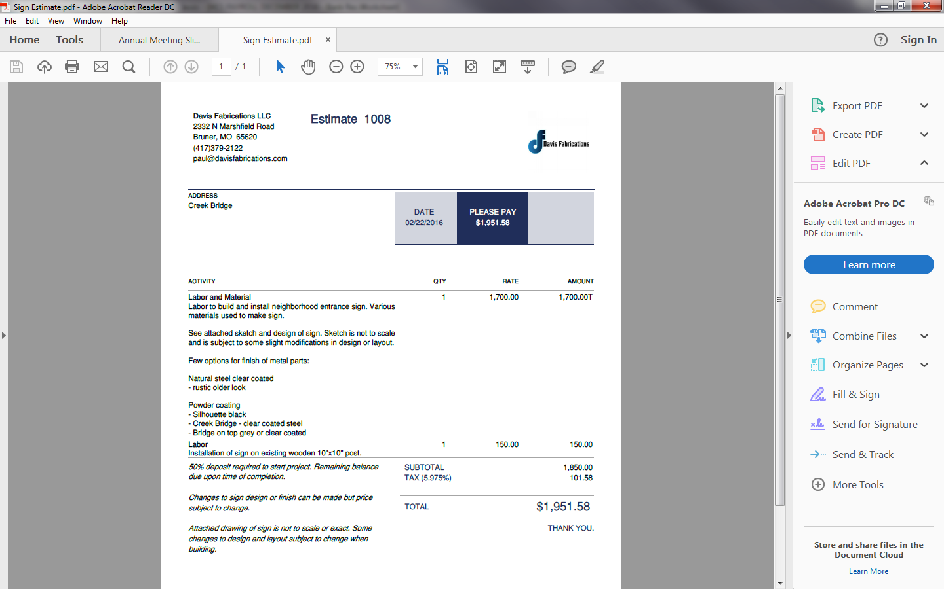

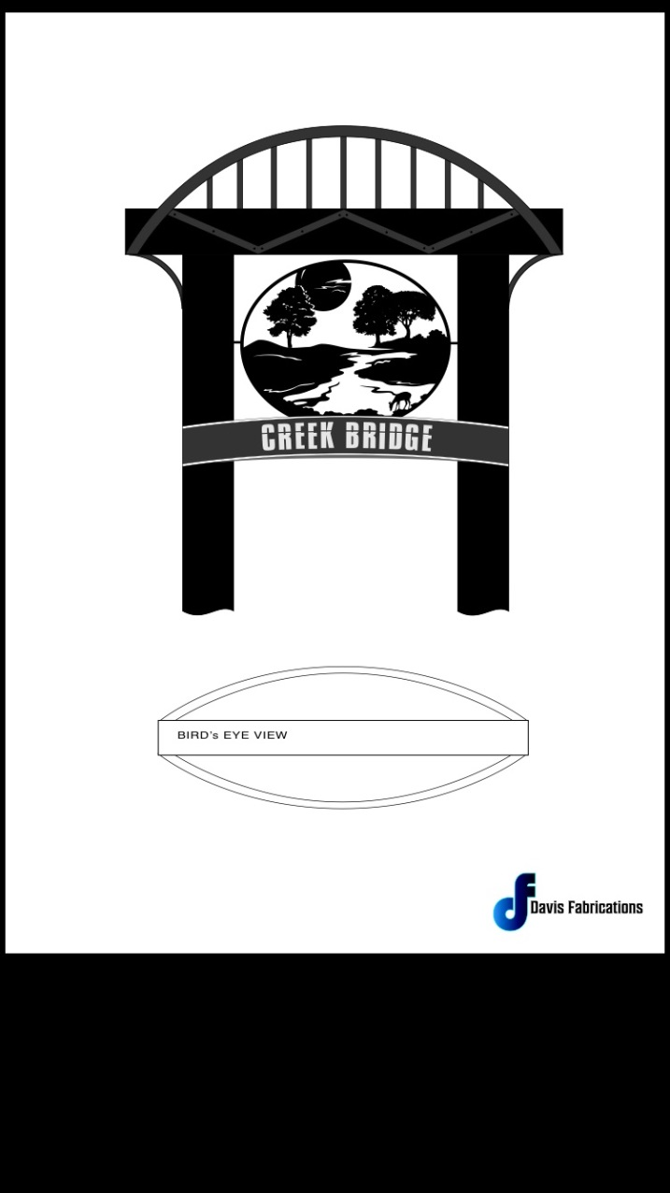

Creek Bridge Homeowners’ Association

Gate Access System - $2,190

Special Assessment in FY 2017 Budget

* Across America Security
* 1 Card Per Home

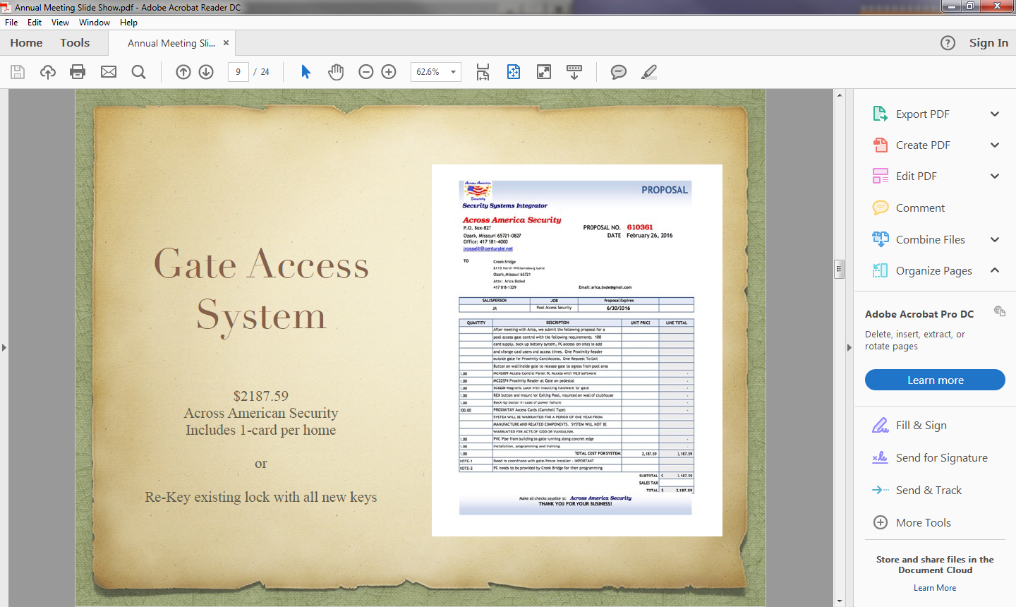

Creek Bridge Homeowners’ Association

Slide Replacement

**Playground Slide Options:**

The slide on the playground is cracked which is causing children to cut/scrape themselves on the way down. In the March 2016 Annual Meeting, $2,008.00 was approved to be added to the budget to replace the slide.

**Update:**

Shortly after the meeting, we were told by the vendor that we would have to pay an additional $1,900 for installation and disposal of the old slide. We currently do not have the money in the budget for this additional cost. We also were told that in any circumstance, we would be responsible for the removal of the current slide.

**Options:**

1. Remove the current slide and block off the opening
   1. Cost for the part to block off the opening - $459.00 + tax/freight
2. Replace the slide with a new slide
   1. Cost of the slide - $2,008.00 + tax/freight
   2. Cost for installation - $1,900.00
   3. We would need to add the additional $1,900 cost to FY 2017 budget
3. Remove the current slide and replace with a vertical ladder climber
   1. This is a cheaper option that we could do since we already have a slide
   2. Cost of the climber - $603.00 + tax/freight
4. Cost to remove the slide will be $95/hour