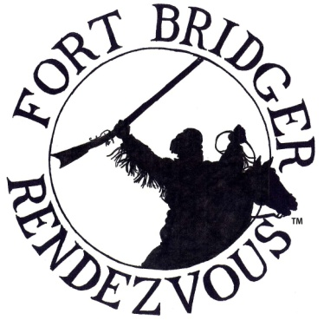
FORT BRIDGER RENDEZVOUS ASSOCIATION
1967 N 950 W
Clinton, UT 84015
fbrainc@hotmail.com
www.fortbridgerrendezvous.net
To Promote, Educate and Re-Live the History, Culture and
Life Ways of the Fur Trade Era of the American West 1790 -1840.

PRIMITIVE CAMPER APPLICATION 2023

As of 2004, The FBRA Board of Directors has made a decision to make the Fort Bridger Rendezvous an Invitation Only Event. Primitive Camps will be judged on cleanliness, appearance, personal conduct and compliance with the Rules and Regulations of all those associated with your camp. Violations may result in a loss of invitation.

By submitting an application and fees, this does not guarantee a Primitive Camp Space on the Fort Grounds. Your cleared check is not a guarantee. FBRA encourages all campers to apply. If you wish to be eligible for a primitive camp space, your application must be postmarked by March 1st 2023. After that date, you will be charged a $10.00 late fee and all primitive camp sites will be assigned on a first come first serve basis. FBRA Members will be given first priority. Confirmation will be mailed out no later than June 1st, 2023 for applications submitted by March 1st 2023.

No refunds will be issued after August 1, 2023

Please print your name and address information clearly in ink. FILL OUT FORM COMPLETELY!
(This is a digital form and can be filled out and then printed)

Personal Name: ______________________________________________________________________

Address: ____________________________________________________________________________

City: ___________________________________ State: ___________________ Zip: _____________

Phone: ________________________________ E-Mail: ______________________________________REQUIRED

# Of Primitive Camp Spaces: ____________ $50.00 per space, received BEFORE March 1, 2023
$60.00 per space, received AFTER March 1, 2023

* $10.00 fee for late registration

F.B.R.A. Membership Dues ______________ $20.00 Membership Dues
(Beginning of Rendezvous to the Beginning of Rendezvous)

TOTAL: $ _______________ Cash or Check* / Check #: ________________

Please indicate size and type of structure ___________________________________________ REQUIRED
(Your entire camp must fit within your 30’ camp space)

2022 Camp Space # ____________ 2023 Desired Camp Space# __________ #Adults_______ # under age 12 ______

Years at Fort Bridger: _______________ If camping in a group list names and camp spots: ______________________

Signature: _____________________________________________________________ Date: ____________________

The Booshway and the FBRA Board of Directors reserves the right to accept or reject ANY application. By signing this application, you state that you and all those in your primitive campsite will abide by the Rules and Regulations set by the FBRA and the State of Wyoming.

The F.B.R.A. operates under a contract with the State of Wyoming. This contract contains a grievance procedure which we are required to follow. If you have a problem which you have not been able to resolve with the help of a F.B.R.A. Board, please contact the F.B.R.A. Secretary at the registration building for a copy of the grievance policy. After Rendezvous the F.B.R.A. Secretary may be contacted by mail, phone, or email as listed above to obtain this policy.
Please read all Rules and Regulations, Thank You.
*Make checks payable to Fort Bridger Rendezvous Association

