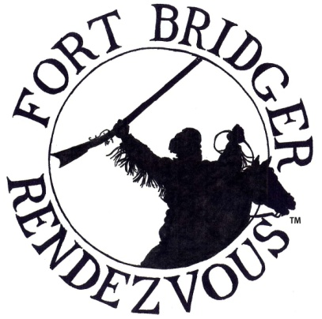
FORT BRIDGER RENDEZVOUS ASSOCIATION
1967 N 950 W
Clinton, UT 84015
fbrainc@hotmail.com
www.fortbridgerrendezvous.net
To Promote, Educate and Re-Live the History, Culture and
Life Ways of the Fur Trade Era of the American West 1790 -1840.

PRIMITIVE COMMERCIAL TRADER / DEMO APPLICATION 2022

As of rendezvous 2004, The FBRA Board of Directors has made a decision to make the Fort Bridger Rendezvous an Invitation Only Event. Traders will be judged according to Trade Items, Food items, Display, Personal Conduct and Compliance with the Rules and Regulations. Violations may result in a loss of invitation.

By submitting an application and fees, this does not guarantee a Trade Space on the Fort Grounds. Your cleared check is not a guarantee. FBRA encourages all traders / venders to apply. If you wish to be eligible for a Trade / Vender Space, your application must be postmarked by January 1, 2022. All spaces after January 1, 2022 will be charged a $10.00 late fee and will be filled on a first come first serve basis. Confirmations will be mailed out no later than April 1, 2022 for applications submitted by January 1, 2022.

No refunds will be issued after August 1, 2022

Please print your name and address information clearly in ink. FILL OUT FORM COMPLETELY!
(This is a digital form and can be filled out then printed)

Business Name: __________________________________________________________________________________________________________

Personal Name: __________________________________________________________________________________________________________

Address: ________________________________________________________________________________________________________________

City: __________________________________________________________________ State: ________________ Zip: _______________________

Phone: _________________________________________ E-Mail: _______________________________________________________ Required

Trade / Vender Spot (limited to 20x20 ft. each) Before January 1, 2021 $125.00__________________________
After January 1, 2021 $135.00 __________________________

Primitive Camp behind Trade Space $45.00___________________________

Traders Offsite Camping $45.00___________________________

Blanket Space (10x10) $65.00___________________________

F.B.R.A. Membership Dues $20.00____________________________
(Beginning of Rendezvous to the Beginning of Rendezvous)

****If you would like a primitive camp spot not with your trader space please fill out a separate camping application****

Check # _______________ TOTAL $___________________________ cash or check*

2021 Trade Space #_________________ Desired 2022 Trade Space #________________ # of People in Trade Spot_______________________

Years at Fort Bridger: __________________ Print Name: ________________________________________________________________________

Signature: ___________________________________________________________________________ Date: _____________________________

The Booshway and the F.B.R.A. Board reserve the right to accept or reject ANY application. By signing this application, you state that you and all those associated with your Trade and Camp Spaces will abide by the Rules and Regulations set by the F.B.R.A. and the State of Wyoming.

The F.B.R.A. operates under a contract with the State of Wyoming. This contract contains a grievance procedure which we are required to follow. If you have a problem which you have not been able to resolve with the help of a F.B.R.A. Board, please contact the F.B.R.A. Secretary at the registration building for a copy of the grievance policy. After Rendezvous the F.B.R.A. Secretary may be contacted by mail, phone, or email as listed above to obtain this policy.
Please read all Rules and Regulations, Thank You.
*Make checks payable to Fort Bridger Rendezvous Association

