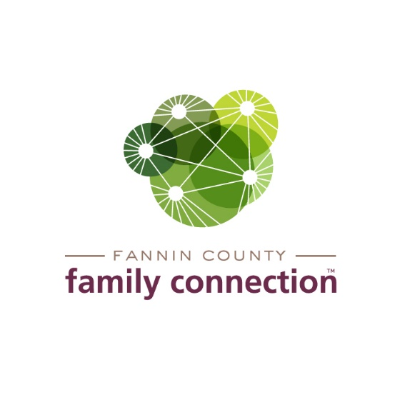

**AGENDA – Collaborative Meeting**

**Friday, August 12, 2022**

11:30 AM **Welcome to the George Link, Jr. Community Room**

***This meeting will be held in person and virtually via Zoom. Zoom will begin at Noon, after the lunch/networking time.***

11:35 AM **Lunch & Networking Time**

**Noon Call to Order, Introductions**

12:10 PM **Minutes - May 4, 2022**

12:15 PM **Let’s Make It Better!** - *Jim McKnight, Facilitator*

Open discussion about the Collaborative and how to make your investment of time beneficial to you and your organization.

12:50 PM **Community Calendar**

1:00 PM Adjourn