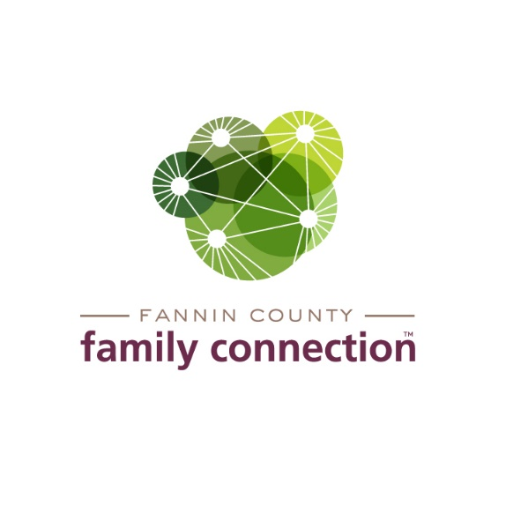

**AGENDA - Collaborative Meeting**

**Wednesday, March 3, 2021**

8:30 AM **Call to Order**

**Welcome to the George Link, Jr. Community Room**

For those attending in person: Please practice social distancing and wear a mask.

Masks are available on-site. Tables and chairs have been sanitized.

8:35 AM **Introductions**

8:45 AM **Minutes – February 3, 2021 Meeting**

8:50 AM **Open Enrollment for Medicaid Clients** – Presentations from CMOs

Joy Sneed – CareSource

Jenyfer Navichoque – Amerigroug

9:15 AM **Read Across America Day Activities** – Kirk Cameron, Executive Director of The Craddock Center

9:25 AM **Community Calendar - Open Forum – Announcements Welcomed**

QPR Suicide Prevention Training – Wednesday, March 31, 10am-12Noon, FCFC

CHI/Memorial Mammogram Coach, FCFC, Thursday, April 8, 10am-3pm

Civic Dinner Plans from FCFC, Thursday, April 22

**NEXT MONTH – Wednesday, April 14, 2021 (delayed one week due to Spring Break)**