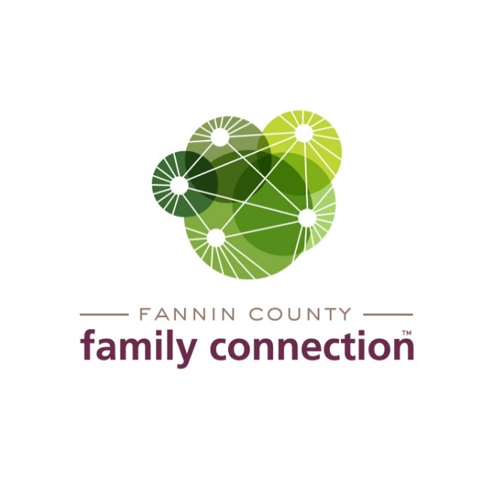

FANNIN COUNTY FAMILY CONNECTION

EXECUTIVE BOARD MEETING

AGENDA

August 12, 2021 2:00 PM

1. CALL TO ORDER
2. REVIEW MINUTES FROM LAST MEETING – July 8, 2021
3. COMMITTEE REPORTS
4. **Finance** – Tom Niswander
5. FY21 Recap
6. Year to Date Review
7. In-Kind Donations Update
   1. Tour of Homes
8. **Strategy Team** – Anna Speessen
   1. Upcoming Mental Health Awareness Television Campaign
   2. Red Ribbon Week & Watch Party Activities
9. **Tour of Homes Fundraiser –** Renee Lunney
   1. Update on Homes in program to date
   2. Prep Task List next 2 months – pictures & descriptions of homes, letter to Chamber of Commerce members, print tickets, design posters and post cards, raffle?
10. FEED FANNIN REPORT – Jane Kimzey
11. DIRECTOR’S REPORT
12. Monthly Statistics
13. Poverty 101 - Training for Faith Presbyterian Church & BR Jewish Congregation, Wednesdays throughout month of August – Open to the public
14. Feed Fannin Online Auction, August 20-29, Preview merchandise Sunday, August 15 and Monday, August 16 at FCFC
15. Poverty 101 “Crash Course” – Friday, September 10, 9a-1p, FCFC
16. Youth Mental Health First Aid – Wednesday, September 15, 8a-5p, FCFC
17. Kiwanis Blues Train to fund Ferst Readers, Saturday, September 18
18. UNG Tomato Sandwich Supper, 5:30p, UNG Blue Ridge Campus
19. Sherry vacation time: Thur-Fri, Aug 27-28; Thurs-Fri, Sept 2-3; Week of September 27 (will be 13 of 20 vacation days for year)