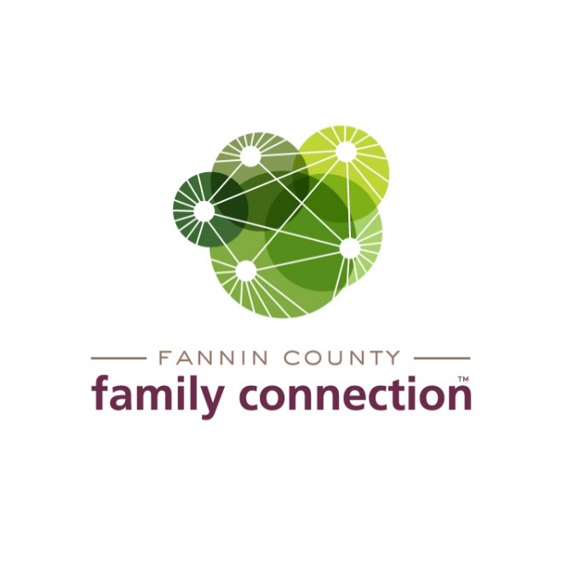

EXECUTIVE BOARD MEETING

AGENDA

August 18, 2022 8:30 AM

1. CALL TO ORDER
2. REVIEW MINUTES FROM LAST MEETING – June 16, 2022
3. COMMITTEE REPORTS
4. **Finance** – Tom Niswander – No Finance Report this month. Work continues on closing FY21-22 & determining employee percentage of work time in various categories.
5. **Fundraising**
   1. Status of Christmas Tour of Homes
   2. Clay Shoot Plans – need chair, determine dates, etc
6. **Strategy Team Reports –** Anna Speessen and RobertGleadall
   1. Mental Health Awareness
   2. Poverty Awareness
7. FEED FANNIN REPORT – Tom Niswander
8. DAY/TIME/WEEK for EXECUTIVE BOARD MEETINGS
9. ED September Vacation
10. DIRECTOR’S REPORT
11. Monthly Statistics
12. Staff Update
13. Impact Fannin – grant opportunity
14. Upcoming Event Dates:

* Thursday, September 1  10am   Mandated Reporter Training – virtual
* ***Friday, September 9 – Friday, September 16 Sherry’s Vacation – Board Meeting?***
* Tuesday, September 20 – Peer to Peer meeting, Calhoun
* September 26 – Great Pantry Makeover work day with Food Lion
* Thursday, September 29 10am-12noon  Roleplaying – staff from Ga Family Connection Partnership to lead training
* Wednesday, October 5 9am-1:15pm, Community Service Conference, Fairgrounds
* Wednesday, October 12 – Reality Day at Fannin High School
* ***Thursday, October 20 – Board Meeting, 8:30am***
* Friday, October 21 – Mammogram Bus at FCFC
* Monday, November 7, 10am-12noon Roleplaying – staff from Ga Family Connection