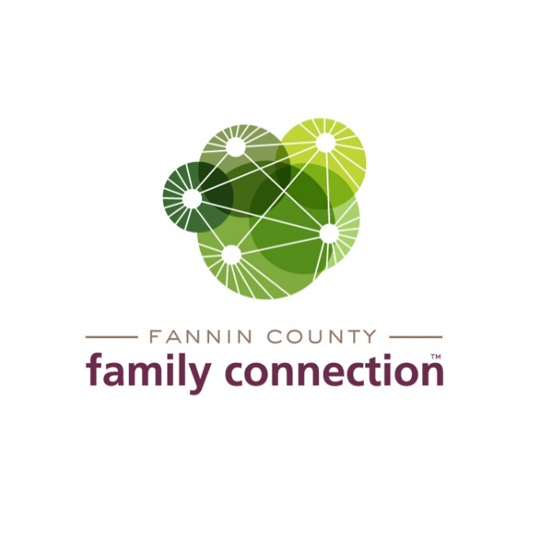

EXECUTIVE BOARD MEETING

February 16, 2023 8:30 AM

1. CALL TO ORDER
2. REVIEW MINUTES FROM LAST MEETING – January 19, 2023
3. OFFICIAL BOARD BUSINESS
4. Resolution – #2023-03 Facilities Team
5. Resolution – #2023-04 Clarifying Duties of Communication & Fundraising Committees
6. Committee Assignments – Current Board; New Board Members to be added after Annual Meeting
7. COMMITTEE REPORTS
8. **Finance** – No report this month. In-depth report and mid-year report completed last month. No significant change in financial position.
9. **Nominating Committee** – Robert Gleadall
   1. Potential Board Members
   2. Develop Timeline for application completion, on-boarding, orientation
10. **Fundraising –** Michael Kilpatrick & Kristy Lindstrom, co-chairs
    1. Current Status; Preliminary Timeline
11. **Strategy Team Reports** 
    1. Mental Health Awareness
    2. Poverty Awareness
    3. Kindship Care
12. **Communications & PR Report** – Kristy Lindstrom
13. DIRECTOR’S REPORT
14. Monthly Statistics
15. Data Review & Annual Planning
16. Upcoming Event Dates:

* Kinship Care Planning Session, Friday, February 24, 11a-1:30p Lunch included
* Leadership Fannin, Social Services Day, March 2
* Compassionate Care & QPR Session – March 8, 1-4:30pm FCFC
* Collaborative, Friday, March 10, 11:30a-1pm
* Kinship Care Follow-up & Project Planning – March 10, 1:30-3pm
* Annual Plan Evaluation with GaFCP, Thursday, March 22, 2pm; Interested Officers and Board members invited to attend
* Financial Literacy Class with Copper Basin Federal Credit Union, Thursday, April 13, 5:30pm, FCFC
* Collaborative, Friday, April 14, 11:30a-1pm