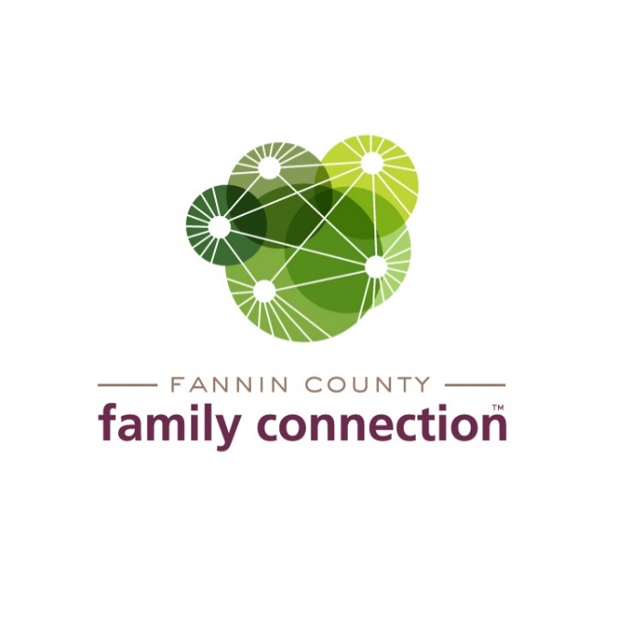

EXECUTIVE BOARD MEETING

AGENDA

January 13, 2022 2:00 PM

1. CALL TO ORDER
2. REVIEW MINUTES FROM LAST MEETING – November 11, 2021

December 9, 2021

1. COMMITTEE REPORTS
2. **Annual Meeting**
   1. Slate of Officers Announcement & Vote – Sherry Echelberger
3. **Finance** – Tom Niswander
   1. Audit Preliminary Report
   2. Investment Report
   3. Mid-year Financial Report
      1. Budget Revisions
      2. Capital Projects
4. **Tour of Homes Fundraiser Recap–** Renee Lunney
5. **Strategy Team Update –** Anna Speessen
   1. Mental Health Outreach
   2. Adult Education Plan for 2022
6. **Committees & Task Forces for 2022** – Jim Yacavone
7. FEED FANNIN REPORT
8. DIRECTOR’S REPORT
9. Monthly Statistics
10. Upcoming Event Dates:

January 20, 2022 – Ambassador Training (inclement weather date 1/27/2022)

March 16, 2022 – Poverty Simulation