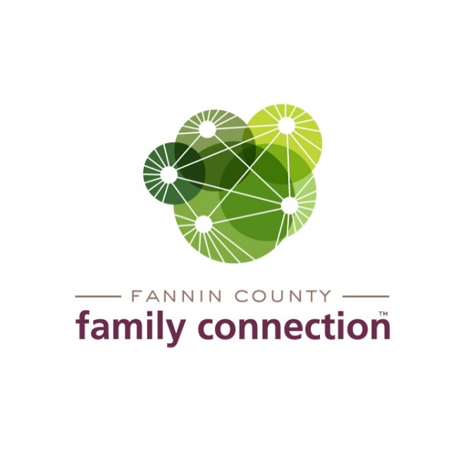

FANNIN COUNTY FAMILY CONNECTION

EXECUTIVE BOARD MEETING

AGENDA

June 22, 2021 2:00 PM

1. CALL TO ORDER
2. REVIEW MINUTES FROM LAST MEETING – May 13, 2021
3. COMMITTEE REPORTS
4. **Finance** – Tom Niswander
5. Year to Date Review
6. Budget Review
7. In-Kind Donations Update
8. **Nominating and Governance Committee** – Sherry Echelberger
   1. Recruitment Results
   2. Potential Board Member Info Meeting
   3. Plan for mentorship and smooth transition into Board Service
9. **Fundraising**
   1. Tour of Homes
10. **Strategy Team** – Anna Speessen
    1. Review of May Proclamation by County
    2. Upcoming Mental Health Awareness Television Campaign
    3. Other outreach activities
11. **Chamber of Commerce Open House** – July 22
    1. Menu
    2. Agenda for the evening
    3. Staff Prep
12. FEED FANNIN REPORT – Jane Kimzey
13. DIRECTOR’S REPORT
14. Monthly Statistics
15. QPR with Fannin EMA – June 25 – Finishes Year 1 Building A Region of Resilience
16. Training for Faith Presbyterian Church, Wednesdays throughout month of August