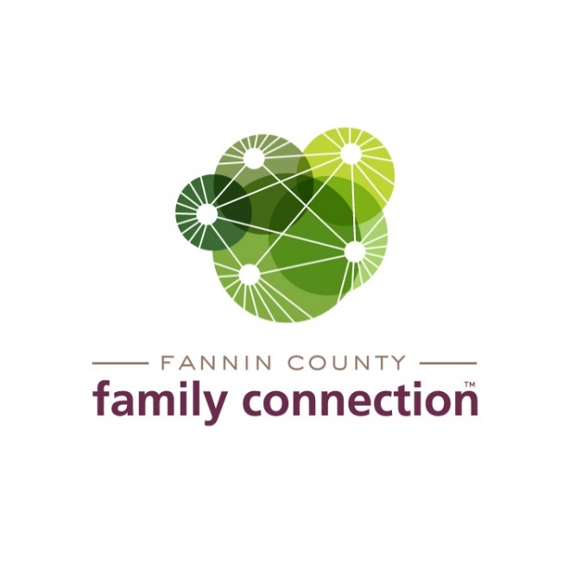

EXECUTIVE BOARD MEETING

AGENDA

November 11, 2021 2:00 PM

1. CALL TO ORDER
2. REVIEW MINUTES FROM LAST MEETING – October 14, 2021
3. COMMITTEE REPORTS
4. **Finance** – Tom Niswander
5. Year to Date Review of Income & Expenses
6. Staff PTO Policy Proposal
7. **Governance & By-Laws Committee** – Tom Niswander
   1. Committee slate of officers for 2022 – vote at January meeting
8. **Tour of Homes Fundraiser –** Renee Lunney
   1. Update on Homes in program to date
   2. Update on Sponsorships and ticket sales to date
   3. Organization plans
9. **Civic Dinner/Poverty Awareness Workgroup** – Sherry Morris
   1. High level themes from Nov 4 and Nov 9 meetings
   2. Follow-up meeting – November 17, 11:45 am at FCFC
   3. Ambassador training – January 20, 2022, back up date January 27, 2022
   4. Poverty Simulation - March 16, 2022 @ Fannin HS “new” gym
10. FEED FANNIN REPORT
11. DIRECTOR’S REPORT
12. Monthly Statistics