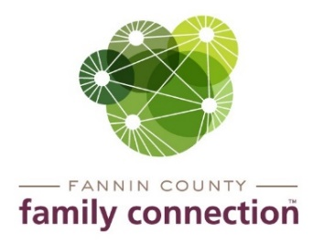

Minutes – Collaborative Meeting – April 14, 2021

The meeting of the Fannin County Family Connection Collaborative was held Wednesday, April 14, 2021 at 8:30 am. In Attendance: Lori Kantner, Joy Sneed, Kristy Lindstrom, Megan Beavers, Kirk Cameron, Mark Knowles, Hollye Petty, Jacqueline McKee, Victoria Turner, Amy Miles, Misty Dove, Benji Parker, Candy Sisson, Megan Beavers, Laura Pike, Sydney Criteser with The News Observer, and board members Cathy Cox-Brakefield, Sherry Echelberger, Joan Rearick, Anna Speessen, and staff Mandi Hyde and Sherry Morris.
Cathy Cox-Brakefield, FCFC Board Chair, called the meeting to order at 8:31am. Attendees were asked to look over the minutes from March 3, 2021 for approval. After a motion to approve by Anna Speessen and seconded by Sherry Echelberger, the minutes were approved without correction. Cathy asked everyone to introduce themselves that were attending in-person and by Zoom.
The speaker for the meeting was Benji Parker with Highland Rivers Health. Benji spoke about the services Highland Rivers offers to adults, children, adolescents, families and veterans of 12 nearby counties. Highland Rivers provides services for mental illness, substance use, intellectual and developmental disabilities with outpatient and community support centers. The closest open access facility to Fannin County that offers services is in Gilmer County. Open access is a walk-in type help that takes clients on a first come and severity of help needed facility. Other services are determined after the initial visit.
Misty Dove mentioned that North Georgia Community Action has moved into the Owenby Building in downtown Blue Ridge and now has Cooling Assistance available for seniors in the community. Also on May 3, 2021 Cooling Assistance will open to all the community. Call for interview – 706-632-2854.
Hope Burns stated that the Friends of the Fannin County Library is seeking people who would be willing to serve on the board. Election in June, Contact Hope at 404-510-4673 for more information.

Community Calendar

- Thursday, April 22, 2021 – Civic Dinner – Fannin County Family Connection will hold a dinner & discussion regarding services provided in the county

- Monday, April 26, 2021 – Diaper Day – drive through at Family Connection starting at 11am and going until all items are gone.

- Thursday, April 29, 2021, 6-8pm and Saturday, May 8, 2021, 10am-noon – Active Shooter Training – at Blue Ridge Community Theater contact Hope Burns at 404-510-4673

- Saturday, May 1, 2021, 1-3pm and Thursday, May 6, 2021, 6-8pm – Darkness to Light – Child Sexual Abuse Training - at Blue Ridge Community Theater contact Hope Burns at 404-510-4673

- Saturday, June 26, 2021 – Walk for Life by Her Hope Pregnancy Center – at Fannin County Recreation Center field – 8:30am registration opens

With no further business, the meeting was adjourned at 9:43am.
Respectfully submitted,
Sherry Morris

