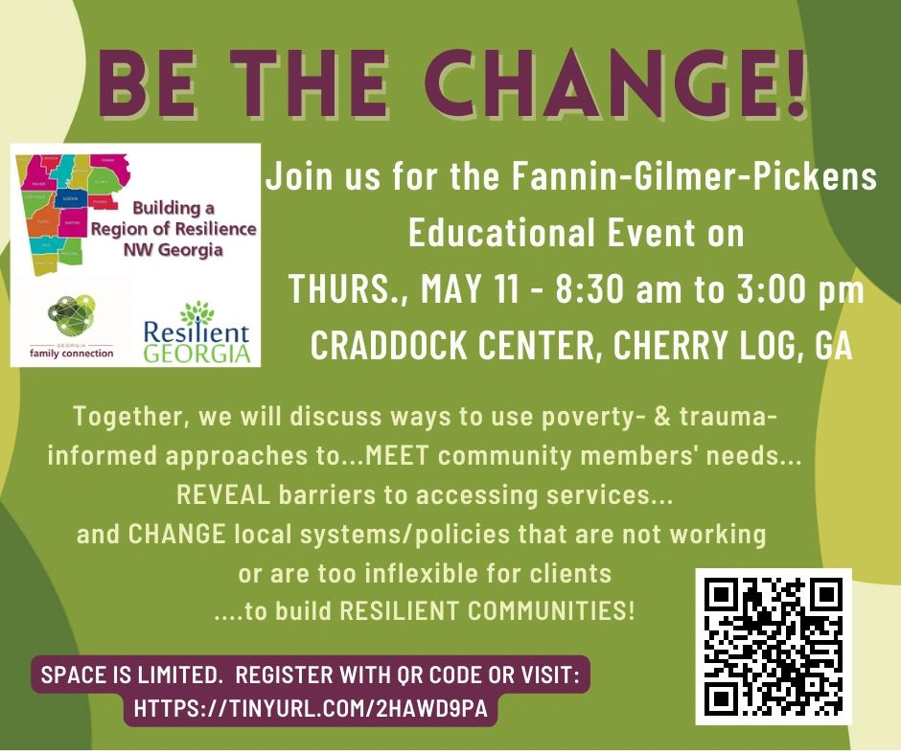

Our purpose for this journey: to create a shared understanding of the systems that touch our families during their life journey, identify where families face barriers, and recognize what as community partners and members we can do to create positive, impactful, and lasting change. Community partners, leaders and social service providers in Fannin, Gilmer and Pickens Counties are invited to join us to collaboratively create changes that improve outcomes for our children and families in need.

