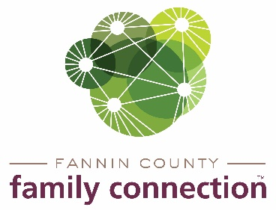

**Minutes – Collaborative Meeting – February 2, 2022**

The meeting of Fannin County Family Connection Collaborative was held Wednesday, February 2, 2022 at 8:30 a.m. In Attendance: Tom Niswander, Jim Yacavone, Mollie Allen, Anna Speessen, Meredith Yacavone, Alexis Edelstein, Lori Kantner, Chris Martine, Kristy Lindstrom, Kirk Cameron, Victoria Turner, Theresa Dillard, Hope Burns, Destiny Morgan, Susan Barnhill, Alexandria Sanford, Amy Miles, Joy Sneed, Mark Knowles, Somilez Francis, Sherry Morris and Mandi Hyde

Jim Yacavone, FCFC Board of Chair, called the meeting to order at 8:33 a.m. Introductions were made by those present and on zoom. Attendees were asked to look over the minutes from November 4, 2021 for approval. After a motion was approved by Chris Martinez and seconded by Tom Niswander, the minutes were approved without correction.

The first speaker at the meeting was Somilez Francis of Morehouse School of Medicine. Somilez discussed the project being conducted in Fannin County by Morehouse entitled Community Education and Training in Opioid Use Reduction (CETOUR). Morehouse has partnered with Highland Rivers Health, Georgia Mountains Health and Georgia Department of Public Health to use a technology-driven, integrated, multidisciplinary approach to education to offer enhanced community centered resources on prevention, treatment, and recovery to address barriers in Substance Use Disorder and Opioid Use Disorder. The Appalachian Opioid Coalition was formed and hosts monthly meetings on the 2nd Tuesdays at 3:30pm to Identify strategies to reduce opioid use, implement strategies, and provide referral to opioid services. Coalition members include health care, social services, mental health and substance abuse providers, drug court, law enforcement, the state public health department, and the faith-based community. The goal is to reduce the prevalence of opioid use disorder in rural north Georgia. Highland Rivers Health offers training on the use of Narcan for opioid overdose.

Sherry Morris spoke about the upcoming Poverty Simulation that will hopefully take place in March 16, 2022. The simulation will require 30-35 volunteers to be role players and up to 100 participants to be the families for the event.

Anna Speessen spoke about FCFC Strategy Team will have mental health awareness articles run monthly in The News Observer. The Strategy Team will also start a focus on Adult Education and will offer online and in-person classes/trainings soon.

Upcoming Community Calendar events: Sat., Feb. 5, 2022 The Craddock Center – Songs & Stories at 3pm.

Sat., Feb. 19, 2022 Fire & Ice –Chili Cook-off & Ice sculptures downtown Blue Ridge.

There being no further business, the meeting was adjourned at 9:39am.

Respectfully submitted,

Sherry Morris