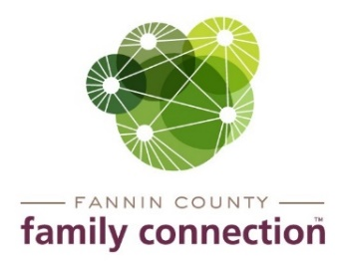

**Minutes – Collaborative Meeting – March 3, 2021**

The meeting of the Fannin County Family Connection Collaborative was held Wednesday, March 3, 2021 at 8:30 am. In Attendance: Chris Martinez, Lori Kantner, Sarah Welch, Joy Sneed, Kristy Lindstrom, Megan Beavers, Kirk Cameron, Keith Reilly, Mark Knowles, Sarah Petraza, Jenyfer Navichoque, Holly Petty, Jacqueline McKee, Shane Stepp, Sydney Criteser with The News Observer, and board members Cathy Cox-Brakefield, Tom Niswander, Anna Speessen, and staff Mandi Hyde and Sherry Morris.

Cathy Cox-Brakefield, FCFC Board Chair, called the meeting to order at 8:37am. Attendees were asked to look over the minutes from February 3, 2021 for approval. After a motion to approve by Chris Martinez and seconded by Tom Niswander, the minutes were approved without correction. Cathy asked everyone to introduce themselves that were attending in-person and by Zoom.

The first speakers were Jenyfer Navichoque and Sarah Petraza with Amerigroup. Amerigroup is a leading managed care company dedicated to improving lives and promoting healthier communities. They provide services to individuals served by Medicaid, State Children's Health Insurance Program and other State-sponsored health programs. They also serve individuals who are Medicare-eligible. They offer several extra benefits with health care for eligible clients. Clients with Wellcare have until March 31, 2021 to enroll in another health care program.

The next speaker was Joy Sneed with CareSource. CareSource was founded on the premise of providing quality health care coverage for Medicaid consumers. Today it offers one of the nation's largest Medicaid managed care plans. They offer a wide variety of benefits for clients. Clients with Wellcare have until March 31, 2021 to enroll in another health care program.

The last speaker was Kirk Cameron, Executive Director of The Craddock Center. Kirk spoke about the *“Read Across America Day”* and how the center gave out 1,100 books to children in the area. The center will be starting a new reading program called *Summer Send Off 2021.* Children will receive books and an art & crafts kit to complete to help encourage reading over the summer.

Anna Speessen a FCFC board member mentioned getting a planning committee together to assess what the needs are of the community and starting a program to help meet those needs.

**Community Calendar**

* ***Thursday, March 18, 2021 – UNG – PEAKS – Planting by the Signs*** – ***7 pm*** - a virtual event about planting according to the moon’s phases and position in the zodiac.
* ***Wednesday, March 31, 2021*** – ***QPR Suicide Prevention Training – 10am to 12pm*** ***– at Family Connection*** - a FREE course on recognizing the signs of suicide and how to help save a life.
* ***Thursday, April 22, 2021*** – ***Civic Dinner –*** Fannin County Family Connection will hold a dinner & discussion regarding services provided in the county

With no further business, the meeting was adjourned at 9:19am.

Respectfully submitted,

Sherry Morris