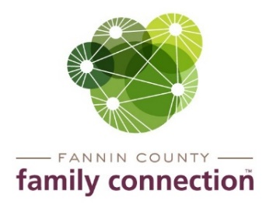

Minutes – Collaborative Meeting – May 5, 2021

The meeting of the Fannin County Family Connection Collaborative was held Wednesday, May 5, 2021 at 8:30 am. In Attendance: Joy Sneed, Kristy Lindstrom, Megan Beavers, Kirk Cameron, Hollye Petty, Jacqueline McKee, Victoria Turner, Misty Dove, Candy Sisson, Megan Beavers, Steven George, Donna Earl, Monica Clark, Chris Martinez, Catia Santos, Sydney Criteser with The News Observer, and board members Cathy Cox-Brakefield, Jim Yacavone, Tom Niswander, Anna Speessen, and staff Mandi Hyde and Sherry Morris.
Jim Yacavone, FCFC Board Co-Chair, called the meeting to order at 8:34am. Introductions were made by those present and those on Zoom. Attendees were asked to look over the minutes from April 14, 2021 for approval. After a motion to approve by Tom Niswander and seconded by Misty Dove, the minutes were approved without correction.
The speaker for the meeting was Hollye Petty with the Fannin County Health Department. Hollye gave an update on the COVID vaccine. Vaccines were first started in December 2020 and have continued to the present. About 8,000 – 9,000 vaccines have been administered, which is about 24% of the Fannin County population. Vaccines are still available with walk-in times on Mondays & Tuesdays. The health departments regular services are back up and running again.
Sherry Morris spoke about the Civic Dinner that was held April 22, 2021 by Family Connection. Many insights on what resources are needed in the county for the residents were gathered and will be used to eventually to provide what the residents need most. Family Connection plans on hosting a Civic Dinner in the future in late fall so the information gathered can be used to help with our annual plan for providing services for the county.

Community Calendar

- Thursday, May 6, 2021, 6-8pm – Darkness to Light – Child Sexual Abuse Training - at Blue Ridge Community Theater contact Hope Burns at 404-510-4673

- Wednesday, May 12, 2021, 12pm – 4pm – Job Fair – UNG Blue Ridge Campus

- Thursday, June 3, 2021 – Thursday, July 22, 2021 – 11am-12pm – Mondays and Thursdays – Summer Meals – Food distribution to Fannin County children provided by Faith Presbyterian, Fannin County Family Connection, Snack in a Backpack, Temple Baptist Church and St. Luke’s Anglican Episcopal Church.

- Thursday, June 17, 2021 – UNG – PEAKS Zoom Event – Presentation from Project Chimps on their operation of the facility and care of the chimps.

- Saturday, June 26, 2021 – Walk for Life by Her Hope Pregnancy Center – at Fannin County Recreation Center field – 8:30am registration opens

With no further business, the meeting was adjourned at 9:16am.
Respectfully submitted,
Sherry Morris

