 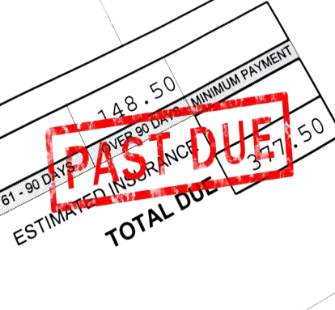

Are you behind on

rent, utilities, or mortgage payments?

Help may be available!

Please call Misty or Sharon

at North GA Community Action, for eligibility.

706-632-2854