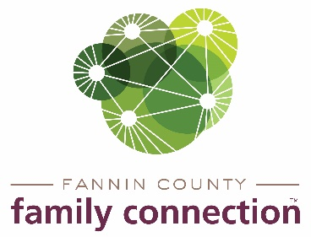

**Minutes – Collaborative Meeting – September 1, 2021**

The meeting of Fannin County Family Connection Collaborative was held Wednesday, November 4, 2021 at 8:30 a.m. In Attendance: Cathy-Cox Brakefield, Tom Niswander, Jim Yacavone, Mollie Allen, Anna Speessen, Meredith Yacavone, Jacqueline McKee, Alexis Edelstein, Lori Kantner, Michael Kilpatrick, Chris Martine, Candace Youngberg, Kristy Lindstrom, Kirk Cameron, Victoria Turner, Theresa Dillard, Steven Kirby, Angie Ledford, Joy Sneed, Mark Knowles, Sherry Morris and Mandi Hyde

Cathy Cox-Brakefield, FCFC Board of Chair, called the meeting to order at 8:31 a.m. Introductions were made by those present and on zoom. Attendees were asked to look over the minutes from September 1, 2021 for approval. After a motion was approved by Jim Yacavone and seconded by Theresa Dillard, the minutes were approved.

The first speaker at the meeting was Steven Kirby with Fannin County Boys & Girls Club. The Club will be reopening on November 8, 2021. The Boys & Girls Club is a nationally endorsed after-school program for students. Our county’s club is located in Epworth but is looking to move to downtown Blue Ridge which would be a more central location for all the schools. Students that attend the program have 4 activities to participate in during the day which include academics, art, group recreation and group outdoor play. People may sponsor a child by sending in a donation to the club. You can also help by volunteering to be a mentor, send in snacks for the children.

Sherry Morris spoke about the upcoming meeting to re-establish the Poverty Awareness Workgroup. People will be needed for the workgroup to strategize for the upcoming Poverty Simulation that will hopefully take place in March 2022. The simulation will require 30-35 volunteers to be role players and up to 100 participants to be the families for the event.

Fannin County Family Connection will host a Civic Dinner November 4, 2021. Local community residents will have a dinner and then discuss needs of the community. A debriefing will be held November 17, 2021 to determine what the greatest need is. Later a plan will be made to help provide this need in the community.

The FCFC Strategy Team will have its meeting November 9, 2021 via zoom. The monthly talk series ‘Your Mental Health’ has been airing on local ETC3 channel for people to hear about mental health issues. Starting in December a monthly article will be run in The News Observer.

Kristy Lindstrom spoke about the Community Service Conference that was held last month by the Kiwanis Club of Blue Ridge. The topic this year was on Human Trafficking – Stolen in the Blink of An Eye. There were several speakers of the event and you may watch it on Youtube.

The upcoming calendar was discussed with agencies announcing the events that were planned for the remainder of November and into December. Toys for Tots is accepting applications now through December 10th. Poverty Awareness workgroup will meet Nov. 9th at 10am at Family Connection.

There being no further business, the meeting was adjourned at 9:33am.

Respectfully submitted,

Sherry Morris