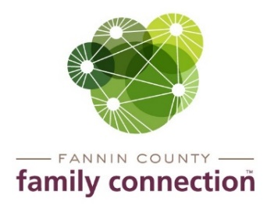

Minutes – Collaborative Meeting – October 7, 2020

The meeting of the Fannin County Family Connection Collaborative was held Wednesday, October 7, 2020 at 8:30 am. In Attendance: Victoria Turner, Benji Parker, Mark Knowles, Sydney Criteser, Chris Martinez, Misty Dove, Cheryl Jordan, Jim Brumbelow, Tara Cantrell and board members, Cathy Cox-Brakefield, Jim Yacavone, Tom Niswander, Sherry Echelberger and staff Mandi Hyde and Sherry Morris.
Cathy Cox-Brakefield called the meeting to order at 8:36am. Attendees were asked to look over the minutes from September 9, 2020 for approval. After a motion to approve by Jim Yacavone, duly made and seconded by Tom Niswander, the minutes were approved without correction. Sherry Morris introduced everyone that was in person at the meeting.
The first speaker was Jim Brumbelow with Marine Corps League Toys for Tots. Jim stated that it was the 5th year Toys for Tots has been here in the county. Last year 3,588 toys were given out to 920 children. Jim said the Marine league provides Open Arms with bags that have hair dryers and makeup to the girls that come to the home. They provided CASA with toys to give to children on their birthdays. The Marine’s also provided the sheriff’s office with stuff animals to give to children that they encounter at accident scenes. Jim said that they have already seen an increase in requests this year and that more money will be needed to help with costs.
The second speaker was Tara Cantrell with Fannin County School System. Tara stated that most of the students were back in the schools and some were doing the online learning. Tara said that because of having the option to come in to school or do online learning that it was difficult to know for sure the number of homeless students. Students that are considered homeless are either living doubled up with another family, living in substandard housing, in a shelter, a vehicle, or tent. The program the school has for homeless students helps get the student enrolled in school, provides transportation to the school of choice, provides free breakfast and lunch, lets the students participate in activities, and gives the students partial credit towards courses they have already had.
The last speaker was Misty Dove with North Georgia Community Action. Misty spoke about the increase in people applying for heating and cooling assistance since April 2020. Misty said she has been receiving money to help with utility bills and rent through the CARES Act and that she will be taking more applications beginning November 2nd. Also the heating assistance for elderly will start November 2nd. People must call Misty to get help. All applications are done over the phone.

Community Calendar – Resources Available

Fannin County DFCS – SHARES - funding to help with rent. Call 706-632-2296

Blue Ridge United Methodist – October 31st - Halloween Drive Thru

Fannin County Family Connection – Christmas Fundraising – December 5th – Sip, Skate & Stroll at Inola 12pm – 5pm. Open House December 11th & 12th at Family Connection – collaborative partners are encouraged to decorate a small tree or stocking to display during the event. ETC will be filming a virtual tour of Family Connection and a few private homes for a Tour of Homes this year that will be shown on ETC during a telethon fundraiser.

With no further business, the meeting was adjourned at 9:30am.
Respectfully submitted,
Sherry Morris

