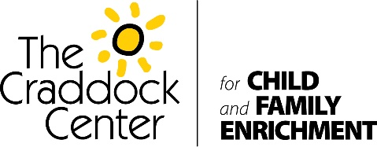

READ ACROSS AMERICA DAY / DR. SEUSS’ BIRTHDAY
On March 2nd, The Craddock Center will celebrate Read Across America Day and Dr. Seuss’ Birthday. On this day volunteers from The Craddock Center will deliver 1100 brand new Dr. Seuss books to the children we serve. Normally, in a non-pandemic year, our staff and volunteers would visit the classrooms dressed as Dr. Seuss characters The Cat in the Hat, Thing 1, and Thing 2 to deliver the books and celebrate with the children.
Read Across America Day is a day to celebrate the joys of reading. It also brings awareness to the importance of reading in education for our children. The founders of this day decided to have it on Dr. Seuss’ birthday. Dr. Seuss is one of the greatest authors of children’s books. Most kids have grown up reading his many entertaining books. The Craddock Center is making sure our kids can share in the joy of his books like many of us have over the years.

