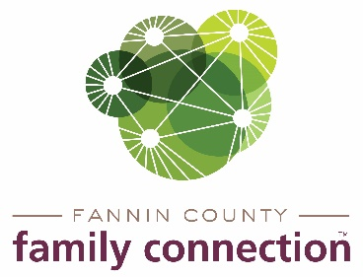

**Minutes – Collaborative Meeting – September 1, 2021**

The meeting of Fannin County Family Connection Collaborative was held Wednesday September 1st, 2021 at 8:30 a.m. In Attendance: Cathy-Cox Brakefield, Tom Niswonder, Jim Yacavone, Mollie Allen, Anna Speesen, Meredith Yacavone, Kimberly O’Neal, Hope Burns, Jacqueline McKee, Cindy Tremble, Alexis Edelstein, Lori Kantner, Tara, Micheal K., Megan Beavers, Chris Marting, Candance Y., and Kristy Lindstrom. Members who joined via Zoom were: Tara Cantrell, Michael Kilpatrick, Megan Beavers, Kirk Cameron, Candace Youngberg, Chris Martinez, and Kristy Lindstrom.

Cathy Cox-Brakefield, FCFC Board of Chair, called the meeting to order at 8:34 a.m. Instructions were made by those present and on zoom. Attendees were asked to look over the minutes from August 11, 2021 for approval. After a motion was approved by Tom Niswonder and seconded by Hope Burns, the minutes were approved.

The first speaker at the meeting was Kimberly O’Neal from North Georgia Mountain Crisis Network. She spoke about that North Georgia Mountain Crisis Network serves victims of domestic violence and sexual assault in Fannin, Gilmer, and Pickens County. Their goal is to help victims to become a survivor. The core services offered are a 24/7 crisis hotline, 24 hour intervention, safe shelter, safety planning, finding support systems, forensic medical exam, emergency financial assistance, community outreach, and household establishment assistance. This organization also stays in contact with the victims to do follow up check ins. Kimberly also spoke on some statistics that included 1 in 4 women and 1 in 7 men have experienced severe violence by an intimate partner. Approximately 20 people per minute experience some type of abuse. Overall, Georgia ranked 22nd in the nation at the rate by which men and women were killed. North Georgia Mountain Crisis network does take donations at the outreach office and clothing donations at the thrift store at two different locations.

Anna Speessen discussed the Mental Health Awareness outreach that is a partnership of several organizations within the Collaborative. The Fannin County Public Library has joined as a partner and will include an easily accessible area for mental health books and information. The plans for the monthly television show are all in order for the remainder of the year. Speessen noted the dates and locations for the watch parties for the movie, “Angst” and invited all to attend. She also said that individual logins could be requested to view the movie at home as well.

Morris announced that the Community Service Conference will be held on Wednesday, October 6 and that this meeting will take the place of the monthly Collaborative meeting. The subject this year is “Human Trafficking – Stolen in the Blink of An Eye.” Morris stated that the four speakers for the event are among the best in the nation on the subject of human trafficking. The Conference will be televised rather than in-person and can be viewed on ETC3 or on FB Live from Fannin County Family Connection’s page or viewed later via YouTube.

Kirk Cameron announced that The Craddock Center had recently hired three persons to conduct their literacy outreach into the pre-schools and elementary schools in the region. They plan to back in the schools in-person beginning during the first week of October.

Morris reviewed the link for the on-line completion of the Annual Vitality Survey and encouraged all to participate.

The upcoming calendar was discussed with agencies announcing the events that were planned for the remainder of September and into October. Cox-Brakefield reminded the group to view the Community Service Conference and announced the next Collaborative meeting scheduled on Wednesday, November 1.

There being no further business, the meeting was adjourned at 9:35am.

Respectfully submitted,

Sherry Morris