
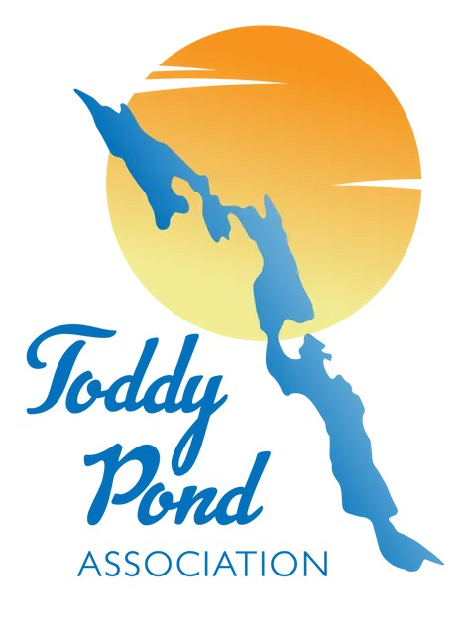
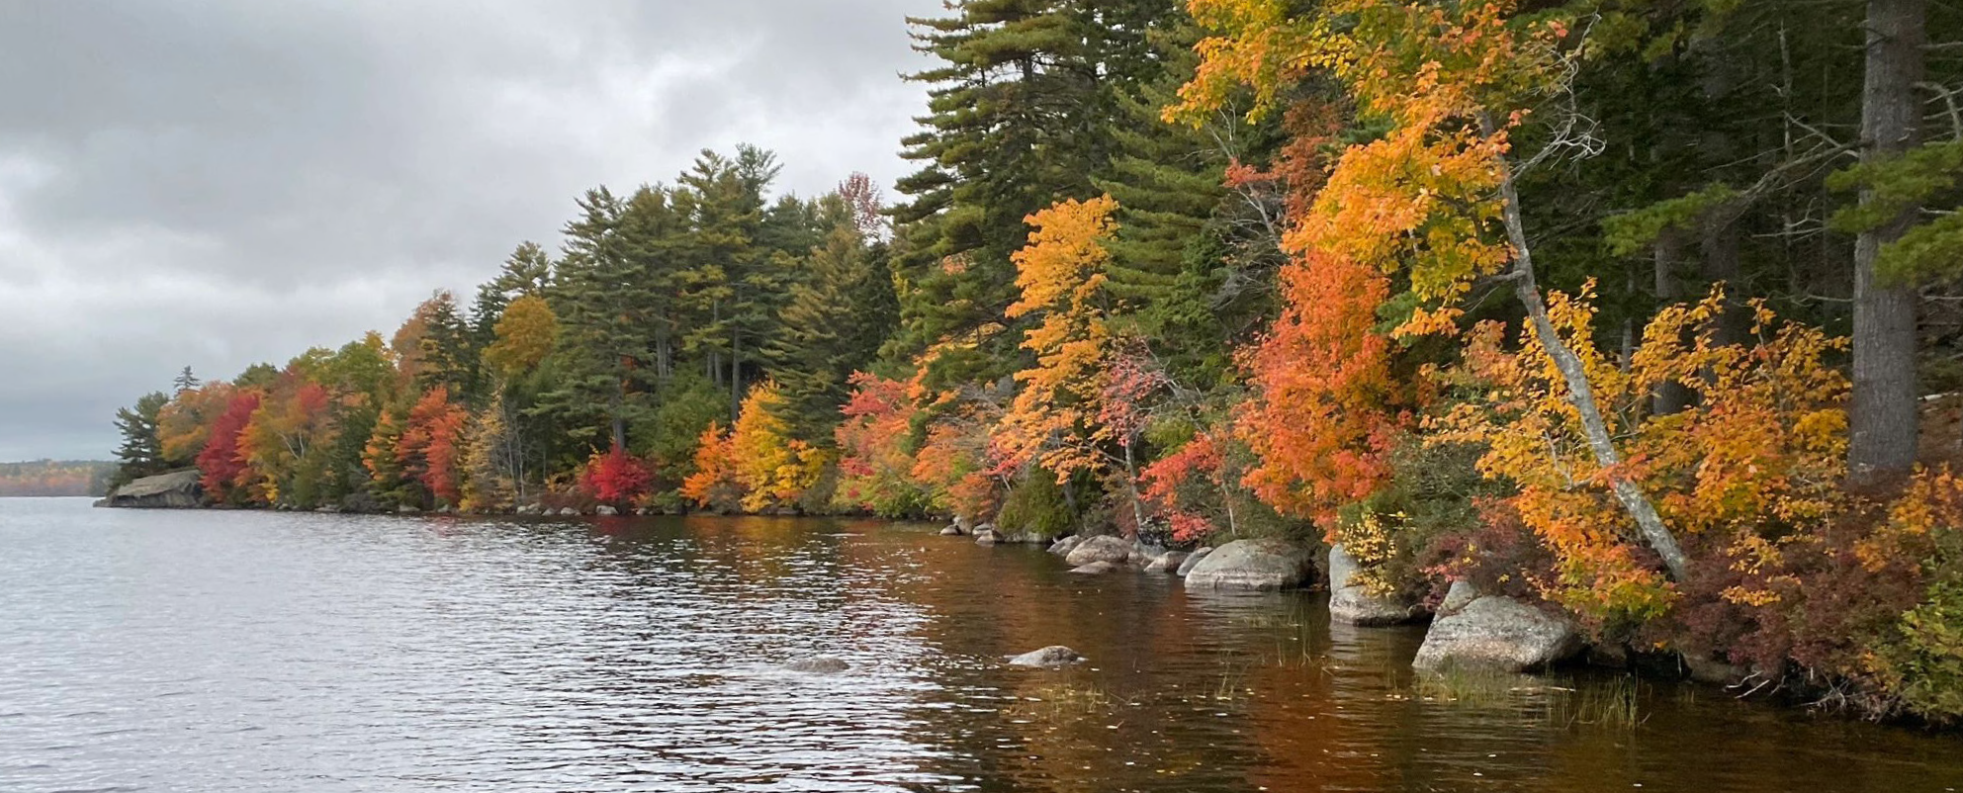
Issue 52 Fall 2024

Newsletter of the Toddy Pond Association

Serving the Towns of Blue Hill, Orland, Penobscot, and Surry, Maine

CAN TPA COUNT YOU IN ?
Across this country it is increasingly difficult to get peo- ple to volunteer. Over the past year, I’ve come to appreciate how much work has been done by the 6 member TPA board. Not only are they good hardworking peo- ple, they are fun to work with! TPA volunteers work to insure the health and wellbeing of Tod- dy Pond. * boat inspections to prevent invasive aquatic plants spoiling our pristine waters, * patrolling the shoreline to spot potential invasive plants, * wa- ter testing, * loon counts, * an- nual meeting, * summer barbe- cue, * Toddy Pond merchandise,
*maintaining a website, * publish- ing our semi-annual Toddy Pon- der newsletter to inform proper- ty owners of topics and matters concerning Toddy and the towns of Orland, Surry, Penobscot and Blue Hill. With the potential for a change in dam ownership and maintenance, that workload has increased, and will require more assistance this coming year to work on a solution for the dam(s). This may involve com- mittee meetings, town meetings, letter writing, conversations with elected and other officials, deliv- ering posters to businesses, etc.
Continued on page 4....

President’s Report
Welcome to fall here on Toddy Pond !
My name is Marc Restuccia and I was recently elected President of the Toddy Pond As- sociation. I’d like to thank the Officers from last year. Chris Closs, President, Robyn Silberstein, Vice-President and Donna Foster, Secretary have all stepped down from those roles. Fortunate- ly, Chris will continue as Vice President and Donna will continue to Chair the all-important Dam Committee. Barry Johnson will continue in his role as Treasurer. Our new Officers: Marc Restuccia, President; Chris Closs, VP; Robin Yurkevicz as Secretary; Barry Johnson, Treasurer.
Retiring from the board: Lucy Leaf and Robyn Silberstein. We want to thank all those folks who have changed roles and/or retired for their decades of dedication to the Association and to our beloved pond. Our “new” board consists of the officers above as well as John Moss, Brian Smith, and Phil Roberts. It’s a great group of folks and we have a lot we will need to accomplish this year. A few words of background on myself. A Massachusetts resident for most of my life,
my wife and I lived in Sterling MA, just north of Worcester and raised our 2 children there. We vacationed on Third /South Toddy many years ago, loved the lake and the area and bought some land on First/North Toddy around the year 2000. We spent a great deal of time on the pond for many years and finally moved here full time in the fall of 2019. Since then, we’ve both gotten increasingly involved with TPA. This past summer Robin took over the Invasive Plant Patrol from Lucy Leaf, and I assumed the Courtesy Boat Inspection duties from Lucy. Yes, it really DOES take multiple people to try and fill Lucy’s shoes. With all of the issues surrounding the dams on Silver Lake, Alamoosook Lake and
Toddy Pond, it will be a busy year. I look forward to working with you all in the year ahead.
Thank you. Marc Restuccia

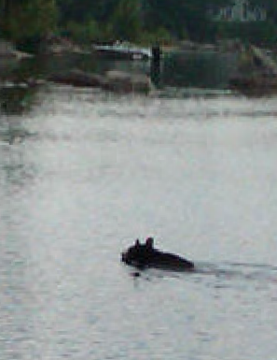
OUR MISSION: To protect Toddy Pond and its watershed through responsible stewardship and education so that we and future generations may enjoy its beauty.
Have I Paid Membership Dues This Year?
We rely on membership dues and donations heavily in our efforts to preserve and protect Toddy Pond. If the year “2024” is printed above your name in the address field on this mailing, you have paid your dues for the 2024 fiscal year. If there is no year indicated, please consider renewing your membership or becoming a new member, thank you!
If you have questions or concerns, contact Robin at: toddymail@toddypond.org

Courtesy Boat Inspections - Achievements and 2024 Summary
For yet another summer season, TPA achieved
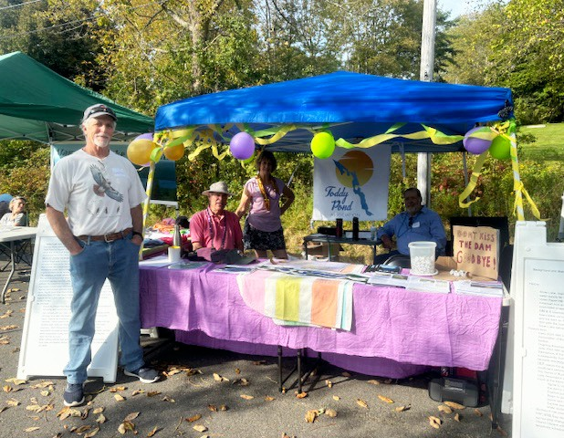
its goal of providing boat inspections at the public land- ing in Orland, from Memorial Day through Labor Day, and on weekends in May. Over 1,000 boat inspections were conducted, 930 on motorized boats. Courtesy Boat Inspection (CBI) is recognized as the first line of defense against introduction of invasive species to the lake, con- sidered all important in protecting Toddy as we know it. We are glad to report that no invasives were found. This was achieved utilizing four paid inspectors covering six days a week (six to twelve hour days) and vol- unteers covering the seventh day as well as early morning slots throughout the week. CBI volunteers really stepped up this year, providing 19% of inspection hours overall. In addition, there were many volunteer hours required to coordinate the program which includes budgeting and grant writing in January, scheduling and hiring of staff during the spring, followed by training and managing the program throughout the season. This year, that in- volved several volunteers coordinating together with Marc Restuccia taking the lead. In addition, the TPA Treasurer, Barry Johnson,assumed additional payroll responsibilities.
Most of the funding specified for CBI this year
was provided by Maine Community Foundation and Toddy Pond donors, Bill and Peggy Mitchell, which makes inspection possible. The state provides approx- imately 15% of the cost of the program, even though Toddy’s busy public landing is owned by the state. Ad- ditionally, TPA also provides a portion of the cost. The biggest challenge the CBI committee faces ev-
ery year is the issue of who will coordinate the program as the responsibilities have come to exceed what volun- teers can reasonably be expected to take on. TPA has been unable to fill a paid coordinator position. Regional collaboration has been discussed for years and may come to the fore again as lake protection challenges increase. A huge thank-you to all the volunteer inspec-
tors, including new volunteers, who stepped up this year, many taking multiple shifts throughout the season, es- pecially to provide early morning coverage throughout the week. Weekend paid coverage also began at 6 AM on most days to show a presence to fishermen. It all shows that Toddy Ponders care about protecting our lake. That is our prime message, hoping that others will care also.

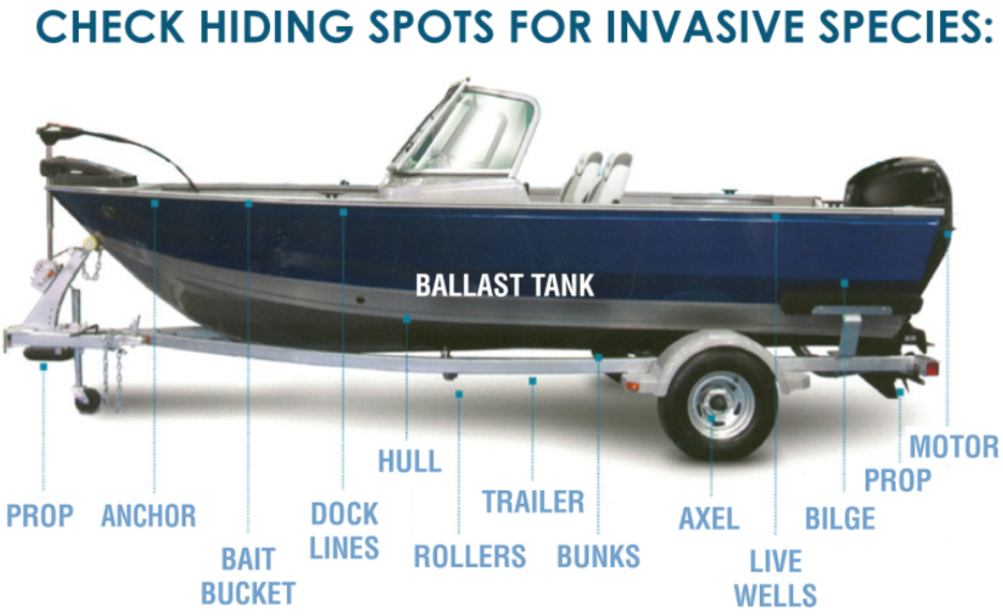
VOLUNTEER INSPECTORS:
Marc Restuccia, Robin Yurkev- icz, Peg Thursland, Floyd Johnson, Robyn Sil- berstein, Bill and Janet Martin, Marybeth Allen, Steve Antell, Bob Evans, Dave and Betty Parsons, Ger- ald Oliver, Coleen Barbeau, Andy and Sarah Nelson Our hard working CBI committee welcomes
new ideas and people - many hands make light work. As sole coordinator, I eagerly encourage anyone with the interest to join the committee for next year as we seek to continue and even enhance this first line of pro- tection from invasive aquatic plants on Toddy Pond.
Finally, special thanks to Lucy Leaf. For many years now Lucy has served as the coordinator for the CBI pro- gram. She has devoted countless hours to not only coordi- nating the program, but also serving as a volunteer Courtesy Boat Inspector. Her knowledge of Toddy Pond, its aquatic plants and the wildlife on the pond is unsurpassed. The in- credible amount of work she has put forth to protect our beloved pond has mostly been done without fanfare or ac- claim. The amount of knowledge and expertise she passed on to me (and my wife, Robin Yurkevicz who took over IPP from Lucy) is incredibly appreciated. Everyone on Tod- dy owes Lucy much and we wish her every happiness and health as she retires from her leadership roles with TPA.
Marc Restuccia, September 2024

6/21 | 7/07 | 7/28 | 8/11 | 8/24 | 9/11
4.1 m | 4.4 | 5.3 | 5.3 | 5.8 | 5.4


The clarity of the water is most affected by the amount of algae suspended in the water and by the amount of tan- nin, which stains the water an ice tea color and is caused by runoff from leaf fall mostly. You might have no- ticed that this fall the reduced rainfall has produced less runoff and consequent water clarity improvement.
Water Quality Note for Summer of 2024
The water clarity, as measured by lowering a Secci disk down into the lake, has remained about the same as previous years. The readings this summer(shown below) have been between 4.1meters and 5.8meters. Though that is a large amount of vari- ability, the observations are affected by the angle of the sun and the cloud cover on any given day, plus any variations in the observers low-light vision capability.
The temperature and oxygen level readings at various depths remain consistent with previous years readings. Here are the readings from 6-21-24. Note that the water temperature gets colder with increasing depth, while the oxygen content gets higher with depth. This is because colder water can hold more oxygen than warmer water.

Meters | 0 | 1 | 2 | 3 | 4 | 5 | 6 | 7 | 8 | 9 | 1 | 1 | 1 | 13 | 14 | 15 | 20 | 30
from surface |  |  |  |  |  |  |  |  |  |  | 0 | 1 | 2
Temp in C | 23  .9 | 23.  9 | 23.  3 | 21.  7 | 19.  7 | 16.  4 | 13.  5 | 10.  9 | 9.4 | 8.  7 | 8.3 | 7.  9 | 7.9 | 7.7 | 7.7 | 7.7 | 7.4 | 7.2

Oxygen level | 7.  6 | 7.5 | 7.4 | 7.9 | 8.1 | 8.2 | 8.9 | 9.7 | 9.9 |  | 10.1 |  |  | 10.  0 | 9.9 | 9.9 | 10.  0 | 9.9


Orland River Day
On Saturday, September 14th, the Town of Orland celebrated the 48th Orland River Day and the Toddy Pond Association was strongly represented. Virtually the entire board participated. From John Moss helping to set up the tent and get the booth ready, to Donna Foster and Dennis contributing decorations, Hershey Kisses and Mardi Gras necklaces for all to wear, along with Chris Closs, Brian Smith, Robin Yurkevicz and Marc Restuccia. All present staffed the booth for the entire day, along with some of Robin’s IPPers. We all had a lot of fun meeting the local public and folks from away. We had a new TPA banner to display and handouts and poster boards to educate the many passersby who stopped to chat. The weather was perfect and the TPA booth was set up right next to the Alamoosook Lake Association’s booth. To- gether we educated everyone who stopped by, about the cur- rent situation with the dams and the shared goal of preserv-

ing our dams and lakes. Both Nicole Grohoski (state senator) and Ron Russell (state representative) stopped by, and we got a chance to chat with them about the dams. They both are aware and knowledgeable about AIM’s intent to be released from ownership and water level management. Both are interested and willing to assist in our efforts to the best of their abilities.
The purpose of Orland River Day is to celebrate the Town of Orland and its community spirit, and to ac- knowledge the key role the Narramissic River, indeed all the bodies of water in Orland, contribute to the town. The event is held each year, rain or shine on the second Satur- day in September. It features a parade, crafts, food, a raft/ canoe/kayak race on the river and the chance for multi- ple local agencies and organizations to educate the public about what they do and how they impact our community.

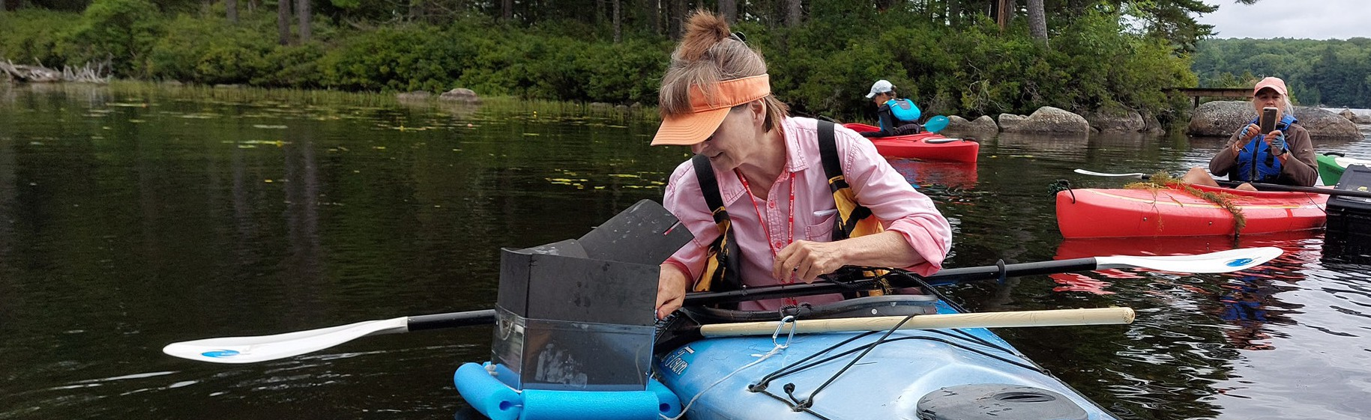
Calling all Kayakers!
The 2024 Invasive Plant Patrol Report

Toddy Ponds’ invasive plant patrollers (IPPers) were busy this summer. The crew consists of thirty dedicated individ- uals, including six new members, - YAY! (who have paddled the shores to survey for evidence of invasive aquatic plants.) With about half the reports in to date, these enthusiastic volunteers have already logged in excess of 60 hours on the water. And it’s fun! The good news is that no invasive species were identified, al- though two samples of milfoil were submitted to Lake Stewards of Maine for closer inspection and DNA analysis. Lake Stewards
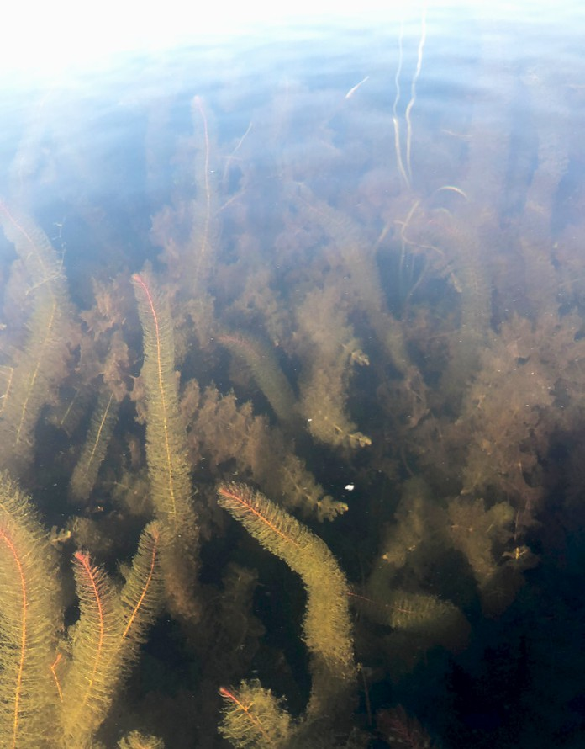
of Maine provides train- ing sessions to teach plant patrollers about both native and invasive plants. This year there were no training ses- sions in Hancock Coun- ty so TPA sponsored our own plant paddle in the Beaver cove on middle
ly hauled her kayak on her yellow car to multiple launch points on Toddy, as well as to Alamoosook Lake and beyond as part of Lake Stewards of Maine travel team. Lucy’s expertise won’t be going anywhere as she’ll continue to participate as an IPPer.
If you would like to get involved we are always looking for new volunteers.Most IPPers use kayaks, and we’ve also had people snorkel, use a paddle boat, and one person with superb balance uses a paddle board. We also need folks with small ﬁsh- ing boats or pontoon boats that can carry kayakers to distant shores or host a volunteer using a viewing scope. As beautiful as Toddy Pond is from the living room window, you will be amazed at the world under the water’s surface once you start looking. The eastern shore of north Toddy and the entirety of the shore that lies in Blue Hill are currently lacking in coverage. Once you start looking at plants you may get hooked! My husband likes to tell the story about the two of us in a canoe on Lily Pad Pond in Baxter State Park, my husband is admiring the stunning view of Katahdin - and I have my head over the side looking at plants!
Robin Yurkevicz, IPP Coordinator

Toddy and a plant ID

workshop at Lucy Leaf ’s house. Both events were well attended.
Everyone has heard about milfoil but did you know that we have ﬁve native milfoils on Toddy Pond? Mil- foils grow in shallow
water in quiet coves that are protected from wind and waves. We try to locate and monitor beds of native milfoil because in- vasive milfoil prefers the same conditions, and hybridization has been confirmed in some lakes. If you see milfoil rooted at the bottom of the pond, let an IPPer know. Invasive spe- cies have been found by recreational boaters on many lakes.
This year marks the end of an era as Lucy Leaf steps down as head of the Invasive Plant Patrol. Many thanks to Lucy who has led the program on Toddy Pond since 2015. Lucy has tireless-
CAN TPA COUNT YOU IN ? (Continued from Page 1)
THANKS to all of you who stepped up with the COUNT ME IN form at the BBQ and the Annual Meet- ing. and we have begun reaching out to folks who have iden- tified a willingness to help. We’ve got people willing to work on building TPA’s Social Media presence and our website, updating our database, and community connections. We need help with virtually every committee and would ap- preciate more board members. Can we COUNT YOU IN ?
At this time, only about 25% of folks who have places on Toddy Pond are members of TPA. With greater involvement of people with ties to Toddy TPA has a more powerful voice. We need folks who can go out and talk to and recruit new members.
Whether you’re a year-round resident or reside during the summer, we could use you. Everyone has skills they can bring to the table. Toddy Pond is home to a bright, energetic, and inter- esting group of people who have ties to Toddy. CAN WE COUNT YOU IN? Please feel free to reach out to any of our Board members.

Bob Allen Dede Carleston Andrea Schober
Terrie Perrine
William and Janet Martin Sarah Levy
Karen and Bob Gross
Robyn and Kurt Silberstein
Rachel Rosa David Baron Courtney Weaver
Linda Jellison
Jeff and Lori Roth Robin Yurkevicz

Dave and Betty Parsons
Many thanks to our 2024 IPP volunteers !
Chris Dadian

Phil Tardiff Daniel Cooke
Doug Randolph Gaye Marie Rogers
Yvette and Richard Tenney Lucy Leaf
Rob Giffin Courtney Swazey Mark Whiting

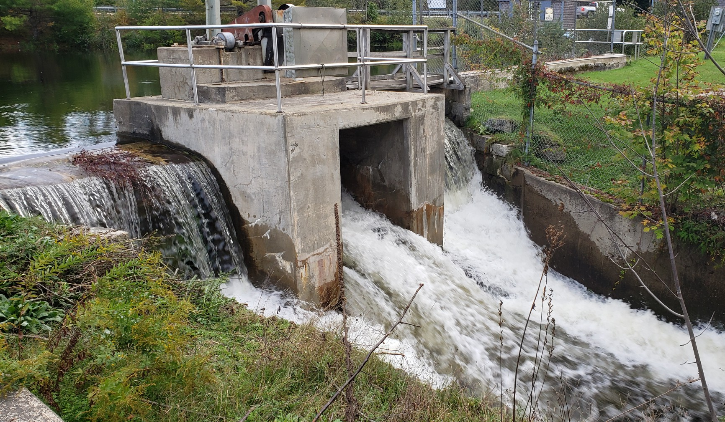
Orland Watershed Committee
The Orland Watershed Committee has been functioning as an extension of efforts to preserve the waters of Alamoosook Lake and Toddy Pond. Our most recent efforts surround identifying similar lake organizations who control and or own their dams
as well as trying to determine the economic impact of our lakes on our communities. Originally created in response to Orland’s Comprehensive Plan and a desire to protect and preserve Orland’s watershed, the committee’s immediate goals are the preservation of the dams on Toddy Pond and Alamoosook Lake as
well as repairing the Orland River dam and potential-
ly improving its fishway. Long term, the committee will be seeking a means to protect and preserve the entire Narramis- sic Watershed through cooperative arrangements with the 7 towns and multiple lakes and lake associations within that watershed. We meet on the third Tuesday of the month at 6:30 pm at the Orland Fire Station. Anyone is welcome to attend. Marc Restuccia, Chair
Your town needs to hear from residents, and those folks who have properties on the ponds.
Five Town Committee
The 5 Town Committee (Blue Hill, Bucksport, Orland, Penobscot and Surry, plus Toddy Pond Association and Alamoosook Lake Association) continue to meet bi-weekly and look for ways to preserve the three dams, and the ponds.
Bucksport has engaged their own law firm, while the other 4 towns have agreed to be represented by a single law firm and have agreed on a shared payment structure.
Each town has scheduled a public meeting to discuss the dam ownership issue. The TPA website has them posted. The group’s consensus is that all three lakes represent a high level of economic activity, recreational opportunities, wildlife habitat and munic- ipal needs to be allowed to be abandoned. Each member has pledged to work within their own towns, and with local, state and federal elected officials to find a viable solu- tion to the ownership question. Every joint meeting synopsis is posted on each town’s website, and can be found on the Toddy Pond Association website.

Bucksport Mill, LLC/Aim Demolition USA LLC
Petition from Bucksport Mill, LLC/Aim Demolition USA LLC for release from dam ownership
On Oct. 18, 2024, The Department of Environmental Protection (DEP) received a petition from Bucksport Mill, LLC/AIM Demo USA LLC for release from ownership of the Silver Lake dam in the Town of Bucksport, and the Alamoosook Lake dam and Toddy Pond dam in the Town of Orland. The petition process is governed by the provisions of 38 M.R.S. 901-909.
The petition was accepted for processing on Nov 2. This process is now in the consultation phase which includes public meetings with the towns. AIM held its public consultation on Nov.14, 2024 in Buck- sport. More than 200 concerned citizens attended and presented ques- tions to AIM about water rights, current company ownership, public safety concerns, conditions of the dams, and past maintenance of the dams. Many more questions related to community concerns, water lev- els, wildlife, and others. These concerns need to be presented to the DEP. AIM provided no answers at the meeting. David Bryant proj-
ect manager at Bucksport Mills LLC said the answers to the evenings questions will be found at this website: bucksportmillanswers.com That website also contains a form for any other questions that people have for AIM, and will be accepted through Dec. 2, 2024.Please be aware that this petition is not a permit application and is not subject to the De- partment’s Ch.2 Rules concerning the processing of the application.
Anyone with concerns can contact the DEP. The key is to state that you are “a party of interest” in the petition by AIM/bucksport Mill. Contact information for Laura Paye who is coordinating the petition process: Laura Paye (she/her)
Hydropower Coordinator Bureau of Land Resources
Maine Department of Environmental Protection
(207) 219-9563
laurapaye@maine.gov

MANY THANKS to Peggy and Bill Mitchell of Camp Nokomis for their generous donations. Their contributions help facilitate the Courtesy Boat Inspection program for the benefit of all.
Thank you to our anonymous donors.

Catherine Davis-Tilton Central Maine Auction Center 44 Concord Drive
Hermon, ME 04401
Phone: (207) 848-7027
Mobile: (207) 745-8546
CMAuctionCenter.com

A Huge THANK YOU to all our Sponsors and Contributors!
Your business support is tax deductible. Consider becoming a TPA contributor at $100 or a sponsor for $250. Our newsletter reaches approximately 550 pond residents twice a year. Contact: toddymail@toddypond.org














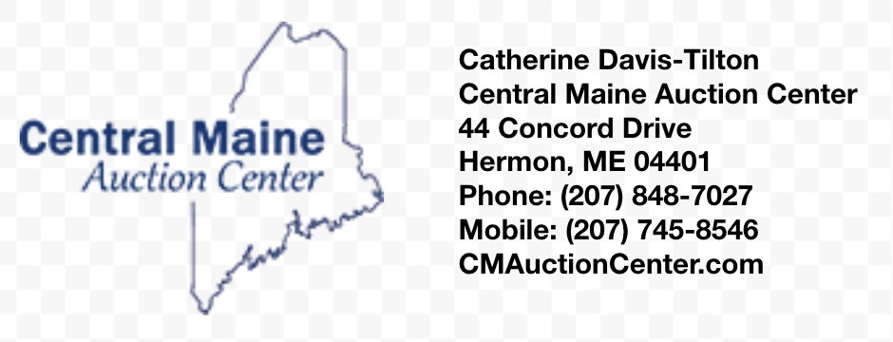




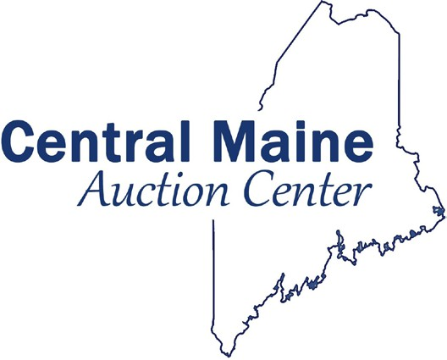


Toddy Pond Association 6
toddypond.org

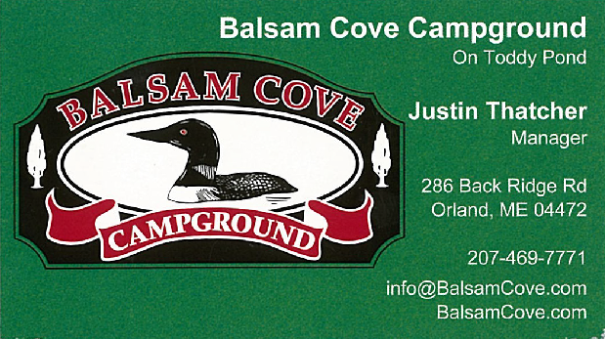
TODDY MARKETPLACE
All Proceeds Support Toddy Pond Initiatives
INQUIRE TODAY AT

toddymail@toddypond.org

$20


$15
$22
$20
$25

Toddy Pond Loon Count Update
Enjoying pretty much ideal conditions, 22 volunteers took to the Toddy Pond waters from
$25
7-7:30 AM on Saturday, July 20 to conduct the 42nd consecutive loon count. Similar counts took place throughout Maine, all coordinated by Maine Audu- bon in their efforts to monitor the health of Maine’s loon population. This year’s total of 22 adults and 2 healthy chicks is slightly above average and seems to indicate our population is stable despite the threats facing them. Foremost among those threats are our resident bald eagles, who took at least three young loon chicks this summer. Lead poisoning and avian flu are also of concern.
$20
$22
The count is a lot of fun, while also making a valuable contribution to citizen science. We could use a couple more volunteers next summer to help ensure full coverage of the pond, especially north Toddy. If you are interested in participating in next year’s count, scheduled on July 19, 2025, please send me an email at leafan@comcast.net.
Steve Antell

Toddy Pond Association Board

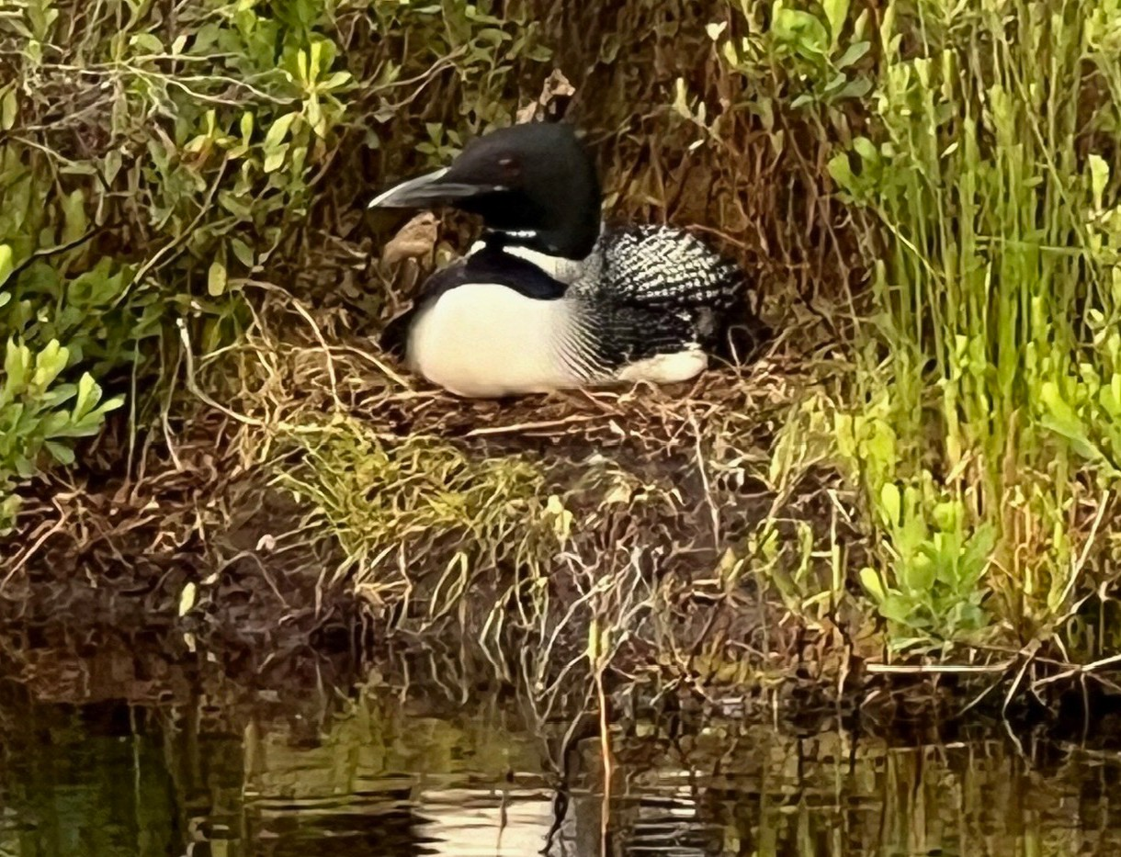
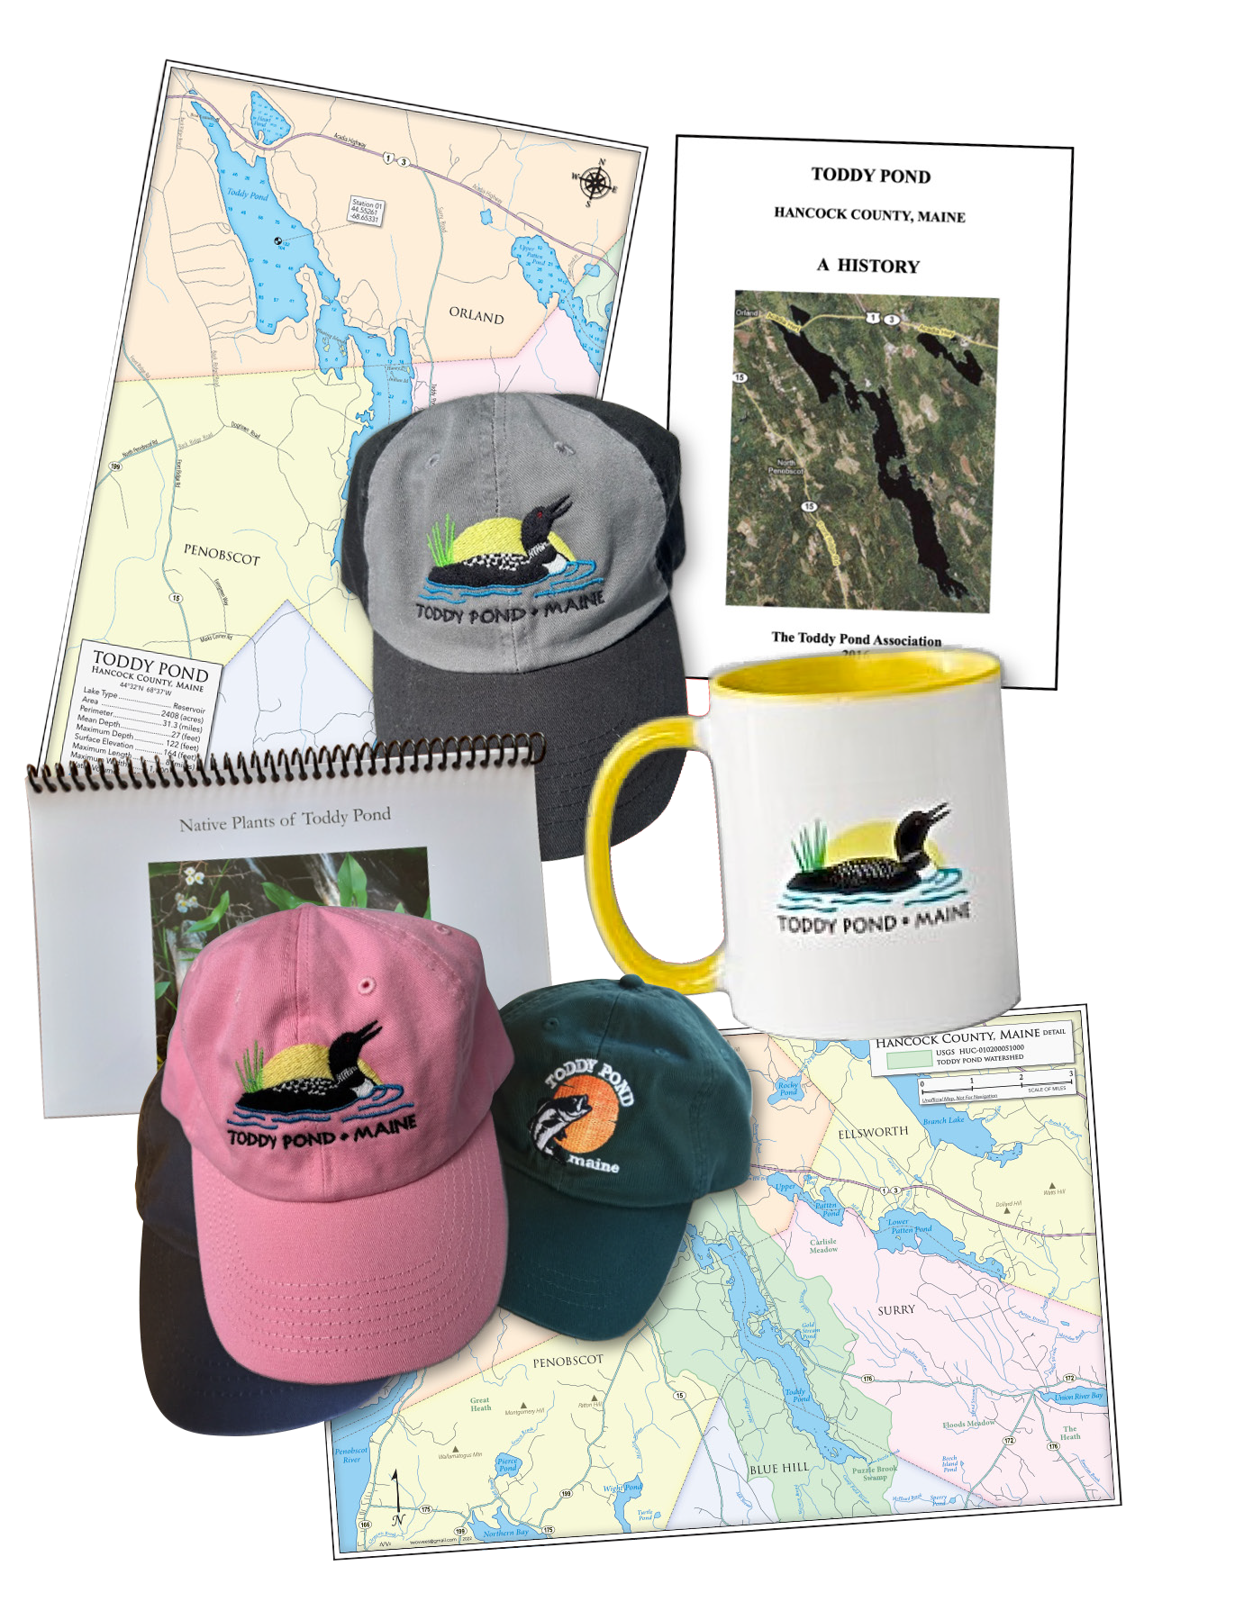
President. Marc restuccia
Vice President Christopher Closs
Treasurer Barry Johnson
Secretary Robin Yurkevicz
Toddy Pond Association 7
5
Board member John Moss
Board member Brian Smith
Board Member Phil Roberts
Board Member Donna Foster

toddypond.org


Toddy Pond Association PO Box 645
NONPROFIT ORG US POSTAGE PAID
PERMIT 46 BANGOR ME
Blue Hill, ME 04614

ADDRESS SERVICE REQUESTED



