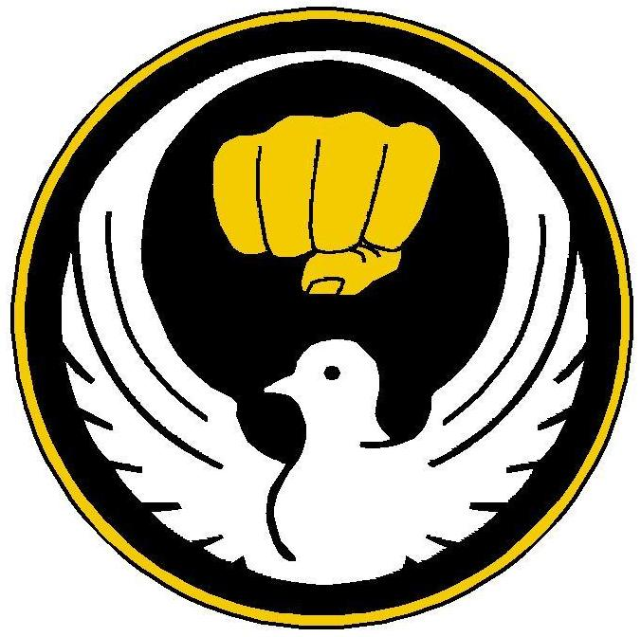
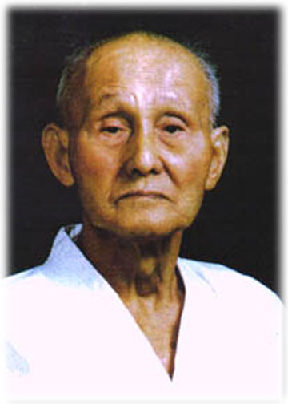
Wado-Ryu
The name Wado-Ryu has three parts: Wa, dō, and ryū. Wa means "harmony," dō means "way," and ryū means "style." Harmony should be interpreted that yielding to an attack is more effective than opposing and attack.
The Founder and Key Principles
Grand Master Hironori Otsuka (1892 - 1982), the founder of Wado Karate studied the martial arts for 85 years, ending his illustrious career as First Generation Karate-do Master of 10th Dan; the greatest title that can be achieved in martial arts.
A key principle in Wadō-ryū is that of “tai sabaki”. The Japanese term can be translated as "body-management," and refers to body manipulation to move the defender as well as the attacker out of harm's way.
Wadō-ryū moves from the balls of the foot rather than the heel, which affects the delivery of almost every technique, the stances and the kata. It makes the style fast and fluid. The style is not based around strength therefore making it ideal for anyone to take up and become proficient.
Japanese Terminology
Karate training is generally taught in Japanese. This is for two reasons; the first being out of respect for the masters who developed and passed on their knowledge but primarily it is used by all karate parishioners so that everyone understands the names for the techniques regardless of what language they speak or country they train in.
Training
Training takes many forms in martial arts but without exception all systems start with good basics. In karate these are called “Kihon Waza”. With a good foundation in basics you will learn combination techniques which are called “Renwraku Waza”. After a period of training and if your instructor feels that you are ready you will start working with a partner which is called “Kumite”. Kumite can be in many forms first you will learn fixed drills with a partner to improve your distance and timing before moving on to free sparring.
Kata
Probably the hardest part of your training in Karate will be when you start to learn “Kata”. Kata’s are a series of fixed techniques and stances that are put together in a practical sequence to drill self defence techniques. Wado Ryu karate has 9 official kata but 15 kata are practiced in total. You will start to learn Kata after attaining your 8th Kyu Yellow belt. Hironori Otsuka said of the Kata Naihanchi it would take more than one lifetime to master, and that’s just one Kata.
Belts and Ranks
Wado-ryu uses a typical karate belt system, beginners commence at 8th kyu and progresses to 1st kyu then from 1st dan to 5th dan black belts for technical grades. The ranks of 6th–10th dan are honorary ranks.
8th Kyu | 7th Kyu | 6th Kyu | 5th Kyu | 4th Kyu | 3rd Kyu | 2nd Kyu | 1st Kyu | Shodan
Yellow | Orange | Green | Blue | Purple | Brown | Brown White Stripe | Brown Red Stripes | 1st Black Belt

Counting
One | Ichi
Two | Ni
Three | San
Four | Shi
Five | Go
Six | Roku
Seven | Shichi
Eight | Hachi
Nine | Ku
Ten | Ju
Some Japanese words to practice.
Stances and Techniques
Hidari hanmi gamae | Left stance
Migi hanmi gamae | Right stance
Musubi Dachi | Formal attention stance
Shiko Dachi | Straddle leg stance
Zenkutsu Dachi | Front stance
Gedan Barai | Downward block
Uchi Uke. | Inside forearm block
Soto Uke | Outside forearm block
Jodan Uke | Upward block
Gyaku Tsuki | Reverse punch
Kizami Tsuki | Jab punch
Mae Geri | Front snap kick
Mae Washi Geri | Roundhouse kick

