

2020 5th Annual Holiday Trio Bowling Tournament

November 7th – November 29th

4 Weekends

Park Ten Lanes

4393 Park Ten Dr. Diamondhead, MS

(228)255-9973

**Shift Times**

Saturdays 1pm 3:30pm

Sundays 10am 12:30pm

***November***

***7 14 21 28***

***8 15 22 29***

01

**$5,325.00 Based on 100 Entries**

**1 $1000.00**

**2 $500.00**

**3 $325.00**

**4 $325.00**

**5 $325.00**

**6 $300.00**

**7 $300.00**

**8 $300.00**

**9 $250.00**

**10 $250.00**

**11 $250.00**

**12 $175.00**

**13 $175.00**

**14 $175.00**

**15 $150.00**

**16 $150.00**

**17 $150.00**

**18 $75.00**

**19 $75.00**

**20 $75.00**

$1,000.00

1St Place

Guarantee

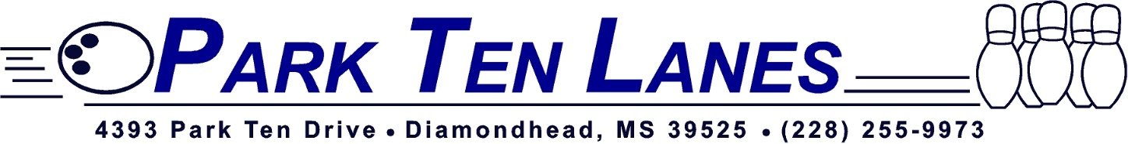

**HDCP 90% of 220**

**Use Highest 2019-2020 book Average (No Summer)**

**Bowlers without a book average will use 220**

**$5,325.00 Prize Fund based on 100 entries**

**Multiple entries allowed but you can only cash once with the same 3 bowlers**

**ALL USBC RULES APPLY**

|  |  |  |
| --- | --- | --- |
|  | **Shift Day** | **Shift Time** |
| **1st Choice** |  |  |
| **2nd Choice** |  |  |

|  |  |  |  |
| --- | --- | --- | --- |
| Bowlers Name | USBC # | Average | Phone Number |
| 1. |  |  |  |
| 2. |  |  |  |
| 3. |  |  |  |



**Entry Fees**

**$75.00 Per Team**

**$53.25 Prize Fund**

**$15.75 Lineage**

**$6.00 Expenses**

**$75.00**

$45.00 Prize Fund

$9.00 Lineage

$6.00 Expenses

**$60.00**