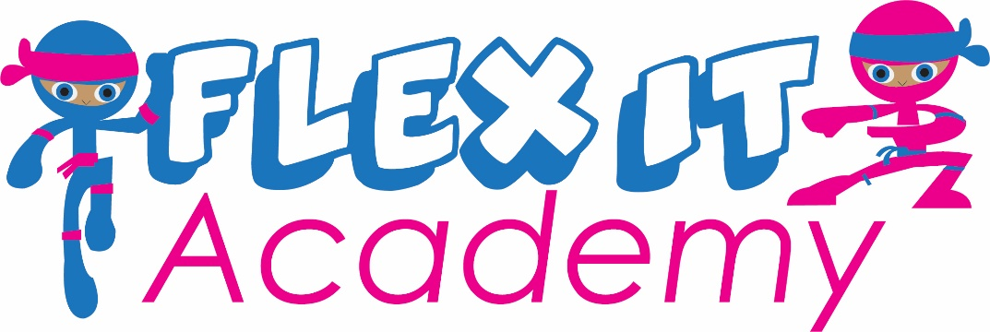

Helpful Information for us:
Please email us your responses at Denise@flexitacademy.com

- What is your name and email address?
- What grade is your child in?
- Does your child have an IEP/504 Plan?
- Where are you located (City)?
- Would you like to see a campus opened near you?
- Do you currently have the Empowerment Scholarship Account (ESA) for your child?
- Would you like to tour one of our campuses?

Thank you!

