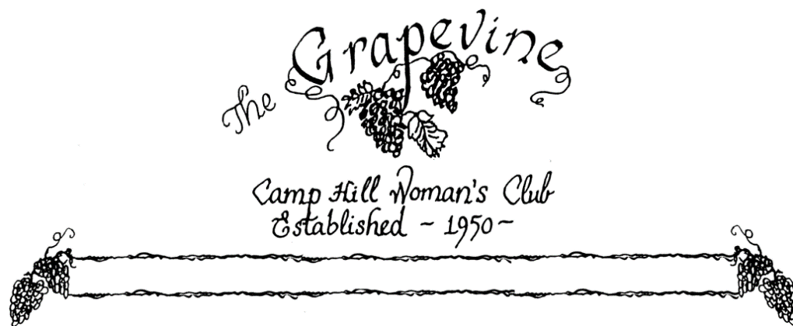

Volume 69 Number 9 May 2017

President’s Message
Dear Ladies,
It is so hard for me to believe this is my last month as president. The year has flown by! I hope you all enjoyed the club year as much as I did. And I hope you will come and celebrate the year at our luncheon on May 9th. I know the club will be in good hands with Rose at the helm next year, and have faith she will get a lot accomplished. Have a great summer and think about the proposed idea of extending our club year through the summer, and maybe taking December and January off so we don’t deal with the cancellation factor.
I really enjoyed each and every one of you ladies and look forward to working with you and getting to know you better.
Remember:
You Are Beautiful in Your Own Way
You Are A Blessing to Your Family and Friends
And
Your Life Looks Good on YOU!!
Your President (for a few more days)
Lori

End of Year Club Activities
The May Luncheon- Peggy Greene & Janet Kissinger, co-chairs
Date: May 9, 2017 Price: $20.00 Place: Susquehanna Club- River Room/ New Cumberland Army Base Time: Meet & Greet- 10:30-11:30 am / Bar 11:00-12:00 / Buffet lunch 11:30- 12:30 * Ice tea and non-alcoholic punch will be available / Entertainment: Lewis Lynch playing the Pauly Harp 11:00- 12:00
Make checks payable to: Camp Hill Woman’s club. Bring payment to the April meeting or send to: Peggy Greene, 2219 Page St, Camp Hill, 17011. Deadline: extended to May 1.
Directions: Go on Bridge Street through New Cumberland, at the end of town, drive over the iron bridge, at the light (at the end of the bridge) turn left on Ross Ave. Continue all the way on Ross till you come to the unattended gate, and left into the parking lot. If you need handicap parking bear left to the street side of club, there’s a ramp to the 2nd floor, and we will be in the River Room. Ladies should try to carpool if possible. We hope all of you will come. Contact Peggy or Janet.
Peggy’s phone #- 763-1789 Janet’s phone#- 761-2364
Bus Trip: Maryke Clark, Sue Watchorn &Beryl Shuker
Ladies don’t forget the bus trip in June!! Same week as Memorial Day
Destination: Flight 93 Memorial in Shanksville, PA
Date: June 1, 2017
Cost: $50.00- make checks payable to CHWC- give to Beryl
Please pack a lunch ( yes, we’re going to” brown bag” it) and we will stop along the way, perhaps Old Bedford Village or nearby state park to enjoy our lunch. Dinner will be at the Jean Bonnett Restaurant ( each at our own expense/ separate checks). We would like to leave a tribute from the CHWC at the Memorial, so if you have any ideas, please contact Maryke, Beryl or Sue. The bus holds 30 passengers and has a rest room. Friends are invited to come along.

Membership news- Betty Geeting will be moving to Connecticut and won’t be returning next year. We are so happy for the time we shared with her. Good luck with your move!!!!

Committee News-
Memorial Day Parade- Yes it’s that time of the year!!! Get your red, white and blue on, show your love and spirit for Camp Hill and the CHWC. We meet in Trinity Lutheran’s parking lot around 9:00- 9:30. The parade starts at 9:30. If you like bring candy to throw to the kiddos along the route!! It’s fun and it really isn’t a hard walk, mostly downhill. If you have any questions contact Liesl Beckley.
Publicity- Nancy Lemmons, Chair
Please keep Beryl Shuker in your thoughts and prayers. She has had a cardiac stent procedure done this past week. And send her a card to lift her spirits – 315 Pinewood Drive, Shiremanstown, PA 17011. Also, Evie Cleckner just had a total knee replacement. Her address: 26 Circle Place, Camp Hill. Phone # 737-2788- Give her some support as well!!!
Some Sweet Thoughts…….
THANK YOU- My Dear Friends of the CHWC, I’d like to extend a sincere THANK YOU to all of you for the many cards, prayers and food following the death of my youngest brother, Danny. Sincerely, Nina Mattern

My heartfelt thanks for the many cards, flowers, visits and get well wishes during the month of April when I “celebrated” my birthday and battled heart problems. Just knowing you care makes me feel better. I hope to see you soon!! Beryl

The Treasurer’s Report-
The balance as of March 5, 2017: 9634.69
receipts: 753.93
disbursements: 1449.00
The balance as of April 4, 2017: 8939.62

*** The treasurer is asking that when you send checks, please put in the memo what the payment is for. It’s important to make sure your money is going in the proper area- dues, events, donations, etc ***
President: Lori Heenan President-Elect: Rose Falco
Vice President: Jocelyn Erway Recording Secretary: Maryke Clark
Corresponding Secretary: Amy Barrick Treasurer: Beryl Shuker

