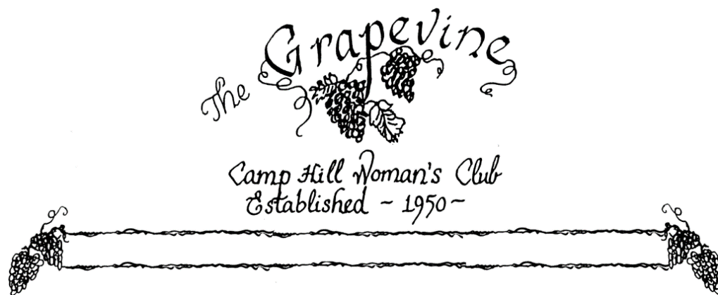

Volume 70 Number 1 September 2017

**President’s Message**

**Welcome Back!!!  
Our first meeting on September 12th promises to be a fun evening with catering of delicious food and friendship renewal.  
We already have plans in the works for a great year, starting with our Italian Dinner on October 20th, followed by the Fashion Show on November 18th and Bingo on April 14th. Be sure to invite your friends to join us for these fund raising events. Our Mission is to help those in need. Let’s continue our good work and Bring JOY!  
Membership is open. Let’s grow our group. Bring your friends and neighbors.  
See you all on the 2nd Tuesday in September at 6:30 PM.**

**Rose Falco, President**

**September Club Activities**

**Social committee, Alice Lucas, chair*:* Your Social Committee has come up with a new idea this year. Your September 12th meeting is going to be a catered affair by Sir D’s Catering. Most importantly, there will be NO COST TO YOU. Bring nothing but yourself- no covered dish, no place setting, no dessert, etc. This is a gift from your Board of Directors.  
Dinner will be served at 6:30. Your Telephone Committee will be contacting you prior to Thursday, September 7th for your reservation. None will be accepted after this date. You may also contact the Telephone Committee members- Carole Ward, Loma Slike, Jo Mitchell, Anne Picirilli, Sue Watchorn or Nina Mattern. Phone numbers and email addresses are in the yearbook. This will be a fun evening, we hope you all can make it!!!! (Menu- Sliced chicken breast with sauce & Flounder stuffed with lump crabmeat- plus salad, starch and vegetables, rolls, etc. With various desserts)**

**Pinochle Group, Linda Ross, chair:** Our group meets at Isaac’s in the West Shore Plaza the 2nd Thursday of each month. We welcome all new members who wish to play. If you wish to play or be a substitute, either way please join us for lunch & cards. Linda’s phone # home: 761-1923, cell: 303-9986.

Lunch Bunch- details for September will be announced **at the regular meeting.**

**\*\*\*\*\*\*\*\*\*\*\*\*\*\*\*\*\*\*\*\*\*\*\*\*\*\*\*\*\*\*\*\*\*\*\***

**REMINDER –Make sure to pay your dues- $30.00. In order to receive this year’s book/directory you need to pay your dues. The deadline for your dues is by the December meeting.**

**********************************

**Membership news-** We have a new member, Gail Ismart. Gail lives at 881 Mandy Lane, Camp Hill, PA 17011. Phone # is 717-737-1122, her email address is, [GISMART@MAC.com](mailto:GISMART@MAC.com). She is sponsored by Lynne Jackson. Welcome Gail when you see her. We are thrilled to have her!!!!

**Committee News-**

**Program-**Jo Mitchell, Chair: The program in September will continue our “Getting to Know You” theme used last September; which was so much fun. Connie Miller, Helen Sajer, and Jill Williamson will share with us the service programs which have fulfilled their lives. These 3 women have given countless hours to problem solving, event organization, and personal interaction. Our community, our country, our world have all benefitted from their dedication. Come and get to know them better!!!

**Publicity- Nancy Lemmons, Chair:** Please let Nancy know if you need to get the word out!! If you know of an event, a member celebrating, or dealing with a health, or personal problem and need support and cheering, give Nancy the details, and she will let us all know. Nancy’s number is 590-7278. Her email address- [nabu426@comcast.net](mailto:nabu426@comcast.net).

**Personal Outreach- Nancy Novinger, Chair:** Let Nancy know of anyone that needs a card for cheering up while dealing with any personal issues.   
Over the summer Terri Dennison and Irene Oravecz both had knee replacements. Nancy Novinger, the chair, broke her leg while on vacation. And Ellie and Tom Hamm are dealing with health issues. It’s never too late to send a card. I’m sure they would all appreciate the love.

**Website:** The CHWC site is up and running! Have a look at [www.chwclub.com](http://www.chwclub.com). We are also on **Facebook.** Make sure to **“like**” our **Facebook page**, comment on items and share anything you might want all to know. Help to get the word out about the club.



**Future events:**

**Italian Night Fundraiser!!!-** October 20 at 6:00 PM. Reservations by October 17- please call Mary Ann Bedway 717-761-2361 or Helen Sajer 717-761-4017. Lasagna/ Salad/ Bread/ Desert- BYOB. Pay at the door- take out available. Nancy Lemmons has flyers if you need them.

**Fashion Show Fundraiser!!!-** November 18, tickets are $35.00, deadline for reservations November 1st. This year’s show will be at the Susquehanna Club at the New Cumberland Army Depot. We start at 10:00 with social, with lunch and fashion show to follow. Mark your calendars, bring your friends and family. Christopher & Banks will be doing this year’s fashions. Contact Lori Heenan or Jocelyn Erway if you have any questions.

**The Treasurer’s Report-** The balance as of April 4, 2017: 8879.22( revised)  
 receipts: 3968.00  
 disbursements: 6679.55  
The balance as of May 5, 2017: 6167.67

***\*\*\* The treasurer is asking that when you send checks, please put in the memo what the payment is for. It’s important to make sure your money is going in the proper area- dues, events, donations, etc \*\*\****

**~President: Rose Falco ~President-Elect: Joann Bobincheck**

**~Vice President: Jocelyn Erway ~Recording Secretary: Maryke Clark**

**~Corresponding Secretary: Joy Cruttenden ~Treasurer: Amy Barrick**

