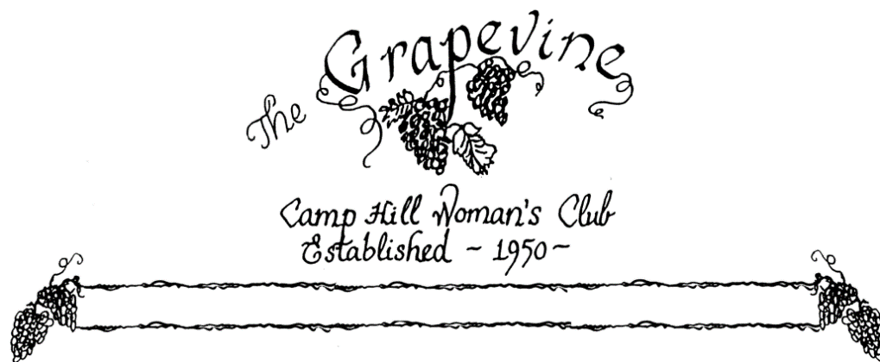

Volume 70 Number 3 November 2017

President’s Message
October has been a busy month!
We kicked off our fundraising with our participation in the Friends Helping Friends sale, enjoyed an Italian Dinner, had lunch at a Greek restaurant, and went on a day trip to the Lehigh Valley Gorge Railroad. Thank you so much to Nina Mattern, Helen Sajer, Carol Staz, and Maryke Clark and all their Committee members who made these events happen.
As we move onto November, Lori Heenan and Jocelyn Erway are working with their committee on the Fashion Show. This is a major fundraiser and it promises to be spectacular with all its “Glitz & Glam”. You don’t want to miss it!
The Holidays are fast approaching. Let’s continue to spread the JOY to those less fortunate with our donations, hard work, and participation in our activities. It’s what we do best.
Rose Falco, President
November Club Activities
Social committee, Alice Lucas, chair: Thank you to everyone who came early to our October meeting to help with our preparations for our dessert. It’s much appreciated. Hostesses for our November 14 meeting will be Nancy Novinger, Harriet Edsall, and Joan Gusic. Please plan on being early that evening so that we can prepare the desserts. Here’s hoping you’ll like the refreshments we’ve planned for the evening. Looking forward to seeing you. Clean up for the evening is Darlington- Gusic.
Pinochle Group, Linda Ross, chair: The Pinochle Group meets the 2nd Thursday of each month at the West Shore Country Club. We currently have maximized the number of regular players, but we welcome everyone and will gladly put you on our wait list or as a substitute. Please call or email me if you wish to be put on our list, of if you have any questions. 761-1923- linross1980@gmail.com.
Lunch Bunch, Carol Staz, chair: This month’s Lunch Bunch will meet for dinner on Saturday, November 11, 2017 at 6:00 PM at Chalit’s Thai Bistro- 5103 Carlisle Pike, Mechanicsburg. We hope to see and share time with the folks that can’t make our Wedneday lunches. Call Carol for reservations and questions- 717-761-4883.

***********************************
*****REMINDER –Make sure to pay your dues- $30.00. In order to receive this year’s book/directory you need to pay your dues. The deadline for your dues is by the December meeting.
**********************************
Membership news-Corrections for the yearbook-
-ANNE SCHRIVER, 325 WESLEY DRIVE, APT 3321, MECHANICSBURG, 17055
-KAE HOLMES- has a new address, she has moved to Homeland, and all of her mail is going to her daughter- Lynn Conway. Her new address is: 118 THOMAS STREEET, HARRISBURG, PA 17112. HER ROOM # AT HOMELAND IS: 209A.
-AMY BARRICK, 1908 LOGAN ST (NOT CT) - albarrick7967@gmail.com (lowercase “a” not uppercase)
Please make a note of these corrections. Also let me know if there are any others- Jocelyn Erway- 117jocelyn@gmail.com- or 717-212-2118
-Dee Parker has resigned from the club. Her husband has been ill for some time. Give her a call and keep in touch with her, I’m sure she would appreciate it.

Committee News-
Program- Jo Mitchell, chair: Our speaker is Mary Ann Milok, PHD, RD, Associate Professor Emeritus of Nutrition and Dietetics at Messiah College. Mary Ann will address the issue of Diet needs in the Older population, especially women. If you attended last month’s meeting a survey was distributed & provided to her. She will review the topics identified on the results. Perhaps we will find that what we ate at 30, 50, or even 60 is not what is best for us now or is it? Please attend and find out the correct answer- Carol Staz.
Publicity- Nancy Lemmons, Chair: Please let Nancy know if you need to get the word out!! If you know of an event, a member celebrating, or dealing with a health, or personal problem and need support and cheering, give Nancy the details, and she will let us all know. Nancy’s number is 590-7278. Her email address- nabu426@comcast.net.
Personal Outreach- Nancy Novinger, Chair: Peggy Greene shared that her daughter is dealing with pancreatic cancer. Keep Peggy and her daughter in your prayers.
THE Website: The CHWC site is up and running! Have a look at www.chwclub.com. We are also on Facebook. Make sure to “like” our Facebook page, comment on items and share anything you might want all to know. Help to get the word out about the club.
Community Service- Sue Watchorn, chair: Eileen Wolf is asking for help for an event that is taking place with the Children’s Cancer Recovery Foundation. Saturday November 11, 10:00 am- 2:00 pm, they will have a table set up at the Capital City Mall to help kick off the holiday season. They need some volunteers to hand out shopping lists & brochures for toys needed, and to help sort the toys as the receive them. If you would like to help, please contact Eileen- 717-658-8152.

November events
Fashion Show Fundraiser!!!- November 18, tickets are $35.00, deadline for reservations is November 10th. This year’s show will be at the Susquehanna Club at the New Cumberland Army Depot. We will start with the Social at 10:00 am, show starts at 11:30, followed by lunch at 12:30. The lunch will be served, not a buffet. This year’s theme is “GLITZ & GLAM”. Please contact Lori or Jocelyn for tickets, or send your checks to Jocelyn. We will be selling tickets prior to the board meeting which is Thurs November 9th. We will be at the borough building at 6:00 PM before the meeting. This is one our major fundraisers. Mark your calendars, bring your friends and family. Christopher & Banks will be doing this year’s fashions. Contact Lori Heenan- 717-215-9014 or Jocelyn Erway- 717-649-3231 if you have any questions. Jocelyn’s address- 117 Lakeside Dr, Lewisberry, 17339.

BonTon Lend a Hand- Rose Falco and Nina Mattern are involved with another fundraiser, much like Boscov’s Friends Helping Friends. Lend a Hand will be held Nov. 8th-11th. If we sell their coupon books, we keep the entire $5.00 and may be eligible for a Bonus depending on how many books we sell. We made over $400.00 from our Boscov sales. Since this event takes place before our next meeting, our profit will come mostly from in store sales. We will be at the BonTon selling coupons several days prior to and on the 4 day sales days. You can buy your book either by calling Nina Mattern or Rose Falco, or stop by our table at the BonTon. Rose will get you a schedule as soon as we have it. Anyone interested in sitting at our table, please call them. This is short notice, but it’s an easy way to earn money for our charities and great savings on your Christmas shopping… over $500.00 in coupons.
** A friendly reminder: if you are unable to attend any of the fundraisers, members are still expected to donate the cost of the ticket to the club. This is a by-law. Thank you*****

Miscellaneous items
From October’s program- Jo Mitchell wanted to share some tips for independent living as we get older- for aging in place, it is important to check flooring for- dangerous throw rugs( remove them), peeling or loose floor tiles, and loose door sills. Also, if stairs are getting more difficult, get some advice from the Center for Independent Living, call Ann- 717-460-5748 or get estimates form 3 chair lift installers.
From Helen Sajer, Italian Night- A HUGE “THANK YOU” TO ALL WHO HELPED WITH THIS SUCESSFUL EVENT. Patricia Baughman, Maryke Clark, Chris Gubicza, Merry Hitchcock, Nina Mattern, Anne Piccirilli, Shirley Wilson, Maryann Bedway, Dot Forrey, Alice Lucas, Nancy Novinger, Beryl Shuker, Carol Staz. And additional helpers- Irene Oravecz, Jennie Johansen, Joann Bobincheck and Dolly Kostelac. Everything from setting up, serving and clean up was so gratefully appreciated and didn’t go unnoticed. With all of your help and those who came to enjoy, made it a great success!!!!!!

The Treasurer’s Report-
balance as of October 1, 2017: 5007.18
Receipts: 3695.00
Disbursements: 396.51
Balance as of November 1, 2017: 8305.67
*** The treasurer is asking that when you send checks, please put in the memo what the payment is for. It’s important to make sure your money is going in the proper area- dues, events, donations, etc ***

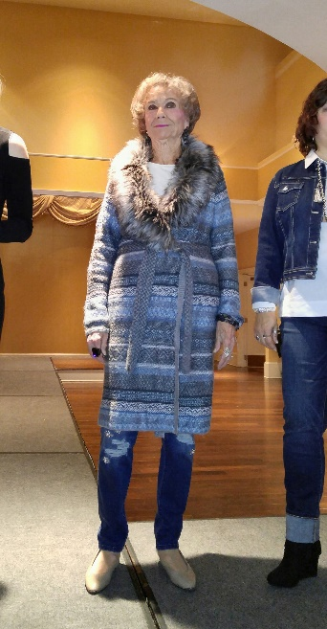

~President: Rose Falco ~President-Elect: Joann Bobincheck
~Vice President: Jocelyn Erway ~Recording Secretary: Maryke Clark
~Corresponding Secretary: Joy Cruttenden ~Treasurer: Amy Barrick

