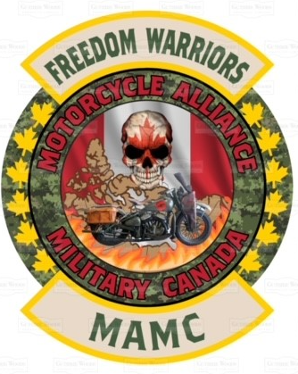 **MAMC MEMBERSHIP APPLICATION FORM**

**FREEDOM WARRIORS**

**MOTORCYCLE ALLIANCE MILITARY CANADA**

First Name

Last Name:

Military: _______ / Supporter: _______ / Partner: _______ / Affiliated: _______ / Hang Around: _______

Service Number:

Call sign / Nickname:

Address:

E-mail:

Cell Number: Home:

Sponsor / Guarantor:

**INFORMATION TO MEMBER:**

**Annual Contribution: $50**

MAMC Colors: Back Rocker MAMC Logo / Front Rocker MAMC Logo / Back Veteran and/or Canada Banners / Nametag / Front Chapter Badge / Rank Badge / MAMC Original Badge _______________$.

Important: Founder or Chapter’s President can terminate your Alliance with the MAMC and/or seize your Rockers/Banner’s at all times if not in conformity with all MAMC “ROE”. Honor and loyalty towards all members of this Alliance are imperative at all times. If you leave our Alliance in “Good Standing” you can keep your MAMC Patches. However, it is forbidden to wear them.

**Definitions /Requirements:** *Military / Regular or reservist*: active or retired, having served a minimum of one year will be considered by this Affiliation. *Partner*: Common Law and/or spouse only

*Supporter*: No Military background / will have a 3-month probationary period before becoming a full patch MAMC member. The chapter/table shall vote and reach a unanimous / The *Prospect* will wear only the front patches for the first 3-Months. *Affiliated / Hang Around*: Member of any category, other riding clubs i.e. MC, RC, Association etc. with more than 3 years in and without motorcycle

**CLAUSE OF DISCLAIMER / WAIVER:**

I acknowledge that, by committing myself to become a MAMC Member and/or to participate on a motorcycle ride in an event organized by MAMC, which I assume full responsibility for any incident and/or accident caused by myself or a third party that may occur during such motorcycle ride or event. Therefore, I acknowledge and agree that any representative, organizer, member, partner, supporter or affiliate of the MAMC will not be liable in any way for damages to the property or any injury, to others and/or I may have suffered during a motorcycle ride or event of the MAMC that may be caused by negligence.

I understand and acknowledge that all members of MAMC participate at these activities at their own risks. While attending the Motorcycle ride or an event, I agree to be filmed or photographed and that my face and my voice can be found on different social media.

**MAMC Member’s Signature: ____________________Chapter: _________________ date: __________**