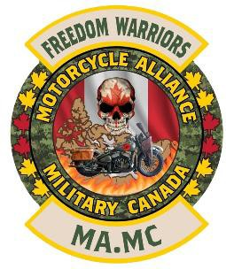

Oath
Freedom Warriors MA.MC
Heroes Sanctuary Office, Gatineau, Qc

I do hereby declare that I will be faithful and bear true allegiance to the motorcycle club “The Freedom Warriors” and that I will support its constitution. I solemnly promise that I shall be loyal to all veterans and civilians within this family, and to all other veteran’s associations. I shall conduct myself with dignity and honor while representing The Freedom Warriors (MA.MC) and refrain myself from any criminal activities.

SIGNATURE: _____________________________

Date: _____________________________

Location: __________________________

WITNESSED / CONFIRMED:

Chapter’s President Signature

A.MC President Signature

