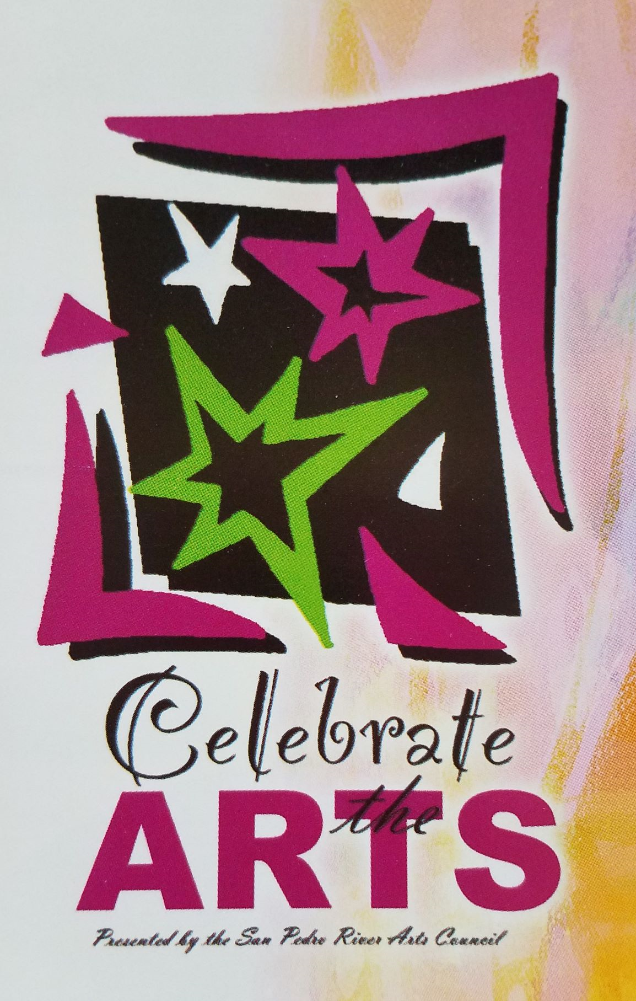
SAN PEDRO RIVER ARTS COUNCIL
14TH ANNUAL JUDGED CONTEMPORARY / FINE ART SHOW
For the entire month of March, 2024 at
Cochise College, 1025 AZ-90 Benson, AZ 85602
CALL TO ALL ARTISTS
Get the entry form online at: www.sprarts.org
Get new category info online at: www.sprarts.org
Get types of art accepted online at: www.sprarts.org
Get art show rules info online at: www.sprarts.org
Need help with your framing? Get the info online at www.sprarts.org
PRIZES $$$$, ribbons, cash awards. Get info online at www.sprarts.org
Need further assistance? Call Deb Warner, Celebrate the Arts 2024 chairperson: 520)9901545
Or Endeavor Art Gallery 520) 586-4630
DATES TO REMEMBER:
ENTRY DEADLINE DATE: 2/1/24 @ MIDNIGHT
RECEIVING DATE: 2/29/24 from 10AM – 3PM
JUDGING DATE: 3/7/24
CRITIQUES: 3/7/24 @ 1PM – 3PM (NOT OPEN TO PUBLIC BEFORE 1PM)
RECEPTION DATE: 3/16 from 1PM – 3PM
PICK UP DATE: 3/29/24 from 12 noon – 3:00PM (be punctual)

This year’s fine art / contemporary art judge will be Sarah Webber, international western artist.
https://www.sarahjwebber.com
This year’s 3D art judge will be Lori Giliberto, Tombstone Art Association’s Craft Director thelilacfox39@yahoo.com

