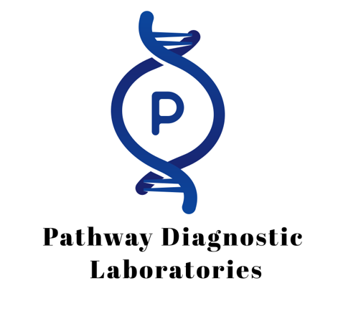

Pathway Diagnostic Laboratories

Patient FAQ – Genetic Testing

1. Who is Pathway Diagnostic Laboratories?
Pathway Diagnostic Laboratories is a fully certified clinical laboratory headquartered in New Braunfels, Texas. We provide advanced genetic testing services using Next-Generation Sequencing (NGS) technology to patients and providers across the United States. Our mission is to deliver accurate results, fast turnaround times, and comprehensive reporting to support personalized care.
You may not immediately remember completing the cheek swab collection, especially if it was done several weeks ago. Please be assured this was a real medical test ordered by a licensed telehealth provider and processed by our certified laboratory.

2. Why is genetic testing important?
Genetic testing provides valuable insights at any age. It can help detect inherited conditions, identify health risks, and guide treatment decisions. Beyond benefiting you directly, your results may also provide important information for your family members, who may share similar genetic risks.

3. How do I know this is not a scam?
We understand that receiving genetic test results in the mail can sometimes raise questions, especially if you don’t clearly remember completing the cheek swab or if a family member reviews your mail and becomes concerned. Please know that your testing is legitimate and fully regulated.
• Pathway Diagnostic Laboratories is a federally certified clinical laboratory operating under CLIA regulations and strict HIPAA privacy laws.
• The testing was performed only after a licensed telehealth provider determined it was medically necessary.
• The sample we processed was collected from the cheek swab kit you completed and returned.
• You may also receive an Explanation of Benefits (EOB) from your insurance. An EOB is not a bill — it simply explains how your insurance processed the claim. You will never receive a bill from Pathway for this test.
This test is part of your medical record and is handled with the same care and compliance as any other laboratory test.

4. Who ordered my test?
During your telehealth visit, the provider first had a wellness discussion to review your general health and lifestyle. Based on those findings, they may have transitioned into a more detailed review of your medical history to see if genetic testing was appropriate.
Genetic testing must meet certain eligibility and medical necessity requirements. In some situations, patients may not qualify. If you qualified, your telehealth provider ordered the test to ensure it was both appropriate and medically necessary for your care.

5. How was the test performed?
You should recall receiving a genetic testing kit in the mail. The kit included instructions to collect a sample using a simple cheek swab (buccal swab). As part of the process, you completed the required sections of the laboratory requisition form, including the patient consent section, and returned the kit to us. Once we received your completed kit, our laboratory extracted DNA from the cheek swab and performed advanced genetic sequencing to generate your results.

6. How long will it take to receive results?
Most genetic test results are available in 2–3 weeks, depending on the type of test ordered. Once testing is complete, the provider’s office will mail your results directly to you.
If you are receiving this FAQ and have not yet received your results, please contact Pathway Diagnostic Laboratories at 830-625-5005 so we can assist you.

7. Should I share my results with my doctor?
Once results are received, you are provided with the option to schedule a follow-up appointment with the telehealth provider to discuss your results, regardless of the outcome. Pathway strongly encourages all patients to take advantage of this opportunity to ensure questions are answered and care is coordinated.
In addition, you should also share a copy of your results with your primary care provider or specialist. This helps your healthcare team have the complete picture of your health.

8. What will the results show?
Your results may:
• Identify genetic changes linked to certain conditions
• Provide insight into potential risks for you or your family
• Help guide your provider in making treatment decisions
Your telehealth provider will explain your results in the context of your health.

9. Will I receive a bill for my testing?
Pathway currently accepts Medicare and Medicaid in certain states. If your plan does not cover the test or a claim is denied, you will not receive a bill. Patients will never receive a bill for testing performed by Pathway, regardless of insurance coverage or claim status.
You may, however, receive an Explanation of Benefits (EOB) from your insurance provider. An EOB is not a bill — it simply explains how your insurance processed the claim.

10. How is my privacy protected?
Your genetic information is handled under strict federal and state privacy laws, including HIPAA. Results are only shared with your ordering telehealth provider and anyone else you authorize. We never share your results with outside parties without your consent.

11. What makes Pathway’s testing different?
• Advanced NGS technology for highly accurate results
• Non-invasive cheek swab collection
• Clear, comprehensive reporting to support patient and family health decisions
• Experienced laboratory team focused on genetics and compliance
• Strong commitment to patient privacy and security

12. How to Contact Us:
If you have any questions or need assistance, please contact us:
Phone: 830-625-5005
Email: info@pathwaylabsdx.com
Website: https://pathwaylabsdx.com/
Address:
Pathway Diagnostic Laboratories
910 Gruene Rd, Bldg 5A
New Braunfels, TX 78130

