A Longish Term Review of H & Y’s Magnetic Filter System

Lenticular cloud over Glamaig, the hill behind our house.
The very first photo I took with the H & Y filter system.
Filter used: 3 stop soft GND.

Probably my favourite shot taken using the H & Y system. In bitterly cold winds waiting for the clouds to, hopefully, clear the H & Y magnetic system came into it’s own; quick to set up and adjust even when wearing gloves. Filter used 4 stop soft GND.

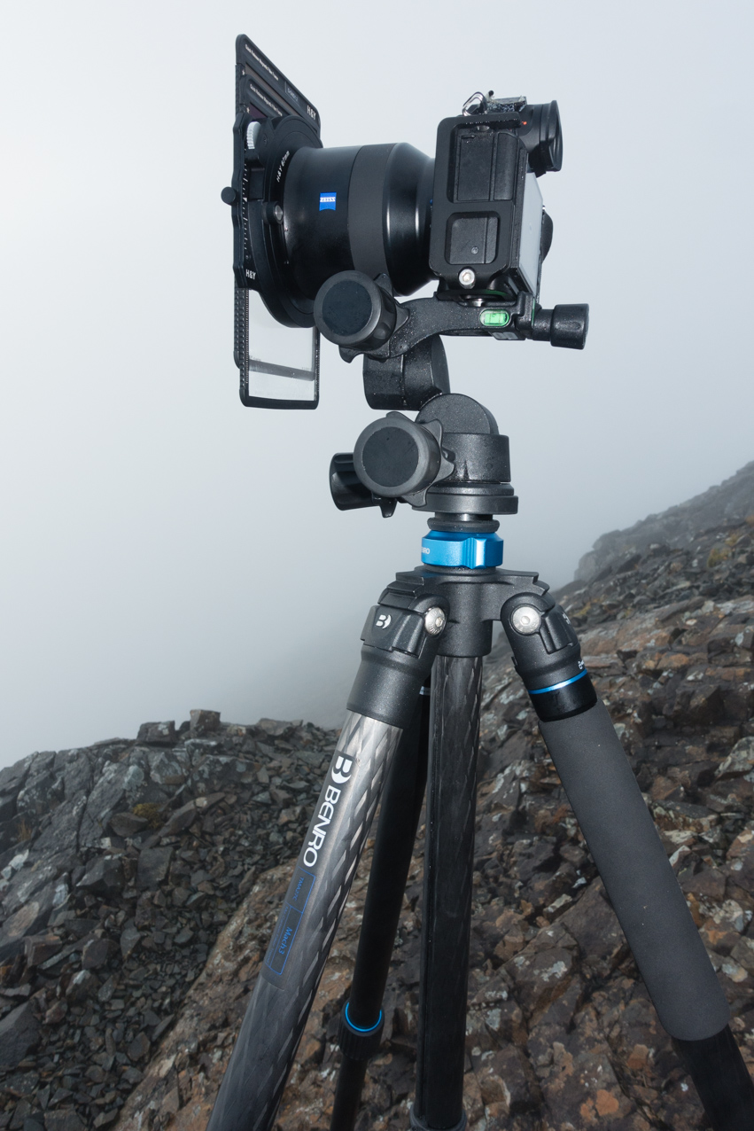
The set up for the above shot whilst waiting for the cloud to clear.

Photographers, like most humans, are always searching for something better, that new piece of gear that will give them the edge. Despite the profusion of software solutions, exposure blending and the like, filter sales are booming and there has never been a wider range to choose from. Top end filter brands vie for your custom, each screaming it’s unique selling feature/s, brand ambassadors extoll their virtues.

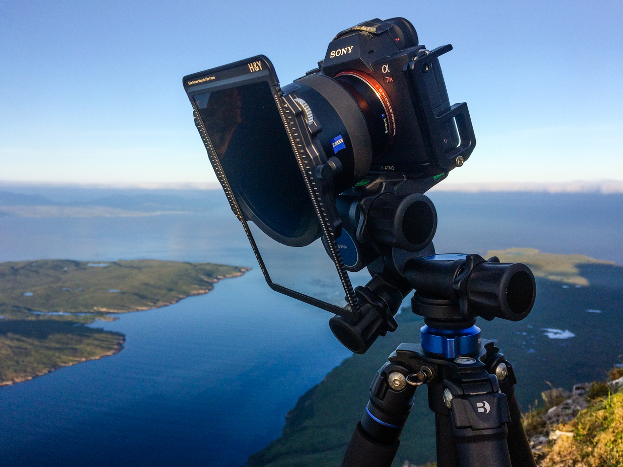
H & Y system in use high on the Isle of Skye

Sunrise from Gars-bheinn looking down to Lochs Coruisk and Scavaig.
Filters used; CPL and 1.2 soft GND

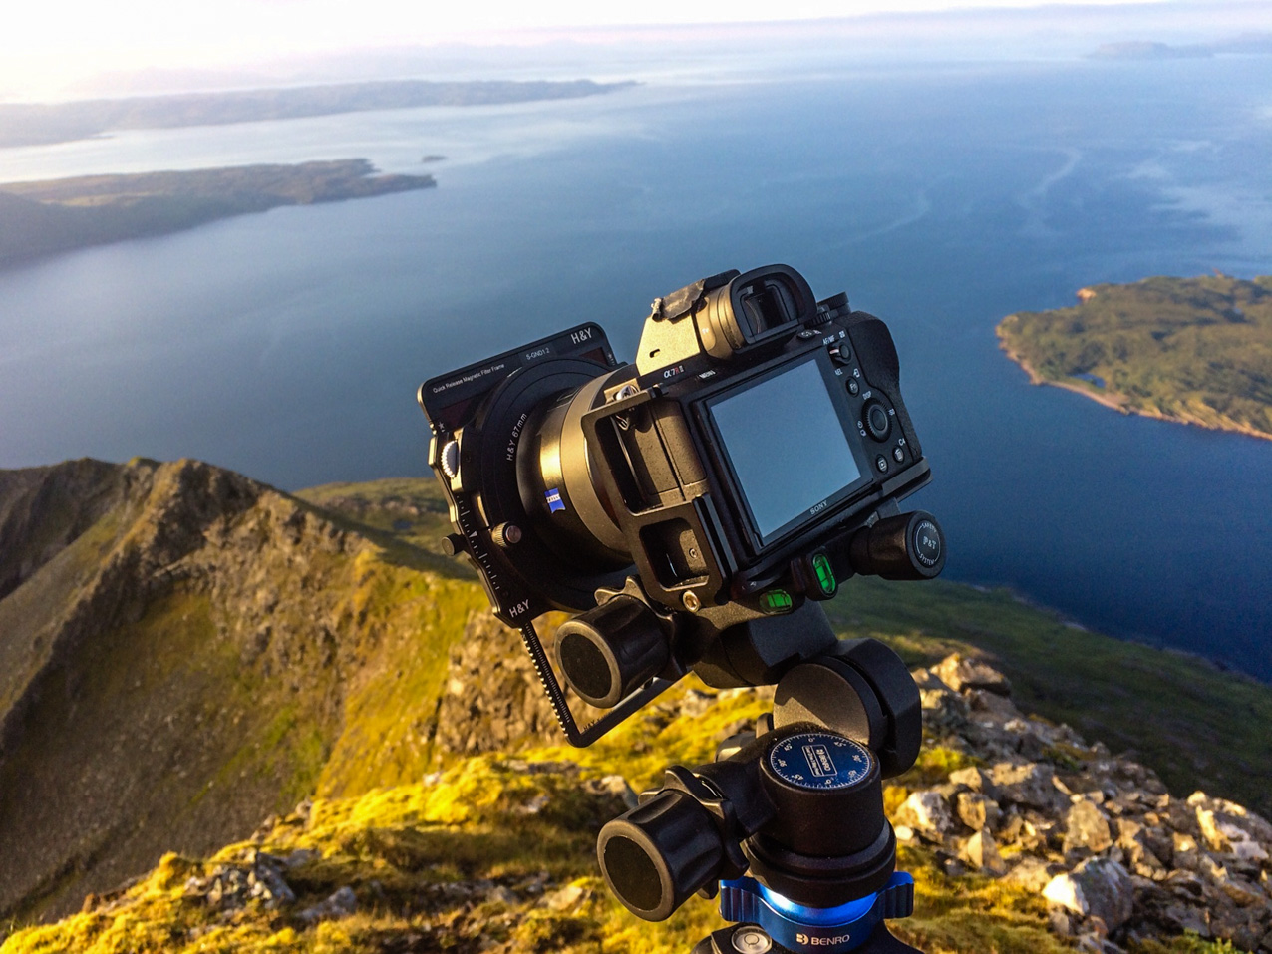
The set up for the above shot. What a morning and a location to wake up to after a bivi

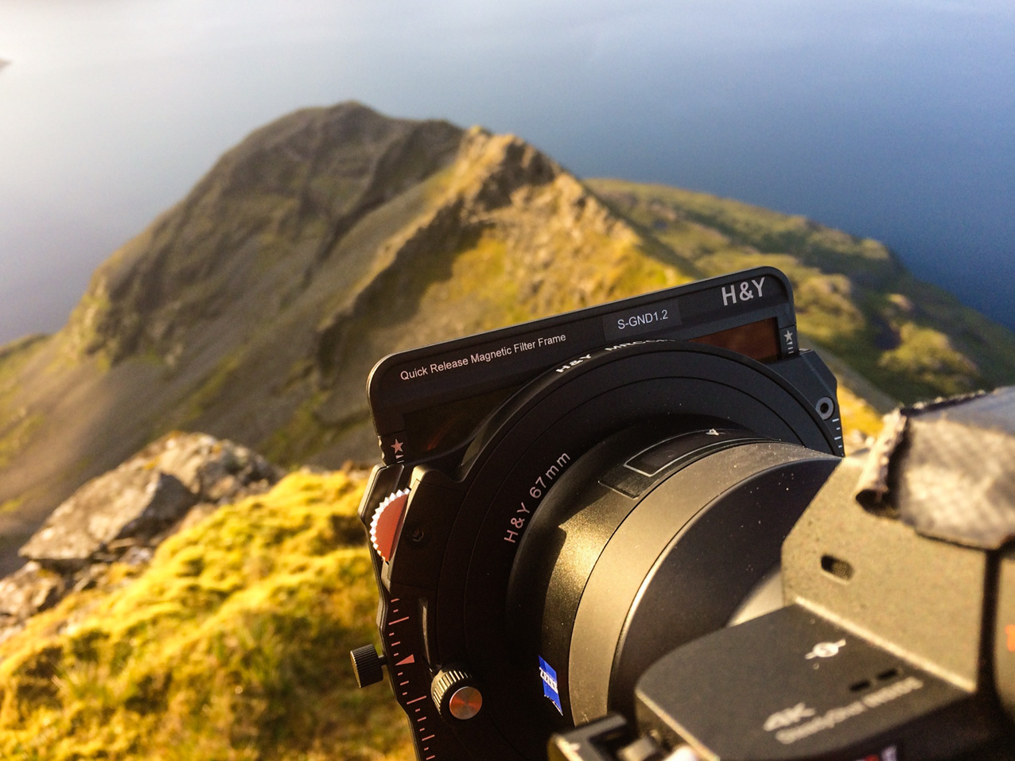
Close up of the set up so you can see the 1.2 soft GND and the CPL inserted

Here’s the advertising blurb from H & Y’s website;

ADVANCED MAGNETIC SYSTEM

The H & Y K-Series Filter Holder (and Magnetic Filter Frames) is the most advanced 100mm system available to landscape photographers. Simple, effective, hard wearing and high quality. No compromise.

Bold statements but can the system live up to the hype? The words “simple” and “hard wearing” certainly ticked boxes for my requirements.

The big selling points of the H & Y system are the magnetic filter frames and the drop in slot for CPLs and ND filters. The magnetic system looks amazingly simple and easy to use but the big question will be how secure the filters are. Similarly, the drop in CPL looks perfect and removes all the faff of a screw in CPL or even magnetic CPLs which often necessitate removing all the other filters first. Sounds good in theory but what was it like in real world scenarios?

Apologies in advance for the length of this review but the system is so different from others that it deserves comprehensive coverage.

As a photographer and mountain guide based on Scotland’s Isle of Skye, choice of gear is crucial. Working high in a harsh mountain environment, weight and bulk of gear can be an important criteria but, above all, the number one factor is “usability.” No matter how good a bit of gear, if it isn’t easy to use then it’s not going to make the final cut. I’m often out in the rain or snow, high winds as well as sunshine. It’s a tough environment, harsh on kit with lots of abrasive rocks, dust and grit, constant dampness and also salt water. Things need to be simple and tough for me to continue using them.

Having used Benro tripods and their filter system extensively, I was prepared to take heavier and slightly bulkier gear into the hills if it made my work flow easier. Function definitely trumps form. The Benro system was near perfect with their filter frame system a big step forward over more traditional filter holders. The main drawback to the system was the screw in CPL which fitted behind the slot in filters. Not only was it fiddly but meant removing all the slot in filters to access it. Having chatted to Mark Hoskins, the man in charge at Benro UK, it seems there are plans to improve the CPL system and I look forward to seeing this.

Just as I was finishing my Benro review, Tim Parkin produced possibly the most extensive and scientific comparison review of filter systems ever conducted. 15 systems and not just the usual much hyped colour and sharpness tests but of much more interest to potential buyers were categories such as “water shedding”, “usability” and even sub categories such “thick glove test-just grads”, “thin glove test-polariser.”

The tests were revealed in a comprehensive series of articles over 4 issues of OnLandscape magazine. It was done in the most scientific way possible, with spread sheets of results and the suspense building as people waited for the final article to reveal the winner.

When the cumulative scores were revealed then the H & Y system was the clear winner, a surprise result many might think given the other big names involved; Lee, the original premium brand, Nisi, Kase and high end marques like the mega expensive Wine Country.

I was totally intrigued and had an interesting chat with Tim. It turns out that of all the systems he had to choose from, the H & Y was the one he went to for personal use.

Me, “sounds like a glowing endorsement for H & Y if that’s the system you like best out of the 15.”

Tim, “Yes – by a long way. Mostly for usability reasons but it ticks all of the essential boxes too.”

This sounded like music to my ears, we were obviously on the same wavelength with usability triumphing over everything so long as a certain base level of other criteria was reached. I’ve long thought all the major brands were much of a muchness optically, once you get above a certain price point, much more important being the user interface and what system works best for the individual photographer.

Being out in the mountains most days means my gear gets a hammering but I also means that with my photographic work I get to meet lots of people and see lots of different systems. As such, I’ve used Benro Filters extensively and had access to Kase, Nisi, Lee and others so have a good idea of the relative merits of each system. People had high hopes of the new Lee system and it is very light, looks very slick but still needs a huge CPL which goes in front of the other filters.

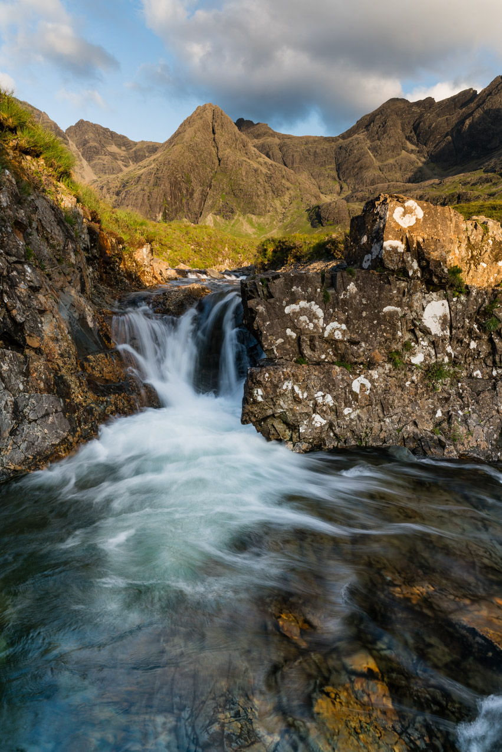
Skye’s iconic Fairy Pools yesterday evening after the tourists have departed.
Filters used: CPL and 3 stop soft GND.

Very interested in the system, I contacted Paul Genge, (MD of PhotoTeq, the UK distributor of H & Y) who asked what items I’d like to review. An extremely well packaged parcel of goodies soon arrived on Skye containing the following loan items;
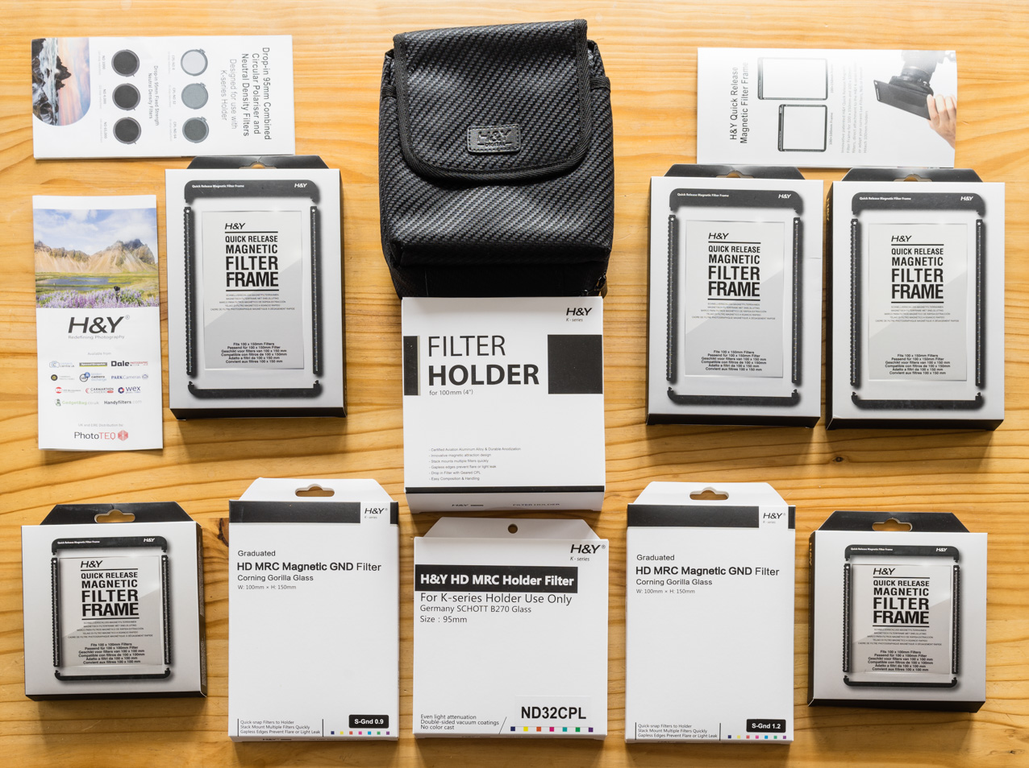
One huge advantage of the system is it’s ability to use your existing filters. The magnetic filter frames can be purchased separately and your standard sized Lee/Kase/Nisi etc filters installed. Thus, I’d asked for 3 100x150mm filter frames and 2 100x100mm so as to be able to use my existing Benro GNDs and NDs. H & Y also sell kits to modify other brand filter holders so you can retain these and still use the magnetic frame system.

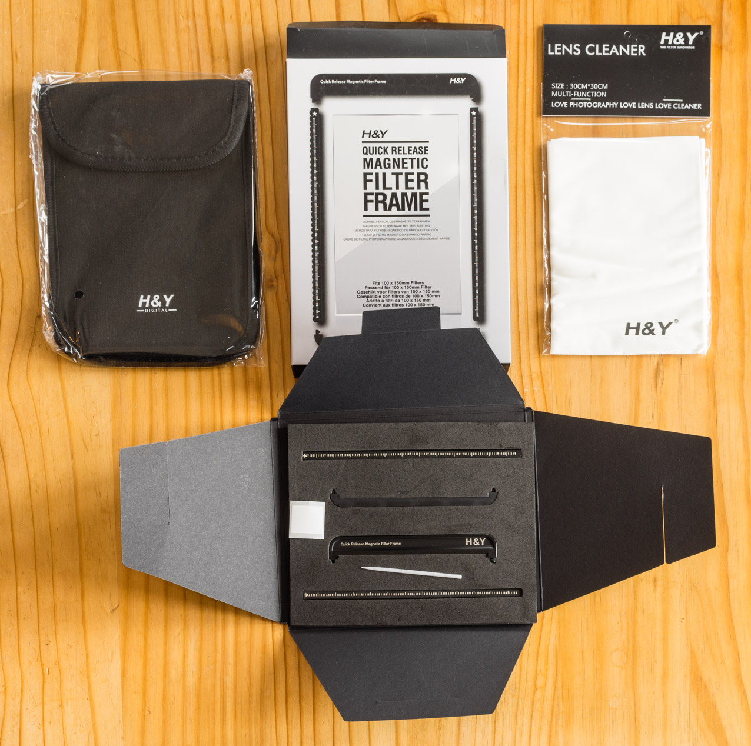

As with all the kit, the frames are really well presented and packaged and include not just the magnetic frame but also a quality neoprene case to protect filter and frame. A nice touch is the addition of a lens cleaning cloth which is useful to keep the filter clean during installation but also useful for the future since you can never have too many. Also included are a small plastic stick used to remove the protective tape from the adhesive strips inside the frame and a white sticker which can be used to identify the strength etc of the GND.

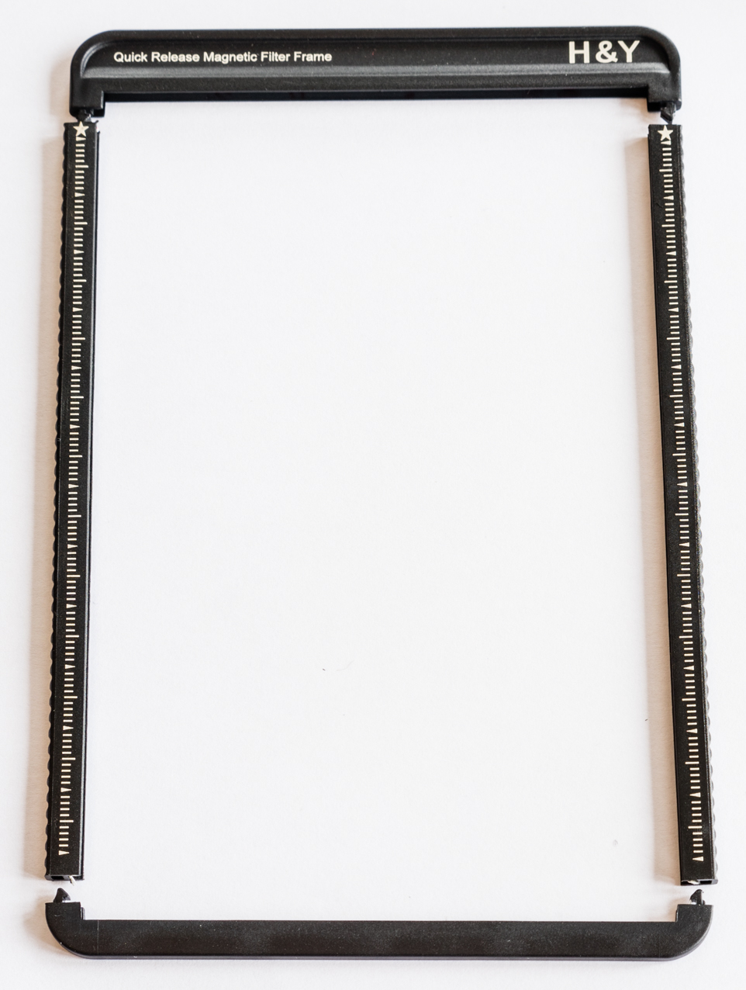

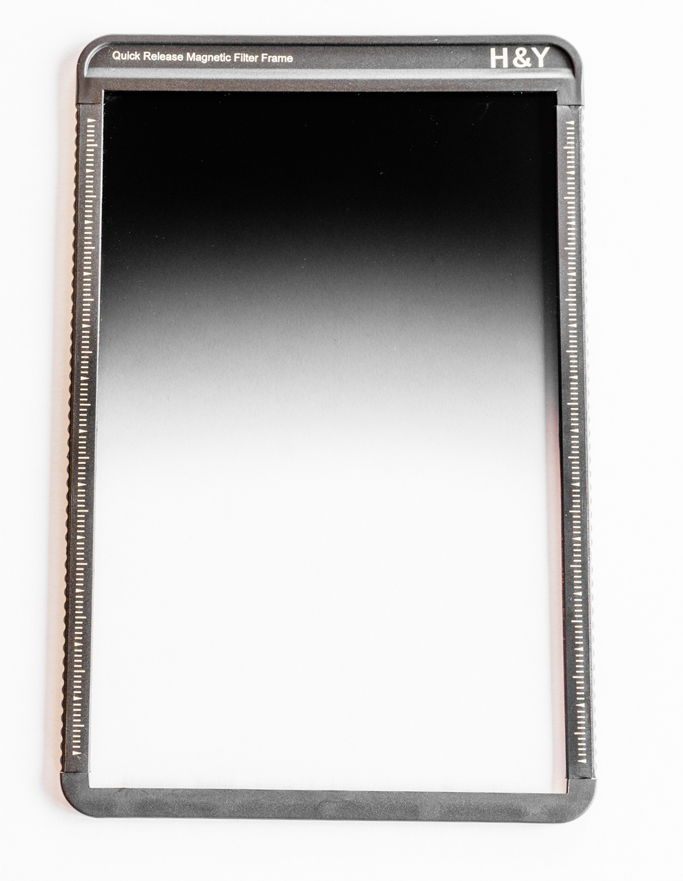
To be honest, I struggled the first time I installed a Benro filter in the filter frame but a quick google, a helpful video and all was sorted. Subsequent fittings were a breeze and the finished holder is very secure. Once you get the knack of installing the filters in the frames, it’s very simple.
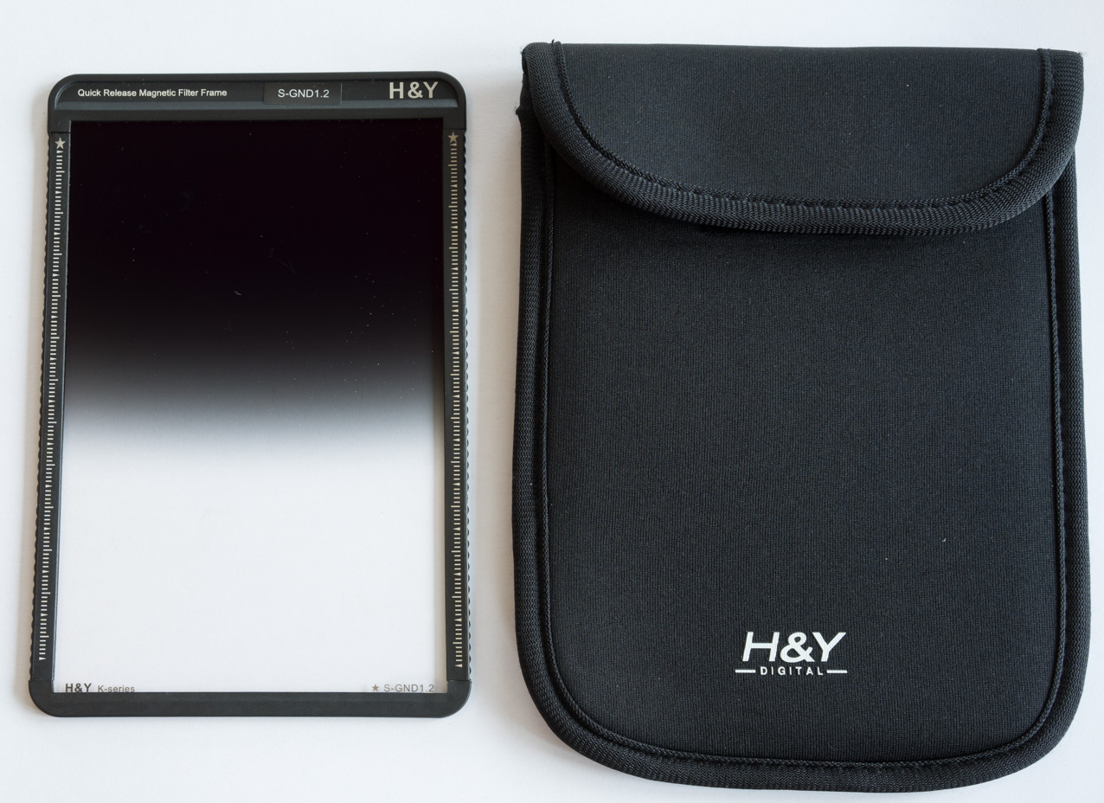
H & Y soft GND 1.2 with pouch. Note useful ID of filter type and strength clearly written in white on black frame. So much easier to read in the field than engraved writing on glass as per most systems (see writing bottom right of filter).

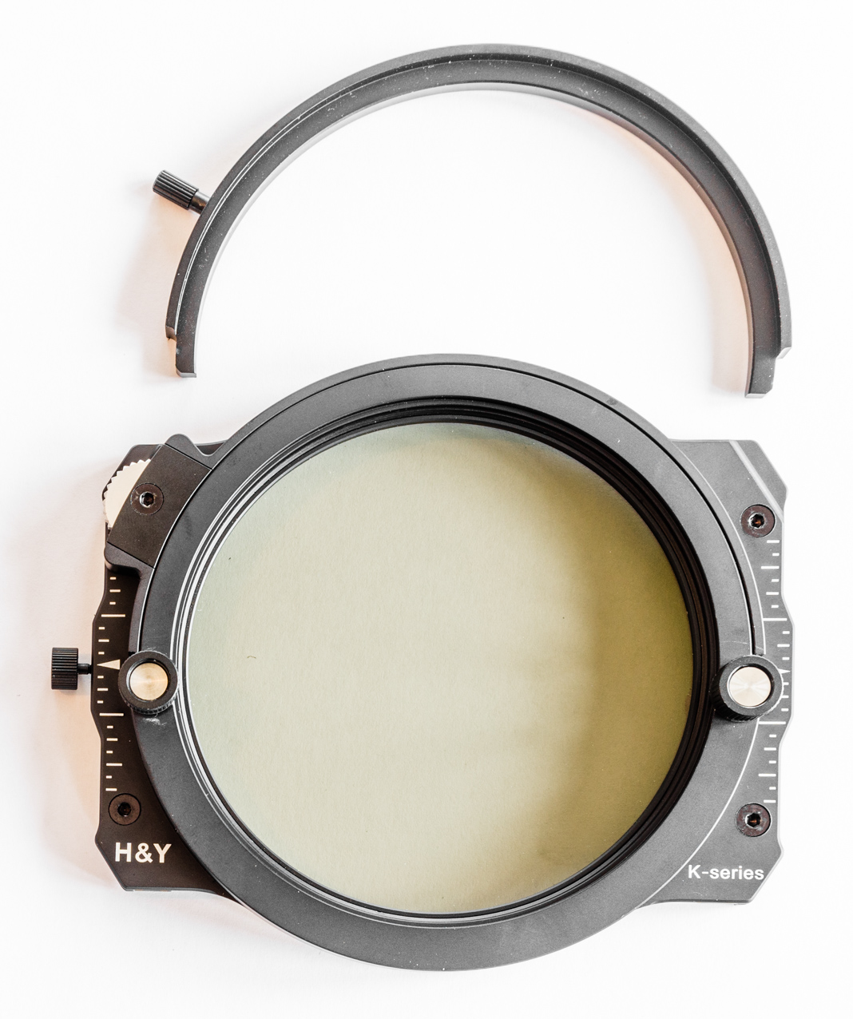
Holder with CPL slotted in and blanking plate to use when CPL isn’t slotted in. This will keep water drops, dirt and dust out but most importantly stop light leaks.

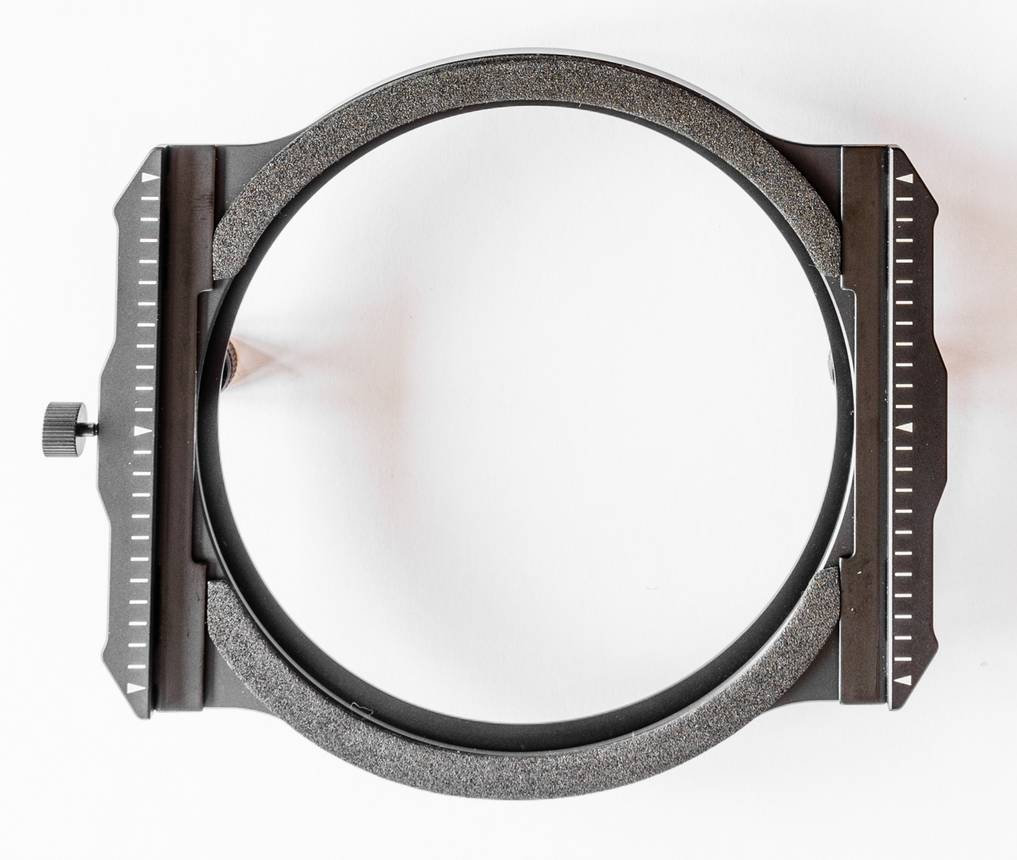
H & Y Filter holder. Note foam gasket to reduce chance of light leaks. Knob on left secures first magnetic filter frame in place preventing it being moved up/down.

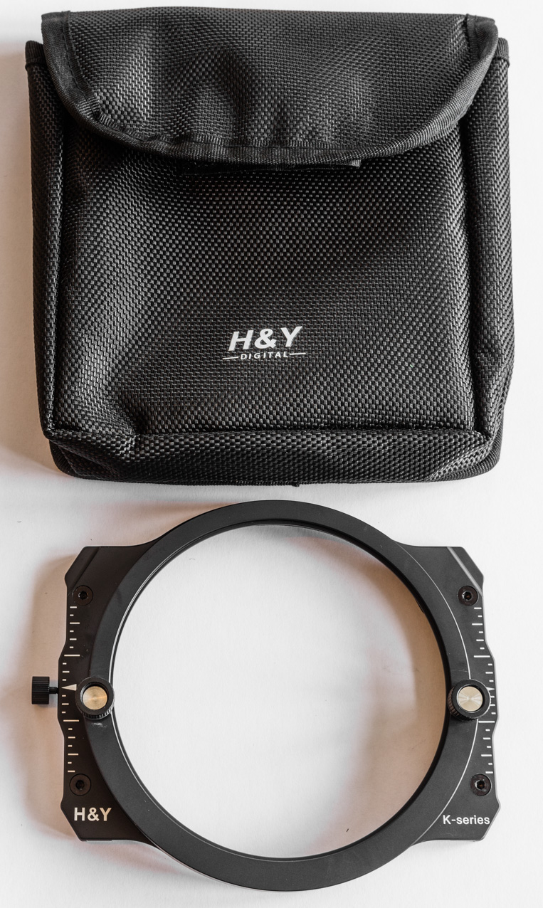
Rear of filter holder showing two circular knobs which are loosened to enable the holder to fit onto the adapter ring which will already be screwed onto the lens.
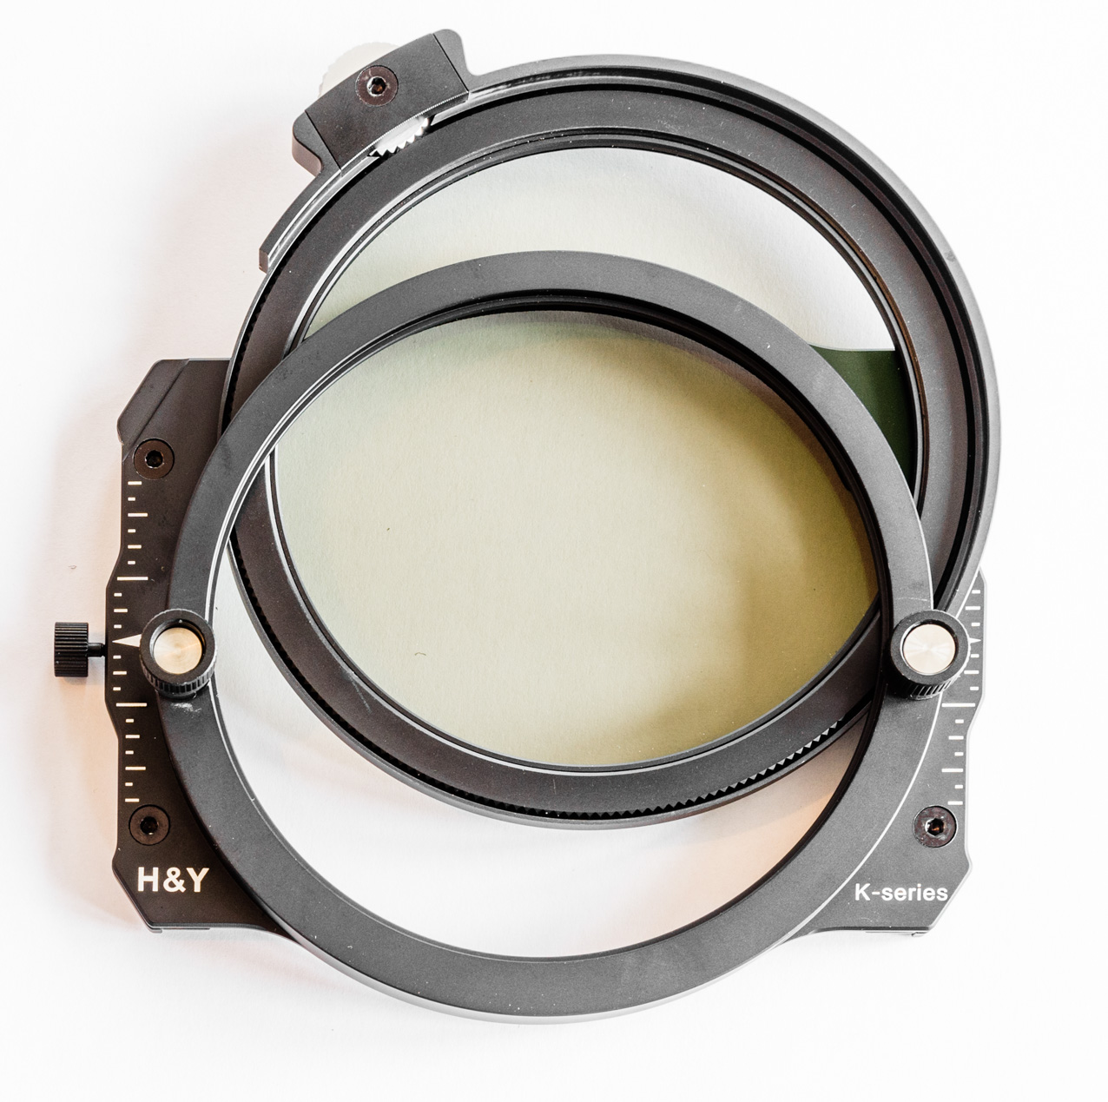
Showing how the CPL or ND simply slots in. Don’t worry, it clicks into place and is very secure once installed.

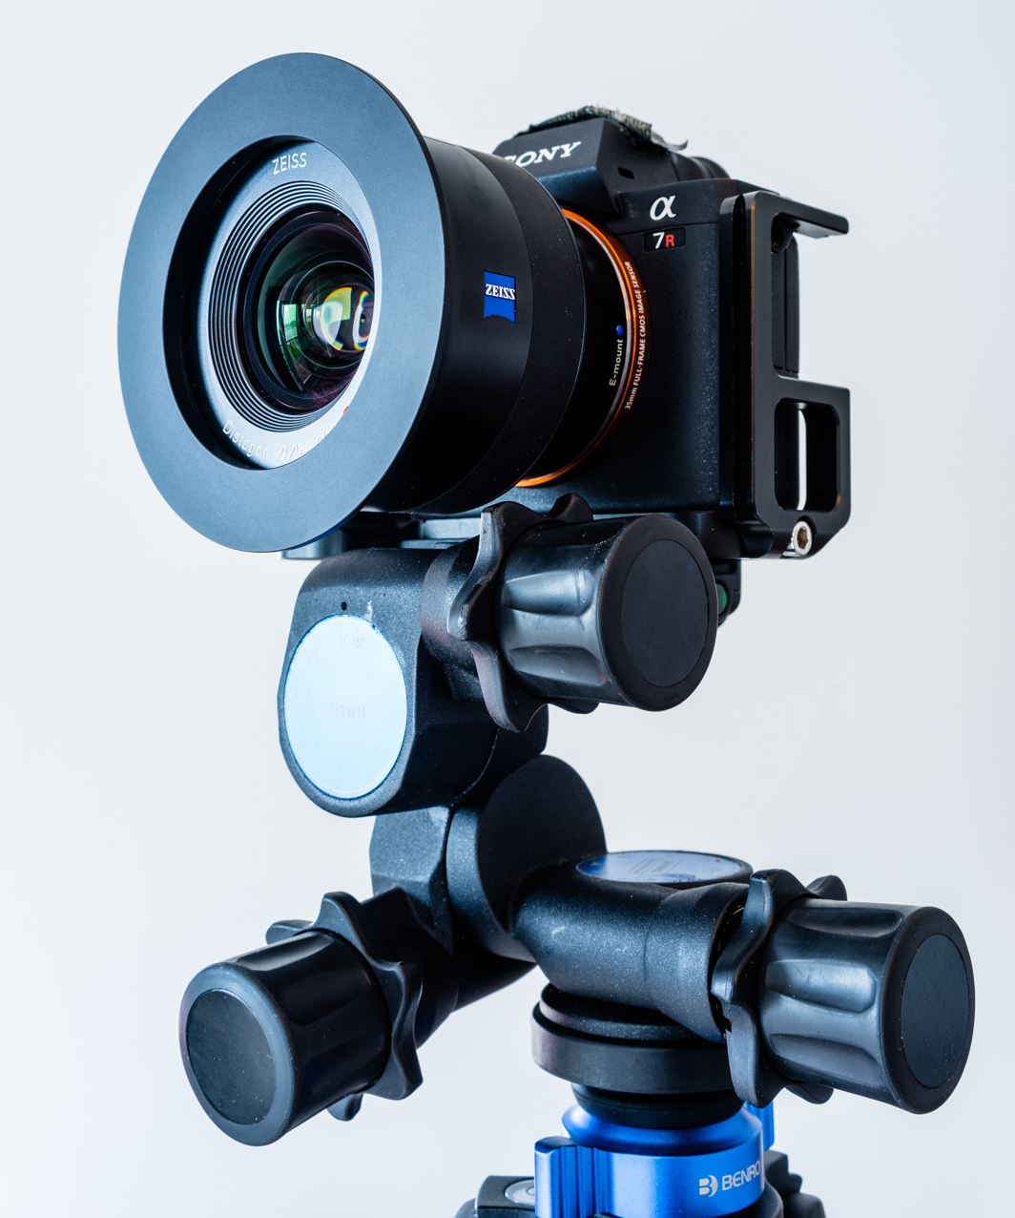
Adaptor ring fitted to lens ready for filter holder attachment. The kit comes with a useful selection of adapters; 67, 72, 77 and 82mm so a good range covered and others sizes can be sourced cheaply.
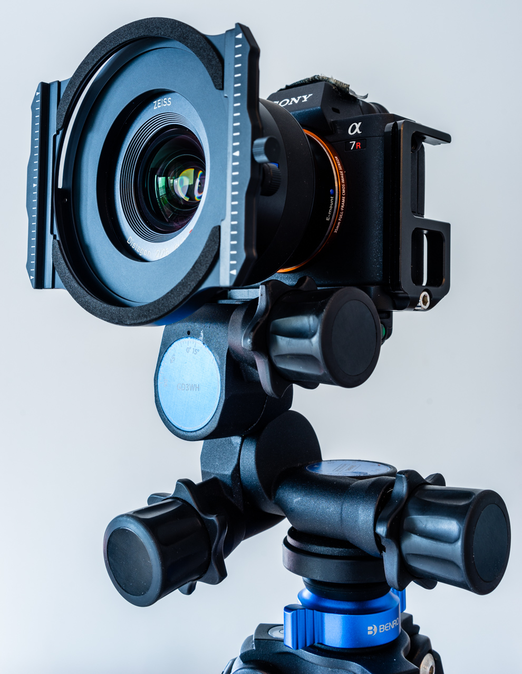
Filter holder fitted to adapter ring on lens.

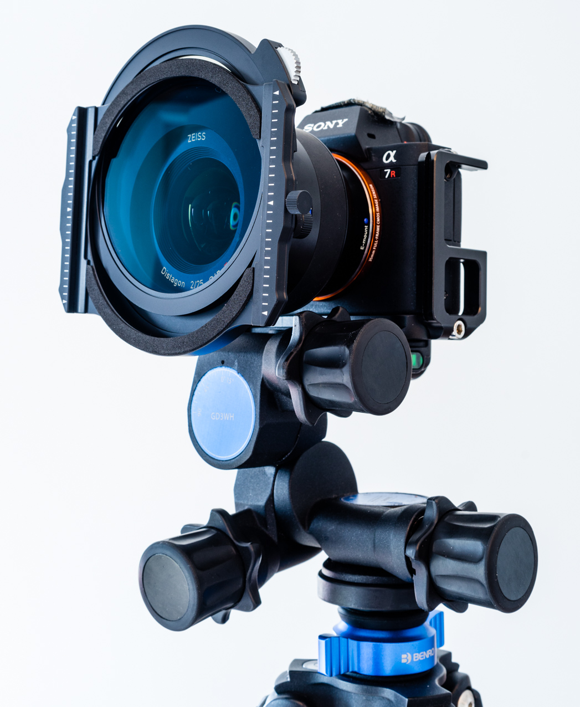
CPL shown partially slotted in from top.

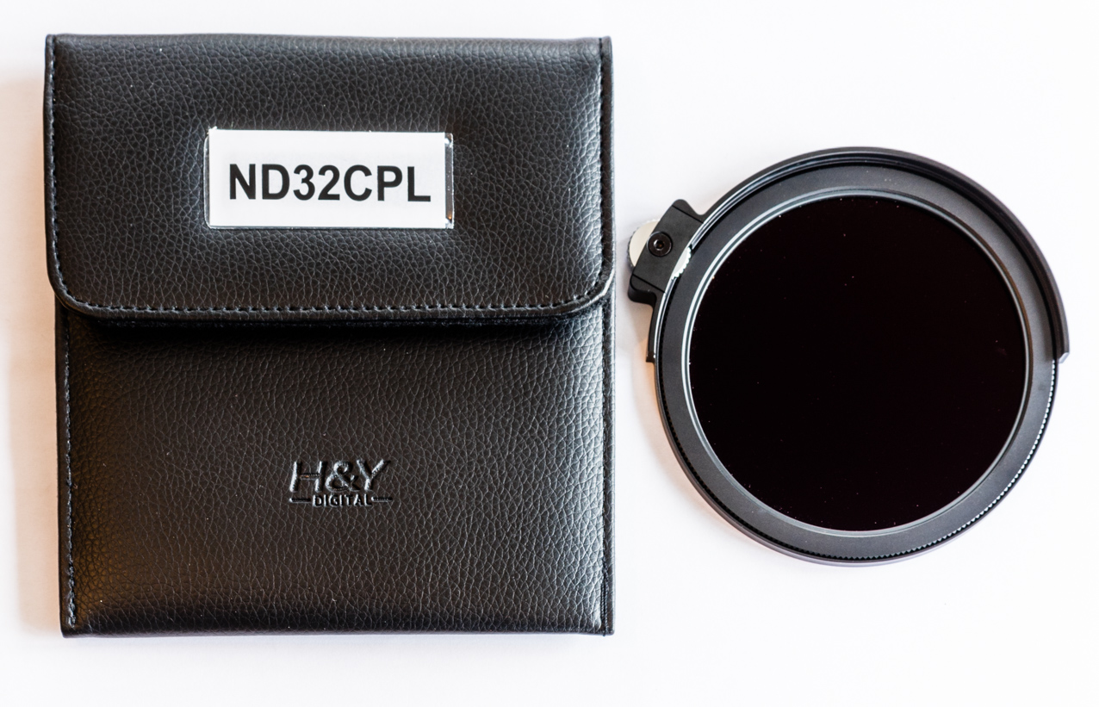
Combined ND/CPL slot in and pouch.

Above are 4 of my favourite photos taken whilst using Benro filters. The H & Y system would need to be good if I was to adopt it. I can use all my Benro filters with the H & Y magnetic filter frames. This backward capability means you can enjoy most of the benefits of the H & Y system whilst using any existing filters you own.

So that’s the system but how did it fare in the real world? Over the last three months, it’s had a lot of use including several overnight trips spent on mountain tops in anticipation of good sunsets/rises. It has been used on short trips, for roadside photos, multi day mountain adventures and reviews of other products including the Tenba Shootout 32L photo backpack and Keela Outdoor clothing. During testing, several newsworthy stories were covered and featured by both national and regional press and the BBC so the gear has had a lot of use, certainly enough to draw some conclusions. Conditions both weather wise and photographically haven’t been great so there’s no stunning results to be seen but the H & Y kit has been subjected to a lot of use and abuse.

Here’s a few conclusions after three months;

1. The magnetic frame system is awesome. It makes for ultra easy positioning of filters especially in bad weather when gloves may be necessary. No fiddly slots to line up. No chances of partially misaligning the filters in different slots. The magnetic system like any good idea is astoundingly simple and just works. I really like the easily identifiable markings on each filter frame; bright white letters on black frame make for easy reading compared to etching/writing on glass filters.

Like most people, I was extremely wary of first especially since the glass filters are not cheap and mollycoddled things a bit. Despite initial fears that strong winds might dislodge the filters, this was never the case. I know this is not a recommended process, but especially using just prime lenses, I often have to move positions and with the speed of light changing then disassembling everything isn’t really a realistic option. Having realized just how secure the magnetic system is, I will now happily scramble around mountain tops with the filter system on the camera, the whole on top of the tripod.

The magnetic system seems faultless to me and one I’m sure others will copy.

Filters stack on to the front of each other and whilst I’ve never used more than two in anger, I have tried three and the whole thing seems just as secure. In fact, the cumulative magnetic attraction of additional filters seems to make the attachment feel even stronger.

For those worried about the security of their precious filters, H & Y are due to release a replacement front to the filter holder which clamps the filters in place. Not sure how this is going to work but it’s good the company are listening to people and updating things. Personally, I see no need but if it doesn’t impede the ease of use then the added security will be a bonus.

2. The drop in nature of the CPL and NDs is equally awesome. No huge CPL (weighty, expensive and potentially fragile) like the Lee system, no fiddly screw in or magnetic system which requires removal of all the other filters to access it. Simple and just works. The gnarled silver wheel makes rotating the CPL a breeze and this is so even when wearing gloves.

3. The ability to make use of my existing Benro filters is a fantastic bonus although I mainly just used the 3 and 4 stops provided by H & K. This backwards capability means entry to the H & Y system can be less costly. There are also filter holder adapter strips to allow you to use existing Lee, Format Hitech and Nisi filter holders as well as their filters.

4. Usability, for me, also included the nature of the actual filters. Most important is how easily they shed water drops, wipe clean easily etc and still look pristine after 3 months hard use. This is especially good for landscape photography where water droplets from waterfalls, rain, sea spray can be a constant battle. The filters wipe dry/clean easily.

5. The filters are rugged, being made from Coming Gorilla Glass v3. Meant to be super tough and that’s reassuring but not something I’ve tested (thank goodness).

6. The filter frame system is the future. Not just do they protect the vulnerable glass edges and corners, add an extra layer of security if they were to be dropped but also make for much more secure handling especially in the cold and/or wet when wearing gloves. Naked glass is as slippery as, well, glass. Also the filter frames enable the filters to be kept clean and fingerprint free so all good. The frames stand slightly proud of the glass so it is possible to place the filter on a flattish surface and know the glass itself won’t be damaged.

I’m really scratching around to find any downsides to the system;

1. Not sure how much I like the attachment system to fit the filter holder to the adapter ring. At the moment, I still prefer the Benro system but that may be due to extreme long term use and associated muscle memory that makes that second nature. The Benro holder attaches with two notches combined with a spring mounted catch which can be locked. It’s simple, easy, quick and requires just pulling one catch (and possibly screwing it locked). Conversely, the H & Y system requires tightening two knobs. It’s probably not too much slower and it doesn’t feel as secure but once tightened actually seems rock solid and I’m more than happy to walk about with the filter holder etc attached.
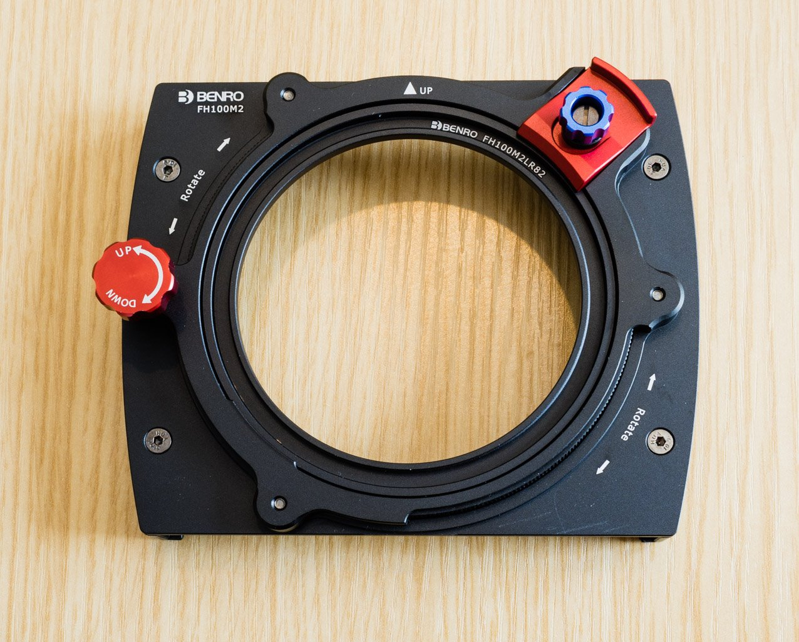
Rear of the Benro FH100M2 filter holder. I loved the latch with a locking knob to secure it (top right) but wasn’t too keen on having to remove filters in order to add/take off the CPL.

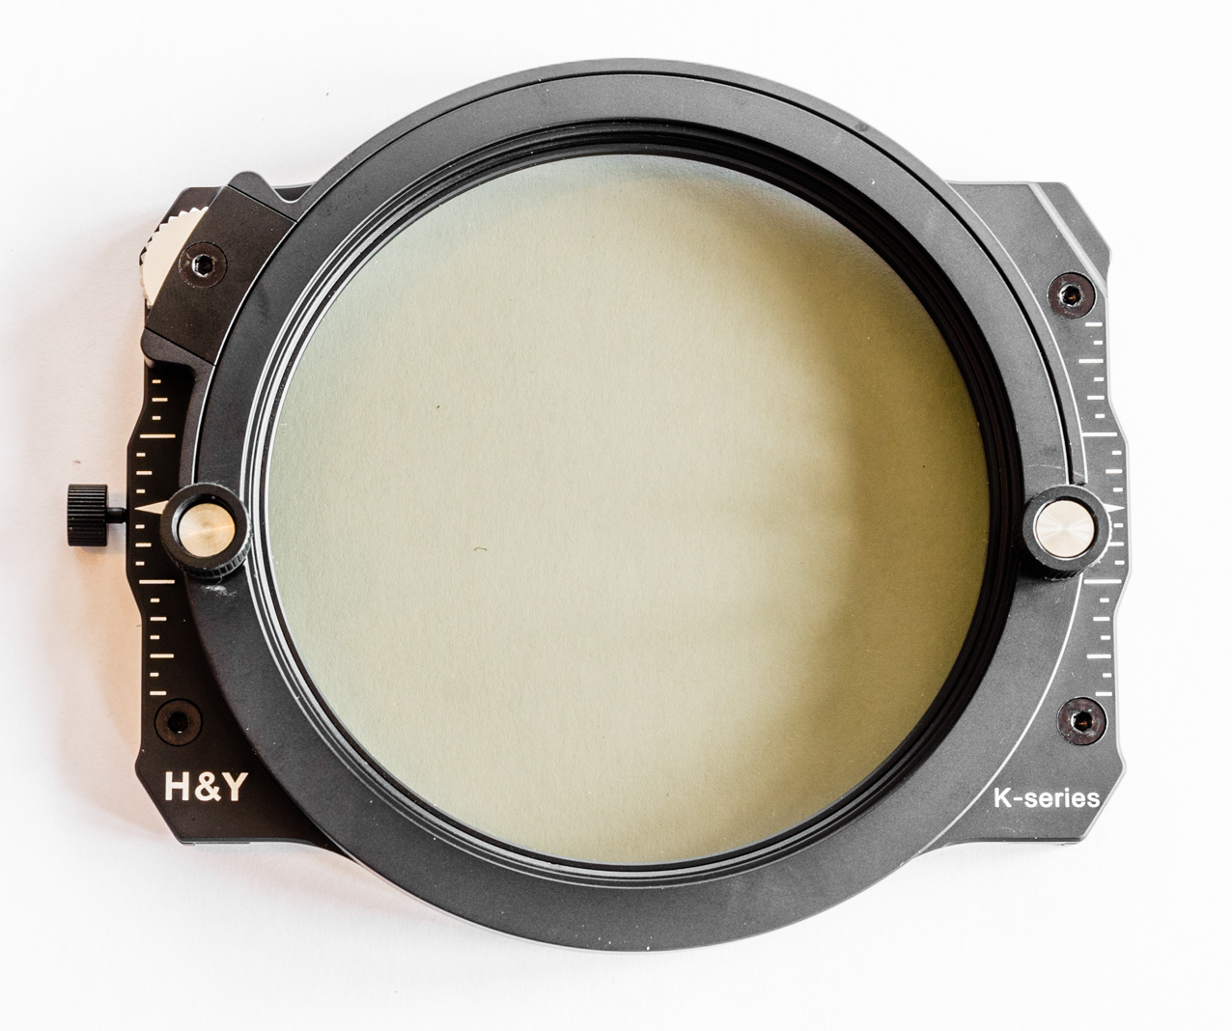
Rear of H & Y holder showing attachment system; the two silver/black knobs are unscrewed and the filter hold slid onto the adapter ring which slips securely into the circular recess. The two knobs are then tightened up. Once in place, it’s equally secure to the Benro.
2. This is a bit petty but the “Luxury Filter Tote Bag” failed to live up to my high hopes. I have yet to find a really decent protective filter case capable of taking filters in filter frames and the filter holder. True, the Tote Bag ticks all the boxes, holds everything, does a good, protective job but it’s design makes for a very heavy and bulky object. I did take it into the hills several times but even though it did a good job, the weight and bulk was too much especially when going out for several days with overnight as well as camera gear.
3. Cost and weight of the system. The system isn’t the lightest but I’m prepared to accept the weight penalty for the added benefits the system brings. H & Y’s lowest scores are for cost and weight. It is expensive and towards the upper end of the premium filters and it is relatively heavy compared to some systems. For my use, the unique features which make the photography so much easier and more enjoyable are well worth these slight downsides.
It is a premium system and this is reflected in the price. I have to say that if I was in the market for a complete high end filter system then this would head the list if I was starting from scratch. Fortunately, I was loaned the entire system and must apologise to PhotoTEQ for holding onto it for so long. This was partially due to pressure of work, partially due to very poor weather but mostly due to me just loving the H & Y system. In fact, I’m putting my money where my mouth is and am in the process of buying the loan gear.

Dawn view across Coir a Ghrunnda to Sgurr Alasdair, the highest mountain on Skye. Photo taken after a night spent on the mountain top in miserable, heavy rain. Filters used; CPL and 3 stop soft GND

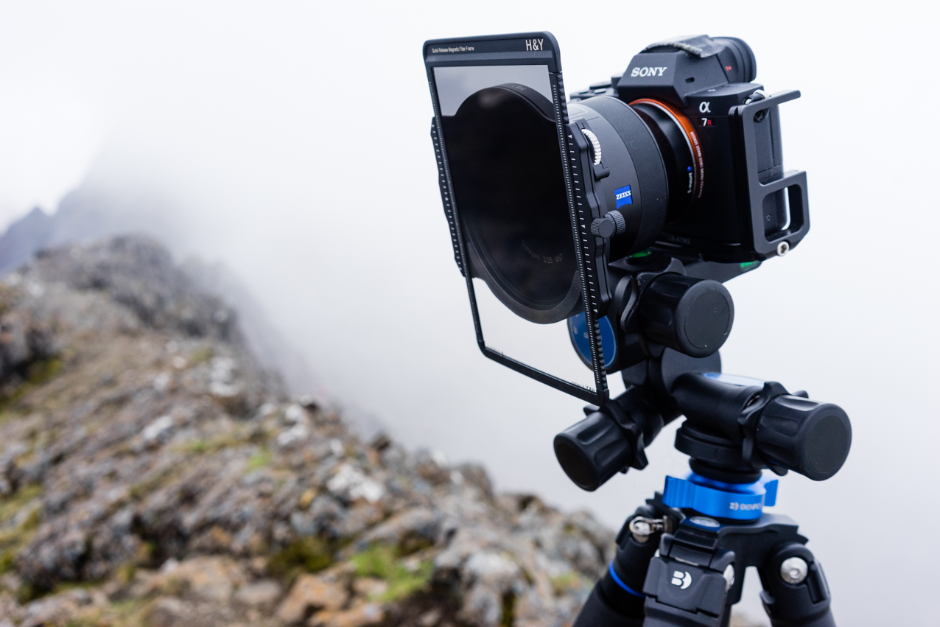
Set up for the above shot.
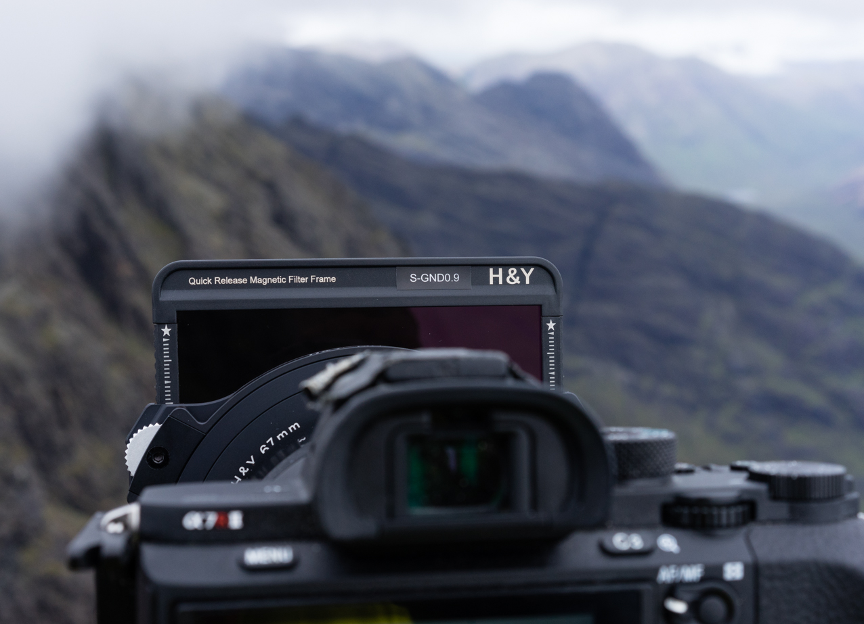
Set up clearly showing magnetic filter frame and the silver wheel on left to rotate CPL.
Sunset the previous evening. Filters used; CPL, 3 and 4 stop soft GNDs.

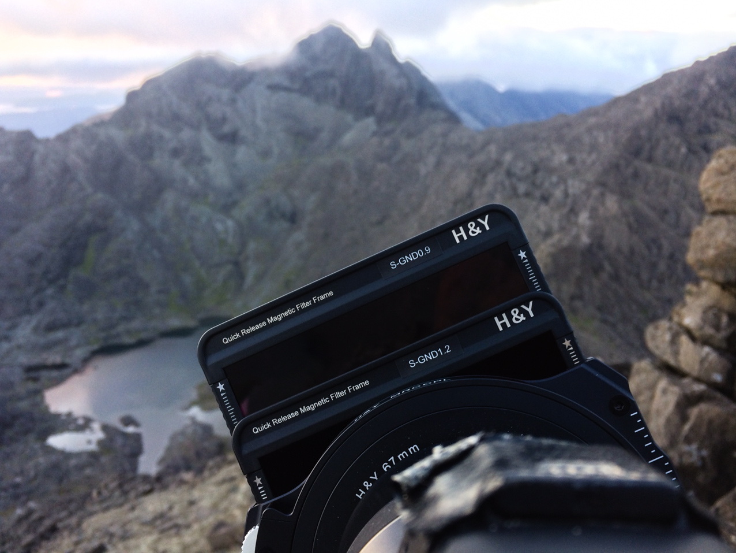
The set up for the above shot taken before the sun set whilst scouting locations.

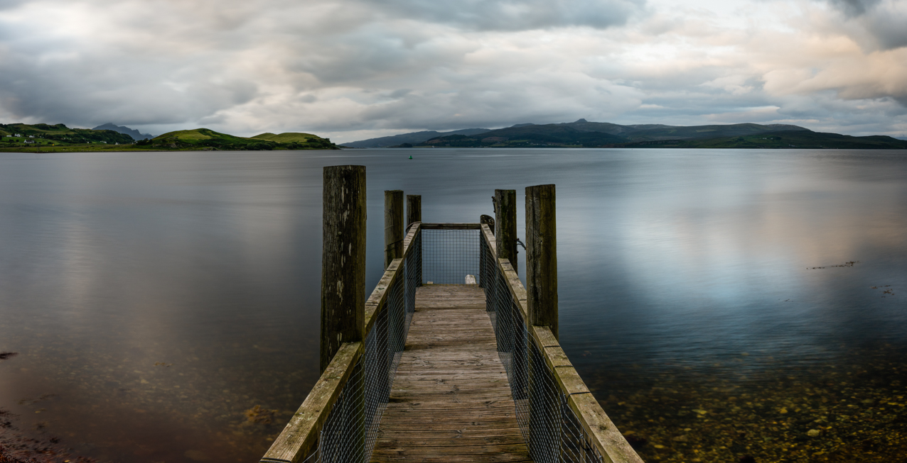
This is the view from where we currently live in Sconser. Being right outside my office, it’s handy and an almost obligatory test shot. Filters used; CPL/5 stop ND and 3 stop soft GND
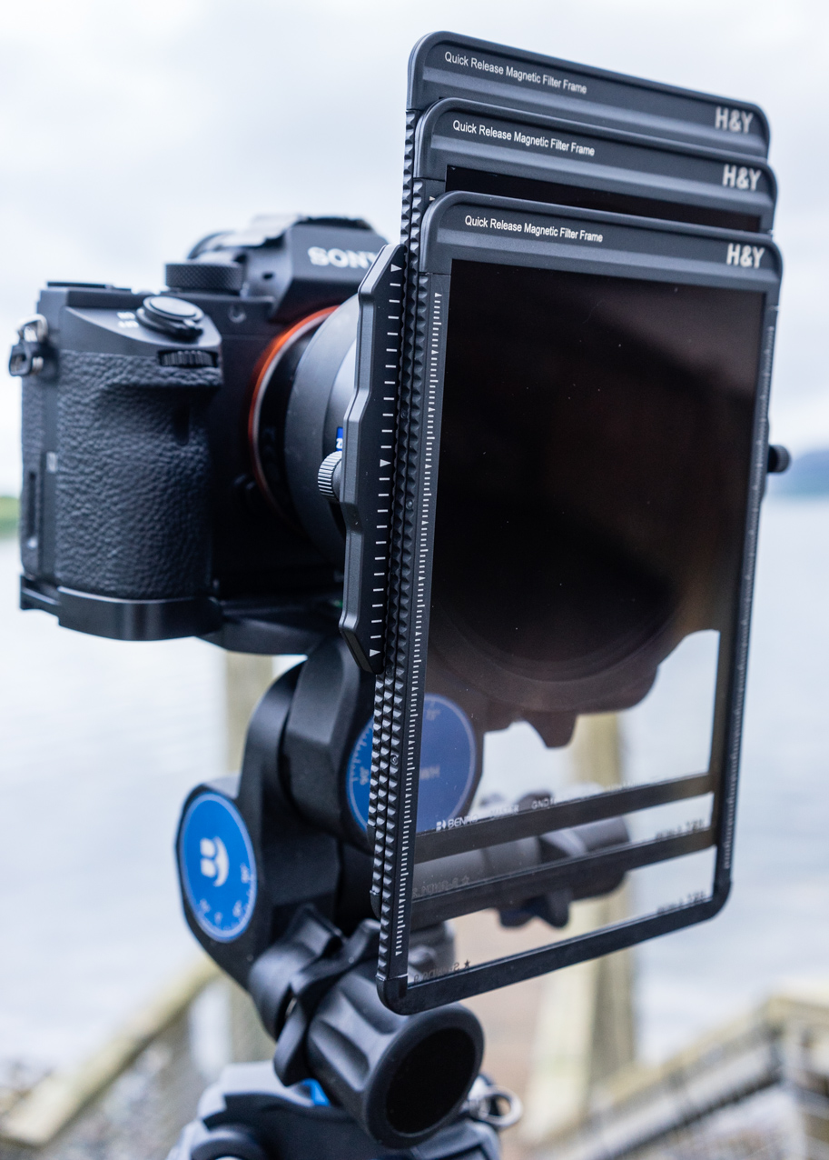
More testing at home; you can easily stack at least 3 filters.
Photo for review of Tenba Shootout 32L backpack and Keela Outdoor clothing. Filters used; CPL and 3 stop soft GND.
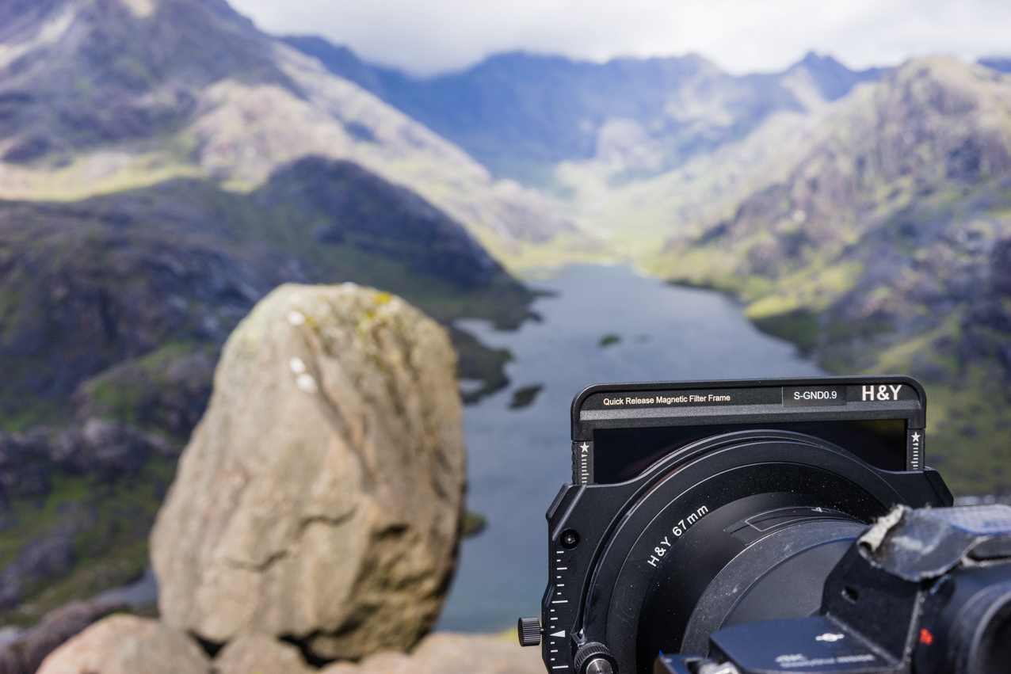
Behind The Shot.

Panoramic shot of lenticular clouds above the Red Cuillin.
Filters used; 3 stop soft GND

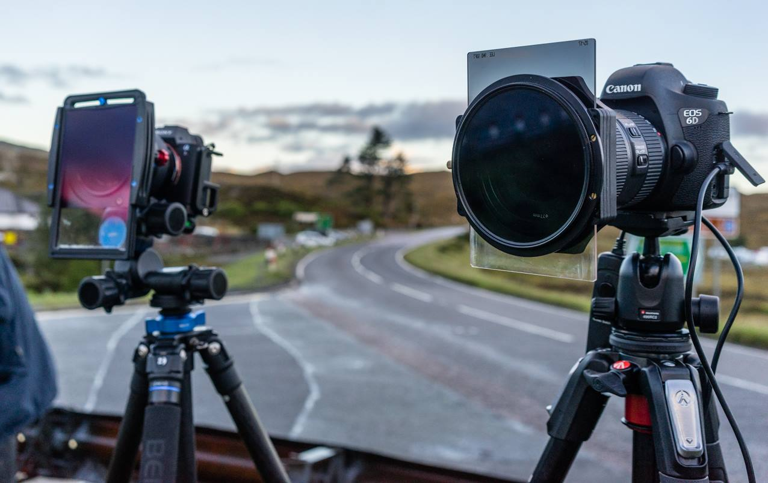
Some of the competition; Benro on left and Lee on right (NB huge CPL)
The Nisi system is popular but you have to remove GNDs to take out or put in the CPL.
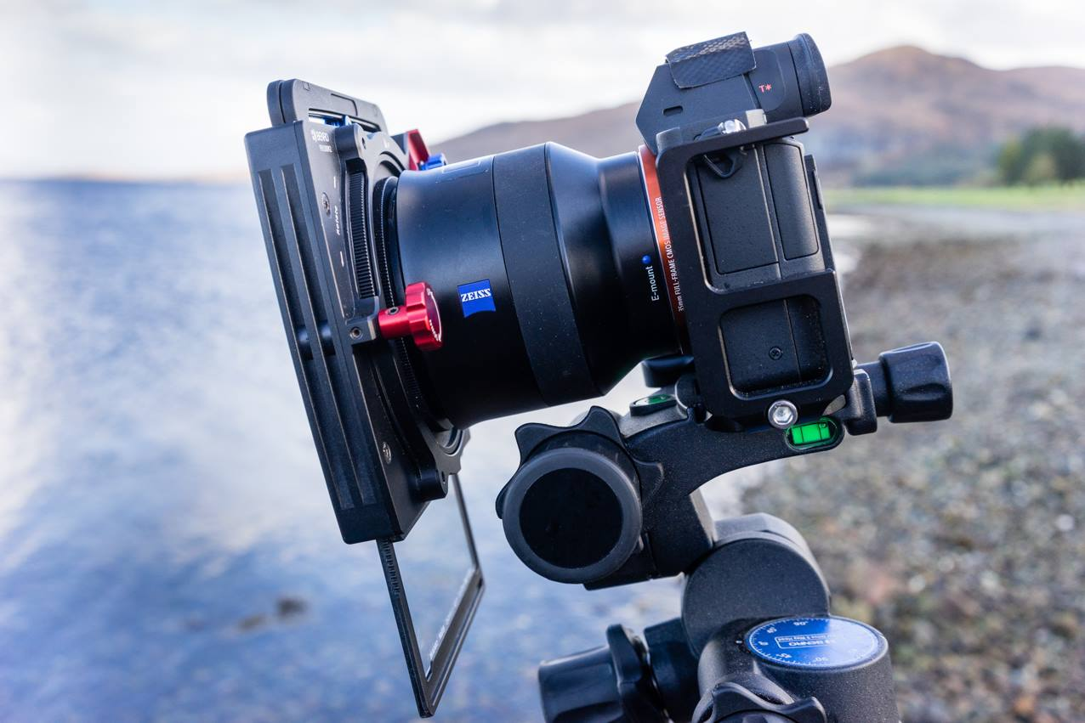
The Benro system in use; similar to the H & Y but with more traditional slide in filters (although they are mounted in frames) and no drop in CPL.

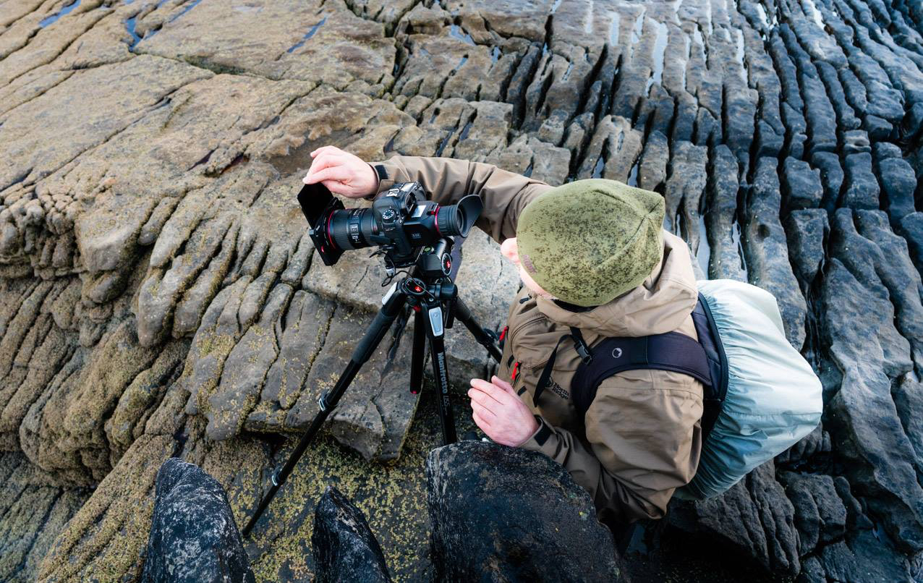
The Kase system scored highly in Tim’s test coming second on the final spreadsheet. It is the lightest holder in the test and ditto it’s CPL so it’s certainly king of the traditional type slot in systems but you have to remove the filter holder/filters to fix it on/off.

Sunrise after a night spent out high on the Cuillin Ridge. Early morning rays hit part of the ridge whilst the rest lies in shadow. Filters used; CPL and 3 stop soft GND.
Very few things in life live up to expectations, let alone advertising spiel but the H & Y system does. It met and exceeded all my hopes and is, to my mind, the best system on the market for my needs. I stress, my needs, since everyone has different requirements. For me, usability trumps all other qualities. Tim’s review shows that the top systems are all capable of producing excellent results so personal choice has to be made on other factors. To me, the ability to use the system in bad weather, perhaps wearing gloves, is infinitely more important than a few percentage points on the colour accuracy or sharpness scales.
For me usability means;
- easy and fast to put filter hold on/off using gloves
- easy and fast to insert and move up/down NDs and GNDs
- easy and fast to add/remove CPL and/or NDs
- water shedding ability of the glass and ability to easily dry and clean the surface
- durability of the glass so tough glass, tough coating and added protection of the filter frames
In my conversation with Tim, he bigged up H & Y’s “usability” but added that “it also ticks all of the essential boxes too. Thus H & Y scored 90% for usability (way ahead of the competition) but also got an impressive 88% for colour, 95% for sharpness etc.

Tim’s testing is very scientifically done with spread sheet results to boot. Just using the H & Y system and gut feeling tells me I’m not missing anything in colour accuracy or the glass reducing clarity and sharpness. Optically the filters are great and a joy to use. I think the black filter frames around the edges help to significantly reduce flare and reflections which may
effect naked glass/resin filters. I was more than happy to take Tim’s tests as gospel and my real world use in the field confirms that H & Y have not just ticked the usability box but also all the essential boxes. Getting things as right as far as possible in camera in the field is important. I’d much rather spend more time up a mountain than in front of a computer doing extensive photoshop work or blending shots. Filters aid this process and I find it all an enjoyable part of photography. The filters just worked, did their stuff and were a joy to use. Without wishing to sound completely mad, the whole set up is very tactile and the magnetic system allows the filters to glide up and down with a science fiction like quality.

Usability is key or me. If you are looking to buy a filter system then try and get hands on experience of as many different makes as possible. The highest performing optically might not suit your needs. The lightest system might not be the most usable. It’s all very well reading reviews or watching videos but you can’t beat seeing and playing with items before purchase. Anyone on or coming to Skye is welcome to drop in to have a play and check out the H & Y system.
Tim sums things up succinctly; “Overall the H&Y is an excellent system, good quality graduated filters with magnetic mounting, simple usability through drop in polarisers and NDs and all reasonably light- weight. Definitely my pick of the crop.” Below is a link to Tim’s video which shows exactly how the H & Y system works.
https://www.youtube.com/watch?v=NtSDWFug5oM&list=PLgZFNzHbtSeBiGq0wL6SgEBi6MLDOjPWp&index=3&t=0s
Sunset from high on the Cuillin Ridge looking down to Glen Brittle and the western isles.
Filters used: CPL/5 stop ND and 4 stop soft GND
Glen Brittle Beach with storm incoming.
Filters used; CPL/5 stop ND and 4 stop soft GND

The above photo helps explain one of the reasons this review has taken longer than usual. My wife and I have just bought a piece of land a few minutes walk from this spot. It has been a lengthy process but we believe we have found an unrivalled location to live on Skye; a beautiful spot at the foot of the Black Cuillin mountains yet close to the sea. We will be running photography courses and mountain guiding from our new house when it’s built.

Many thanks to Tim Parkin for allowing me to freely quote from his review and to Paul Genge for arranging the extensive collection of loan gear. If anyone is interested in Tim’s in depth review then check out OnLandscape. It’s a subscription magazine but he has said he hopes to make available the test as a free download; https://www.onlandscape.co.uk/
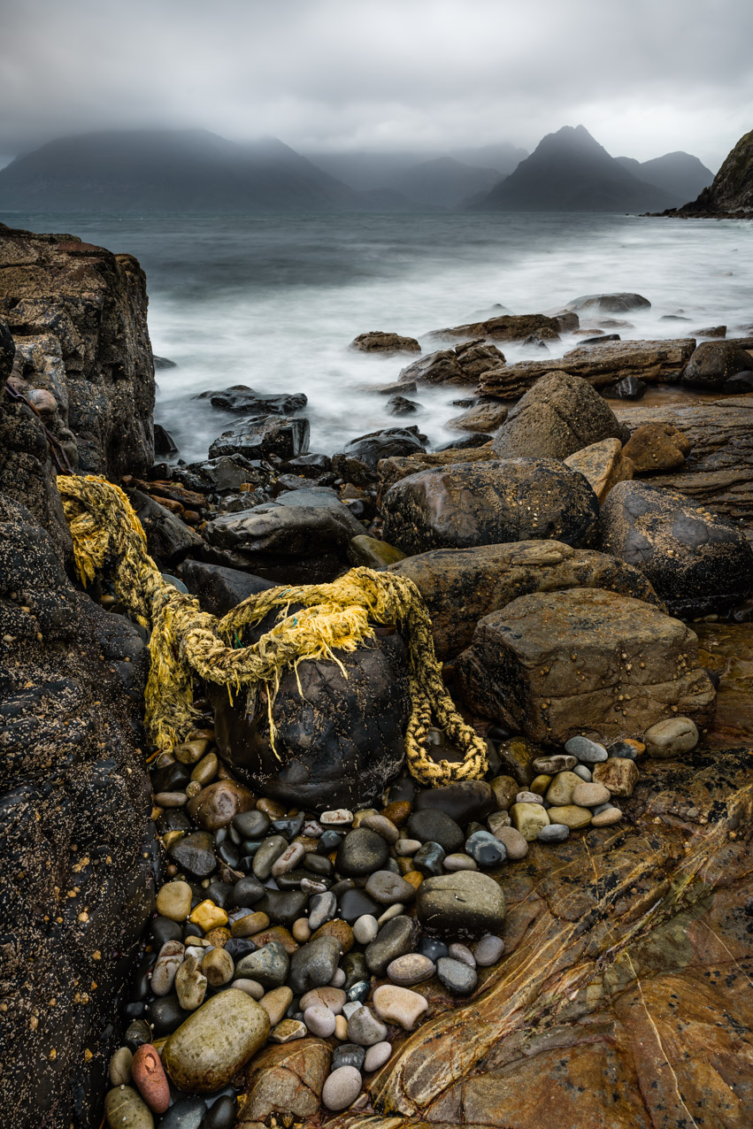
Moody light at Elgol with view to the Cuillin hills.
Filters used; CPL and 3 stop soft GND

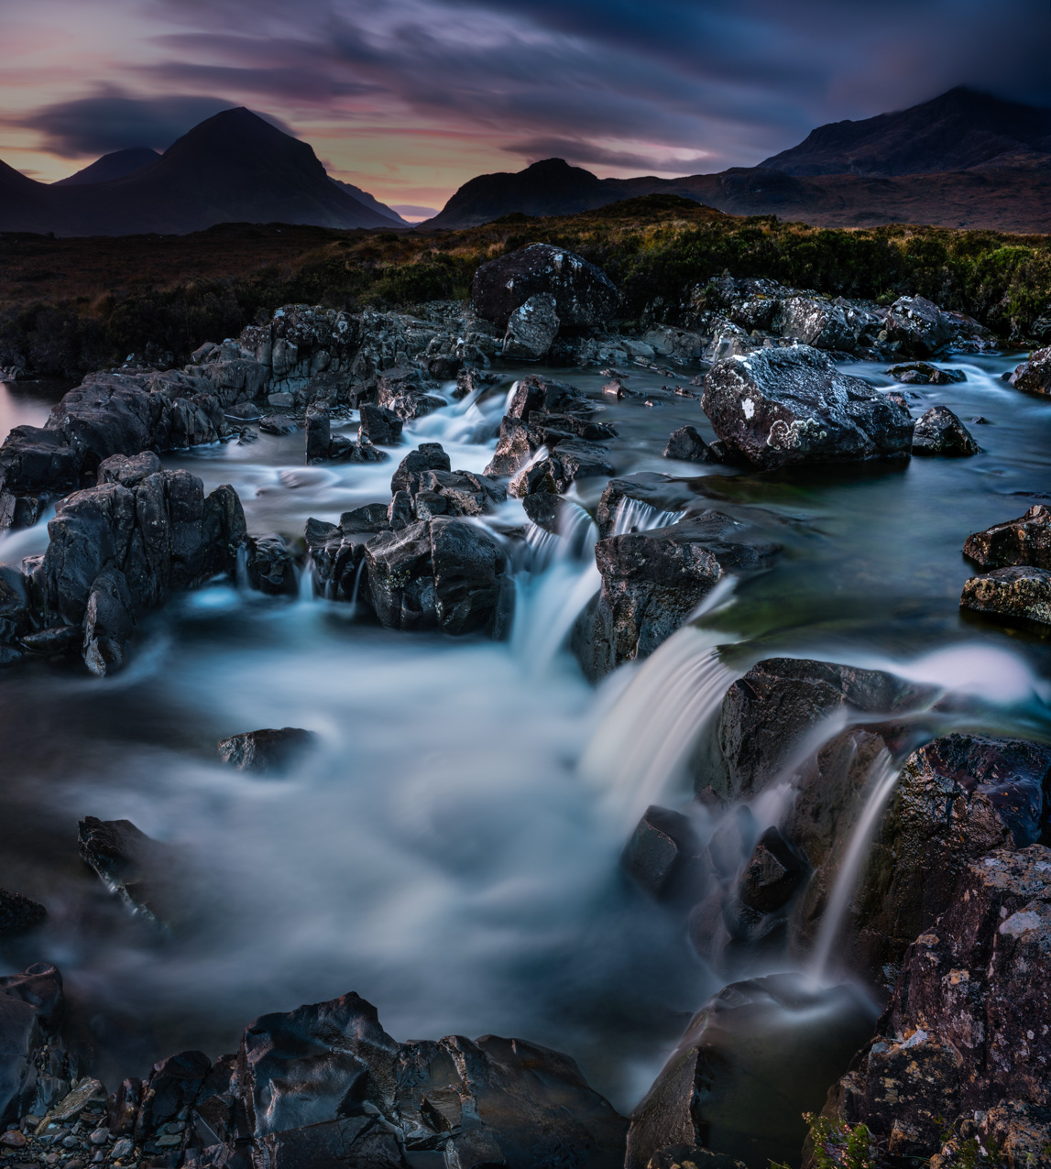
Sligachan Dreamscape.
Filters used; CPL/ND and 4 stop GND

