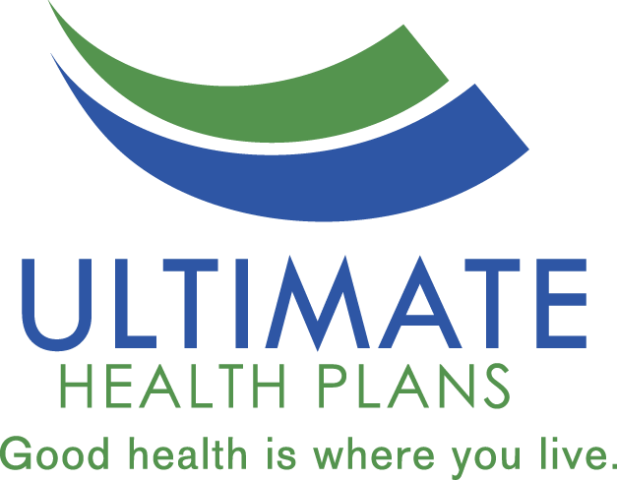
2022 Special Needs Plan (SNP) -
Model of Care (MOC) Training Attestation

I attest that the employees listed on the attached roster have completed the annual Special Needs Plan Model of Care training. I also attest that the employees understand that they are responsible for knowing and adhering to the information provided herein.

Signature |  | Date Completed
Name (Print)
Organization |  | Tax ID

Please print below the names of all additional employees covered under this attestation:

Employee Name | Training Completion Date

