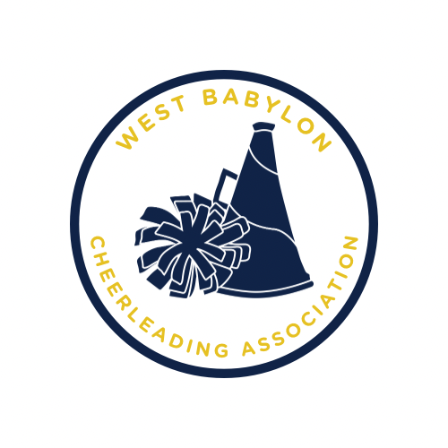
WBCA Sponsorship Form
Please complete the sponsorship form and send it with
your donation (cash or check) no later than
July 15th, 2026 made payable to:
West Babylon Cheerleading Association
26 Railroad Ave #162
Babylon, NY 11702
OR Fill out form here: https://forms.gle/oQutmUZqouspLiUq8
Family Name or Business
Name:_______________________________________________________________________________ Address:__________________________________________ Phone Number:______________________
EXACT Name on T Shirt:_______________________________________________________ Sponsor Level:_________________________________________ T-Shirt Size:_______________
⃞ CASH/ Venmo (WBCheerleading) / Zelle (westbabyloncheer@gmail.com)
⃞ CHECK
Payments can be made via Venmo @wbcheerleading using the note WBCA Tee Shirt Sponsor *Blue level and above, names and logos must be submitted to the WBCA (westbabyloncheer@gmail.com).
T-shirt deadline is July 15, 2026.

WB Spirit Level | Eagle Level | Blue Level | Gold Level
No Name:  $25 Sponsorship  T-shirt ONLY | Small Text-Only:  Bottom half of shirt  $35 Sponsorship  Family Name  (ex: Smith Family)  ONE T-shirt included per sponsorship | Small Text-Only: Bottom half of shirt  $50 Sponsorship  Bi-weekly social media posting promoting your business August thru November  T-shirt included | Medium Text  Middle of shirt  $75 Sponsorship  Bi-weekly social media posting promoting your business August thru November AND Your business displayed on our banner at Pape Field throughout the season.  T-shirt included

