Do you have these items at home?

Make a Scavenger Hunt!

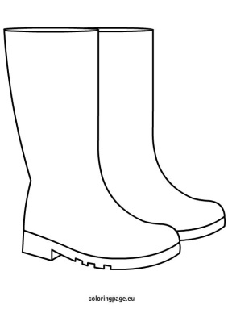 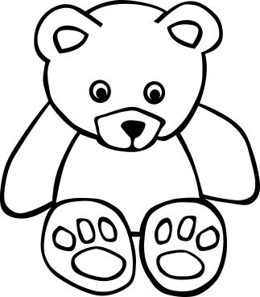

 

 

Hide the items around your house and form clues for a family member to find them. Or, have someone else do the hiding and you do the hunting! You can use any of the items from the reading to seek, or come up with your own adventure essentials! Have fun!!