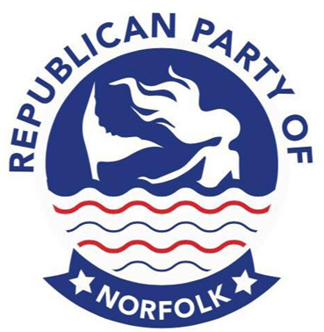
Republican Party of Norfolk
2024 Donor Form

Campaign finance laws require that the information with an * be completed in full.

Please type or print:
*Name: _____________________________________________________________________________
*Street Address: __________________________________________________________________
*City/Zip: __________________________________________________________________________
Home phone: ___________________________ Cell phone: ___________________________
Email: _____________________________________________________________________________
*Employer: ________________________________________________________________________
*Occupation/Type of Business: ________________________________________________
*City and State of Employment: ________________________________________________
*Amount: $_____________________________

Brunch 1st or 2nd Saturday of the month.
Business meeting held at 7:00 pm, the 3rd Thursday of the month at:
Calvin Presbyterian Church
2901 E. Little Creek Road
Norfolk, VA 23518

For information check our website at www.NorfolkGOP.org

Republican Party of Norfolk
P.O. Box 9236
Norfolk, VA 23505

